**“The Investigation, implementation, and evaluation of a secure cloud native web application, using micro services-oriented architecture.”**

By

Angelidis Kyriakos

A DISSERTATION

Submitted to

The University of Liverpool

in partial fulfillment of the requirements

for the degree of

MASTER OF SCIENCE

17/03/2021

ABSTRACT

**“The Investigation, implementation, and evaluation of a secure cloud native web application, using micro services-oriented architecture.”**

By

Angelidis Kyriakos

The new technological advances in the fields of cloud computing and the way the IT technology is being delivered to the end user. Have injected an entire new set of requirements regarding the security, software design and delivery, deployment, and coding approaches being followed for the development process to be applied.

The research conducted intends to explore these aspects, in the concept of the mechanism are based . To not only provide a comprehensive analysis but also communicate the essence of their application, due to the change rates occur. Thus, the analysis is demonstrated covers the range of the issues are raised by illustrating the appropriate solutions and functionality. To enhance the understanding about their application.

DECLARATION

I hereby certify that this dissertation constitutes my own product, that where the language of others is set forth, quotation marks so indicate, and that appropriate credit is given where I have used the language, ideas, expressions, or writings of another.

I declare that the dissertation describes original work that has not previously been presented for the award of any other degree of any institution.

Signed,

Angelidis Kyriakos

“This dissertation contains material that is confidential and/or commercially sensitive. It is included here on the understanding that this will not be revealed to any person not involved in the assessment process.”

**Student, Supervisors and Classes:**

|  |  |
| --- | --- |
| Student name: | Angelidis Kyriakos |
| Student ID number: | H00067179 |
| GDI name: | Kathleen Kelm |
| CRMT class ID: | LAUR - 906 |
| DA name: | Is-Haka Mkwawa |
| CAC class ID: | CKIT - 702 |

To my father

ACKNOWLEDGEMENTS

A big thank you to all those who truly an selfless helped me.

.

**TABLE OF CONTENTS**

Page

LIST OF FIGURES 2

Chapter 1. Introduction 4

1.1 Chapter Introduction 4

1.2 Problem Statement 5

1.3 Project Aims and Objectives 8

1.4 Approach 11

1.5 Outcome 12

1.6 Chapter Summary 14

Chapter 2. Background and Review of Literature 15

2.1 Chapter Introduction 15

2.2 Research Background 15

2.3 Literature Review 17

2.4 Theory 26

2.5 Terminology 32

2.6 Chapter Summary 37

Chapter 3. Analysis and Design 38

3.1 Chapter Introduction 38

3.2 Project Specification 38

3.3 Research Methods 39

3.4 Design Considerations 45

3.5 Chapter Summary 55

Chapter 4. Implementation (Realisation) 56

4.1 Chapter Introduction 56

4.2 Details of the Implementation 56

4.2.1 Problems Segmentation 56

4.2.2 Components identification 58

4.3 The IT Artefact 68

4.3.1 The main demo 69

4.3.2 Cloud Configuration Requirements 79

4.3.3 Performance 92

4.3.4 Observability 97

4.3.5 Security 101

4.3.6 Deployment 113

Chapter Summary 121

Chapter 5. Results and Evaluation 122

5.1 **Chapter Introduction** 122

5.2 **Evaluation of IT Artefact** 122

5.2.1 **Microservices Patterns Implementation** 123

5.2.2 Applications Security 124

5.2.3 Cloud Native 127

5.3 Chapter Summary 130

Chapter 6. Conclusions 130

6.1 Chapter Introduction 130

6.2 Lessons Learned 130

6.3 Strengths and Weakness of the Project 131

6.4 Academic Application and Limitations 132

6.5 Business Application and Limitations 133

6.6 Recommendations / Prospects for Future Research / Work 134

REFERENCES CITED 137

APPENDICES 145

References 154

LIST OF FIGURES

Page

Figure 1 Monolith Versus Micro-services 20

Figure 2 Use Case Diagram 48

Figure 3 Back-End System 49

Figure 4 The entire structure 50

Figure 5 Index Interaction 51

Figure 6 Assets Interaction 52

Figure 7 Compotition Patter’s interaction 53

Figure 8 Systems Components Required 57

Figure 9 Problems Partitioning 60

Figure 10 Micro-Services Design Concept. 63

Figure 11 Services Interaction Concept 64

Figure 12 Patterns and Techniques 65

Figure 13 Implementation Details 65

Figure 14 Application’s cloud accomplishment 66

Figure 15 Cloud Characteristics 67

Figure 16 Cloud Requirements 67

Figure 17 Deployment Requirements 68

Figure 18 Security Concept 68

Figure 19 Security Requirements 69

Figure 20 Cloud Security Concept 69

Figure 21 Microservices Security Concept 70

Figure 22 Containers Security Concept 70

[Figure 23 Basic Security Mechanism 105](https://192.168.1.12/6.1.1-53/web-apps/apps/documenteditor/main/index_loader.html?_dc=6.1.1-53&lang=el&customer=ONLYOFFICE&frameEditorId=iframeEditor&compact=true&parentOrigin=https://192.168.1.10#%CE%A3%CF%87%CE%AE%CE%BC%CE%B1!22|sequence)

Figure 24 Evaluation Approach 126

Figure 25 Bounded Context 127

# Introduction

* 1. Chapter Introduction

The chapter intends to introduce and briefly analyze the problem as the required solutions are applied. For the process follows to be analyzed and adequately demonstrated to distill the objectives encapsulated. And to identify the concepts should be covered as the formed by the generated questions context, within the solution applied.

Additionally, an introduction of the research approach is being leveraged to produce the required result alongside the identification of the methods being applied to the objectives are developed, is provided. While the outcome expected, as the development purposes contained, are appropriately illustrated.

In brief, the concepts addressed by this chapter are:

* problem's introduction, questions derived, and solutions applied,
* objectives distilled introduction,
* research approach and methods used, and
* Expected outcome and development purposes.

The analysis of which, will attempt to provide a result, by which:

* The anticipated aims and generated objectives are analyzed.
* The prototype created for demonstration purposes is introduced.
* A comprehensive overview of the investigated problem and issues generated are provided.
* The dissertation's questions are stated.
* The research approach and methods utilized are analyzed and demonstrated.
* And the project under construction is briefly introduced.

For the required knowledge and understanding about the problem and its solution, generated issues and requirements, as of resulted outcome's formation and purposes, to be enhanced.

* 1. Problem Statement

The problem faced is that of the development of a secure cloud-native web application using the micro-services pattern. The primary analysis extracts a variety of interrelated aspects in the fields of:

* security
* cloud-native nature's accomplishment,
* micro-services pattern's application,
* generated issues and requirements identification,
* and created services formation and deployment.

To set the limits and extensions within the solution should be navigated.

Moreover, the multidimensional nature of the problem faced, generates the realization that the variety of the sub-problems are extracted should be treated uniquely. Throughout the separate investigation and analysis activities that applied to each sub-problem is identified. For the issues and requirements contained as the techniques and patterns are leveraged to be distilled and the details and information needed to be obtained and properly integrated to support the development and demonstration processes.

Thus, resulting the expected coherent output that intends to include the details of the aspects are studied, and dictate the methodology the solution should comply with, through which the problem's nature is properly reflected.

So, the solution that being followed is generated by the analysis process is applied on a prototype developed, partially, and according to the sub-domain investigated. To cover, the key issues and requirements are formed and the techniques and patterns are utilized, throughout any interrelated development attempt, that utilizes the micro-services pattern.

More specific, as stated above, the solution itself must be segmented according to the studied sub-domains content, reflecting investigated problem's nature, for the reliable outcome to be produced. And the same repetitive process, that extract’s the required details through which the sub-domains key issues and derived requirements are settled, to be applied. By the artifact’s components are encapsulated and the configuration properties are leveraged investigation and demonstration activities are applied. That are performed within solution's boundaries and reflect the defined objectives numbers, while introduce similarities regarding their nature, application, and results produced.

Thus, generating the realization that the observed differences lie within the investigated concepts, but not the result's nature and formation that follow's the problem's multidimensional nature to ensure a reliable and coherent outcome via the detailed investigation, integration, and demonstration processes are applied. On the gathered sources and prototype's features utilized, that is developed using the filtered information acquired, regarding:

* design and formation
* interaction and communication
* packaging, deployment, and orchestration,
* system's security, and,
* scalability and performance.

Well-defined techniques, methods, and patterns are adopted for the required functionality and attributes to be implemented.

The analysis of which will be performed within the introduced dissertation questions context, consisting of:

* How can the micro-services architectural pattern be applied within the application's development process?
* What are the issues and requirements are generated, as the solutions utilized, from micro-services patterns application?
* How can the application's cloud-native nature be achieved?
* How can containerization, deployment, and orchestration processes be performed within investigated context?
* Why systems security and communications privacy issues are important, and how can they be applied both within the services created and infrastructure used?
* How systems availability, performance, and scalability requirements introduced can be addressed?

Thus, setting, the directions and boundaries within the required output will fluctuate.

(Christudas, 2019, Indrasiri and Siriwardena, 2020)

* 1. Project Aims and Objectives

The dissertation's primary purpose is to investigate and demonstrate the composition, development, deployment, and evaluation processes and identify the generated issues and techniques are leveraged within the development process of a secure cloud-native web application utilizing the micro-services architectural pattern.

More specific, there is a set of directly extracted tasks that need to be resolved, consisting of the:

* systems and services design, formation, and development,
* services interaction and communication,
* services and systems security concept,
* application's cloud-native nature accomplishment,
* services packaging, deployment, and monitoring.

The investigation and composition of which try to produce a coherent output for the components, techniques, and patterns are utilized appropriate demonstration. And distill the variety of issues and requirements are encapsulated within the objectives are defined, for the initial objectives and functionality required, such as:

* Business's functions definition and assignment to micro-services, as domains and bounded context's identification leveraging the DDD principals,
* services formation and implementation,
* micro-services interaction and communication, employing the different communication styles according to the use case studied,
* services security, leveraging the common approaches injected such as JWT and mTLS. For securing the application by applying the appropriate authentication/authorization, access control, and encryption patterns.
* Container-level and cloud security issues are raised, tackled via container isolation and communication security, infrastructures derived network functions and the appropriate configuration applied, utilized techniques.
* Security mechanisms detailed analysis is applied on system edges, as realized the door throughout attacks are being launched impacting the entire ecosystem.
* cloud-native nature's accomplishment through containerization and deployment methods. Consist of services packaging using docker images, cloud deployment techniques leverage the service-per-container pattern, and pod's governance and monitoring methods.
* Scalability, and performance and availability requirements are achieved employing the well-defined techniques and methods, as inherited by the cloud functions.

To be appropriately and in-details integrated, analyzed and demonstrated within a coherent document, to clarify the introduced aim and the generated aspects for the result produced to be used within interrelated development attempts.

The intentions claimed are meant to cover only the back-end functionality range. This introduces services formation and development, internal and external communication and interaction, data manipulation, services integration, monitoring, packaging, and deployment functions. Alongside the detailed security attention are required, generated by the entry points number and architectural style's nature applied.

(Christudas, 2019 ; Indrasiri and Siriwardena, 2020 ; Gray and Nadeau, 2016)

* 1. Approach

The research approach utilized for the project's production is qualitative research, in which the investigation process is conducted for stated problem's knowledge and understanding enhancement. Simultaneously, the data analysis activities are undertaken inductively and are navigated from the particular to the generic, using a case study research design for the variety of the information gathered to be appropriately filtered and integrated. To produce an output that the in-depth analysis of the investigated domain and the extracted sub-domains is demonstrated, throughout the developed prototype's features and components are utilized. For the research method's utilization according to the task being developed to be enforced.

Thus, approach’s application would be initiated throughout problems analysis and segmentation into well-defined tasks processes, that intend to produce small and flexible analysis units. To simplify the entire investigation, integration, and demonstration procedure that is being performed individually in a repeatable manner throughout the sources appropriate selection and filtering activities are applied.

Additionally, the research methods are leveraged according to the task's expected results are enforced, and can be applied for the resulted outcomes purposes utilization as well, via the different methods of:

* literature review, meant to provide the required theory background,
* and the case study applied to clarify specific parts of interest,

(Cresswell, 2014 ; Berndtsson, Hansson, and Olsson, 2008)

* 1. Outcome

The project intends to extend knowledge and understanding about the researched domain by:

* Investigating the existing literature and related cases for the best practices and techniques used. To produce and analyze a prototype by which the key aspects and related solutions will be demonstrated.
* And to provide both the theoretical and practical background, to investigate, analyze, and demonstrate the components, features, and techniques utilized for aims completion.

More specific, it will try to demonstrate the cloud-native applications development context, utilizing micro-services pattern. In a layered form, which meant to illustrate the steps required, from conception to implementation and deployment, as the variety of the issues and requirements generated. For the developed output to follow a specific form, regarding the objectives constructed re-composition process, in which the concepts, of:

* design and formation
* communication and interactions
* containerization and deployment
* security.

Will be illustrated in a sequential form, providing the required details according to the task are demonstrated. While, and for result's formation purposes, the objectives developed will maintain their unique nature. Even if the composition processes leveraged meant to produce a coherent tailored document, that can be used by readers throughout any development attempt.

An in-depth analysis of the implementation motives details acknowledges that the project undertaken intends to follow a layered process based on the applied partitioning activities. Which slice the problem into direct well-defined sub-objectives, each of which is being constructed uniquely mitigating the development complexities and workloads caused. While the individual analysis processes applied are performed separately, alongside, and parallel with the undergoing background segmentation procedure. To repeatedly conduct the partition process until aspects, issues, and requirements encapsulated are completely identified for solution's simplification purposes.

The basic idea behind procedures adoption is that of the tree-structure partitioning process, performed to enhance aspects, issues, and requirements housed identification activities, that can graphically be represented via the tree leaves produced. Thus, supporting and simplifying the undergoing development processes, for an accurate and reliable coherent outcome to be resulted with which the required objective's analysis processes will properly be integrated and demonstrated.   
(Tanasseri and Rai, 2017; Christudas, 2019 ; Indrasiri and Siriwardena, 2020)

* 1. Chapter Summary

The chapter briefly introduces the problem under investigation and the appropriate solutions being followed, as of the direct extracted by the stated aim objectives.

Additionally, the description of the research approach leveraged for the expected result is provided, and an introduction of the layered data analysis process applied is deployed. And is perceived as the introductory chapter used to illustrate the context and data analysis methods, with which the actual project will be deployed. Being utilized as a transition point that attempts to navigate the development efforts to the next phase. For the existing literature and resources obtained, used as the foundation on the top of which the actually project is being constructed, to be demonstrated.

# Background and Review of Literature

* 1. Chapter Introduction

The chapter provide’s an overview of the literature upon which the development of the artifact is based. More specifically, it analyzes the concept and demonstrates the theoretical building blocks are being utilized within the development process, can be used as the foundation upon which the project is being build.

* 1. Research Background

The concept introduced by Lewis and Fowler(2014a) defines micro-services architectural style as a suite of independent services are being built around well-defined business functions, utilizing various programming languages. While is enabled by lightweight communication mechanisms such as HTTP resource API’s, independently be deployed and scale. Thus, maintaining, the centralized management requirements to the bare minimum.

And enhanced by Newman (2015), which states that the produced micro-services must be small and autonomous, doing only one thing. Follow the well-defined set of established key principals, best practices, and required standards, for the inherited benefits to be acquired (Newman, 2015). Being adopted to overcome monoliths disadvantages, while generate a set of common characteristics, consisting of:

* Componentization via services. The application is segmented into multiple independently replaceable and upgradeable services, that communicate via web requests.
* Being organized around business capabilities.
* Products not projects, as the same team is responsible for the service over its full life cycle.
* Smart endpoints and dump pipes. The decoupled and cohesive nature is applied using simple REST and lightweight communication protocols.
* Decentralized governance and data management. Various development technologies, standards, and databases can be used.
* Infrastructure’s automation. Automated testing, deployment and management requirements are generated.
* Design for failure and evolution. The need for failure and change tolerance designs is being enabled, using the automate detection and restoration mechanisms via real-time observation.

That enable concepts basic features, such as: a) the created services implement only one business function, b) the scaling operations are performed by the replication processes are applied across multiple servers, according to resources availability. As better illustrated within below picture:

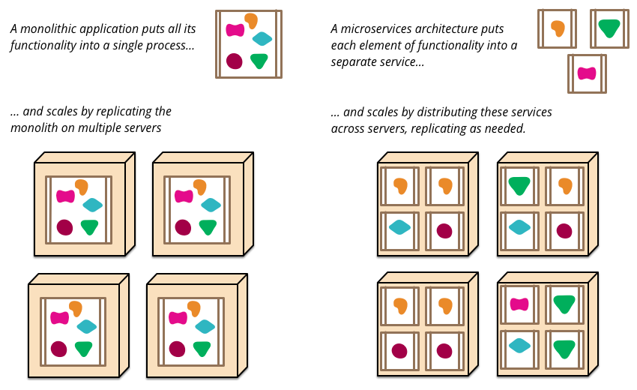

Figure 1 Monolith Versus Micro-services

* 1. Literature Review

An extensive examination of the literature covering the domain and its aspects is provided by Francesco, Lago, and Malavolta(2019), which Identify Newman(2015) and Fowler and Martin(2014a) as the key sources utilized by most investigated papers. Thus, our provided definition and initial examination about the concept follow their perspective.

**Micro-services concept. Issues and considerations:**

The micro-services architectural style is a development approach, with which a single application is being constructed as a suite of independent services, each running in its own process. Communicating with lightweight mechanisms such as HTTP resource API’s and they are built around well-defined business capabilities, utilizing a variety of different programming languages.

Additionally, their component-based nature, which complies with distributed systems restrictions, by requiring various remote entities to collaborate for the expected functionality to be resulted. Generate a set of sub-issues, consisting of the services:

* integration: responsible for collaboration, management, and technology selection tasks, ensuring autonomy and changes independence requirements,
* design: dealing with business’s functionality determination, services formation, and domain’s segmentation tasks, ensuring high cohesion and loose coupling,
* development: theory and patterns are identified and applied within the implementation.
* Deployment: navigate the packaging techniques as infrastructure’s selection decisions, to enable a variety of benefits and functionality that can be integrated within deployed ecosystem,
* security: responsible for communication, data integrity, and systems behavior tasks.

Must be addressed and composed for the micro-services domain to be formed, and the fundamental concepts of services autonomy, monitoring, isolation, decentralization, change flexibility, business reflection, and deployment’s independence to be resulted. (Newman, 2015)

While the features above consist of the key motivational powers, that direct the choices and decisions throughout applications development life cycle. The theory of the hexagonal architecture that hides services internal logic (Cockburn, 2005). Alongside the Domain-Drive Design that divides a domain into different bounded contexts according to well-defined business functions, being explicit about their interactions tackled by Evans (2004). Must be acknowledged and applied, as is being adopted and enhanced by the new technological, visualization, containerization, and cloud innovations raised (Sill, 2016), to best align with the micro-services concept.

More specific, the DDD notion where the investigated domain is being divided into a variety of bounded contexts, that are the explicit boundary descriptions implement a specific business logic. By defining the context and setting the boundaries in terms of usage and physical manifestations, within which the service applies (Evans, 2014). Alongside the hexagonal architecture introduced (Cockburn, 2005), that provides a clear separation between the domain model and the input/output functions. By dividing a service into a variety of autonomous components, interacting via several exposed interfaces. Enable the key design principles of : 1) high cohesion, 2) loose coupling, for the contained benefits such as: 1) heterogeneity, 2) resilience, 3) scaling, 4) deployment simplicity, 5) organizational expression, 6) composability, and 7) replaceability to be obtained.

Further, deploying our assumption about pattern’s distrusted nature, which treats an application as a collection of autonomous services, that interact over the network with inter-service or remote procedure calls.(Indrasiri and Siriwardena, 2020) An entirely new set of decisions in terms of services communication, collaboration, and coordination, impacting systems design, must be made, introducing the communication concepts of:

* Synchronous style: with the remote server to be blocked until the received request to be served,
* Asynchronous style: in which the caller does not wait for the operation to be completed,

That are some of the communication styles are utilized, enabling the two main collaboration approaches of the request/response and event-based, to be allocated accordingly.

To the request/response implementation, the client initiates a request and waits for the expected response to be obtained. In contrast, the event-based approach emits events informing specific state changes, expecting the receivers to utilize accordingly, and is being leveraged for the business logic decentralization process to occur. While causes inter-boundaries communication management issues by the coordination concepts of:

* orchestration, in which the entire process is being guided and driven centrally,
* choreography, in which the components of the system are being informed about an event that initiates the expected functionality.(Newman, 2015)

Being accomplished throughout the various development technologies are applied, that best fit the request/response communications model. Such as the remote procedures call (RPC) and Representational State Transfer (REST) architectural styles are utilized.

With the last to present a broader adaptability rate due to the simplicity and compatibility features provides, as is inspired by the web and injects the concept of resources. Being the common utilized domain representations demonstrate database items externally, in a lightweight JSON format over the commonly used HTTP protocol. (Newman, 2015)

**Cloud-native nature. Compatibility, infrastructural and deployment issues**

Investigating the methodologies being followed for applications cloud-native nature accomplishment. The What is and How to applications cloud behavior is obtained questions, are the first come to mind. Being extensively answered by the terms utilized, that determine cloud behavior as the set of principles and best practices are adopted. For the cloud compatible applications that distill the maximum of the hosting environment provided benefits, to be developed. These encapsulated rules, which cover the key aspects of:1) code base, 2) dependencies, 3) configuration, 4) backing services, 5) development stages, 6) processes, 7) port binding, 8) concurrency, 9) disposability, 10) dev/prob parity, 11) logs, and 12) admin processes. Are applied within any development attempt to result applications which, as stated by 12-factor-app:

* "use declarative formats for setup automation",
* "have a clean contract with the underlying operating system, offering maximum portability between execution environments",
* best fit modern cloud platform deployments,
* "minimize divergence between development and production, enabling continuous deployment for maximum agility",
* and, "can scale up without significant changes to tooling, architecture, or development practices",

To tackle the challenges generated by the set of component-based characteristics, consisting of:

1. The instantiated components must be properly configured and always located, due to the environment's nature. That is characterized by the critical terms of isolation and instantiation, as the services are frequently loaded and crash within different zones. Thus, maximizing automation properties definition and discovery requirements, being solved by the discovery and externalized configuration patterns.
2. The packets flow must be managed and filtered, respectively. Additionally, due to communication and performance overhead purposes, load-balancing capabilities must be provided. This logic enables the requests to be forwarded to the correct instance and the responses, generated by multiple services, to be properly aggregated. For the resources consumption minimization, throughput’s improvement, and services security features to be enabled, tackled by the gateway and load balancing patterns.
3. The ecosystem deployed must be designed for failures encapsulating failures tolerance capabilities, for the errors generated by the environment to be managed. Which alongside with the scaling capabilities provided in an automation form, the robust systems that preserve their functionality are being produced. Addressed by the resilience and scaling per service patterns implementation.

(Esposito, Castiglione and Choo, 2016 ; Torkura et al., 2017 ; Fazio et al., 2016 ; Jaramillo, Nguyen, and Smart, 2016 ; Christudas, 2019 ; Indrasiri and Siriwardena, 2020)

For the inherited benefits to be obtained, consisting of services:

* deploy and update speed and simplicity,
* lose coupling,
* enhanced scalability capabilities throughout balanced resources consumption,
* optimized components allocation,
* decentralized data governance.

Expanding the “what is” investigation, the understanding of cloud computing enablers is mandatory. That Injects into the big picture the concepts:

* Hypervisor-based resource virtualization, that supports the creation of unique virtual machines that share a set of physical resources, to enhance fault-tolerance and security via isolation context features. With each VM to host a distinct OS instance, being utilized when multiple different applications at multiple servers are required.
* And the container-based virtualization, in which an isolated and secure environment containing the required components for the application to run, is leveraged. To enable the hardware resources instantiation, relocation, and optimization flexibility. While is considered the best micro-services utilized solution, due to its lightweight nature and the resources sharing technique contained, resulting in low overheads and footprint, as of instantiation times reduction.

(Christudas, 2019)

With the container-based approach to be perceived as the best fit solution, applied throughout various tools used for services fast packaging and deployment. While enables the container provisioning and network problems management capabilities, as includes the registry resource for the required storing and versioning functions to be applied.

(Fazio et al, 2016)

**Security and Performance Requirements and Implementation.**

System’s security is considered one of the most critical issues introduced due to the ecosystems complexities being inherited by the micro-service's and infrastructure's nature. The point here is that the benefits obtained by the component-based architecture are not coming without a cost. The traditional security mechanisms that cover only the systems perimeter can be proved ineffective, as attack’s surface is being broadened due to the entry points numbers and communication loads. (Yarygina and Bagge, 2018).

Thus, the security concept generates considerations related to data protection, while in transit and at rest, underlying OS, and networks traffic issues. That are being addressed as the set of the subsequent tasks of: a) cloud computing, b) containerization, and c) micro-services security sub-concepts. Being applied in an inside-out and on them form, for the security measures on the different architectural layers are forming the system to be implemented. (Newman, 2015)

Further analysis, supply the realization that the micro-services security sub-concept can further be segmented, according to the location applied, into the well-defined main tasks of:

* Edge security, that deals with the authorization and authentication functions applied using the token-based authentication schema. That is being formed by the cooperation of the API gateway and SSO server components for the authentication functions to be applied and the JWT tokens to be generated and validated.
* Service-to-service communication security, that is responsible for inter-service communication issues, being applied leveraging the trust based on the mTLS solution.
* access control authorization mechanisms, to define and verify the required access criteria, by attaching policies to a given resource.

Are being applied alongside the inner-service security functions. (Yarygina and Bagge, 2018, Indrasiri and Siriwardena, 2020, Christudas, 2019)

Supported by the cloud security provision that address’s the: a) data at rest and transit, by applying robust encryption algorithms, and b) network traffic, leveraging application firewalls, IDS/IPS solutions, as network manipulation policies techniques, issues raised.

## Theory

The solution applied must reflect problems component-based nature, which introduces a set of interrelated sub-concepts, that are being addressed separately regarding the issues and requirements are generated and integrated for the expected outcome to be resulted.

Thus, and for the micro-services domain investigated, the key tasks of services: a) design, b) development, c) integration, d) deployment, and e) security requirements are distilled, being analyzed and resolved individually for the various merged sub-solutions required to be provided and the expected functionality be obtained.

Beginning our theory investigation, applied in a sequential form, the concept of micro-services design is introduced. That generates the questions of how the DDD principals are leveraged for patterns application are being utilized and the development process follows is being supported by the output produced.

Thus, the first step is to determine the design principles are required for our micro-services to be formed. Fortunately, the DDD approach injects the concepts of sub-domains and bounded context, simplifying the entire procedure. That is being initiated by the business domain into distinct sub-domains segmentation process is applied regarding the business use case provided and the analysis process leveraged, for the business functionality to be determined. Being followed by a repeatable division process applied to each sub-domain, until the set of the distilled contexts that encapsulate a unique business function to be formed, (Newman, 2015) for the required services to be allocated accordingly.

In a sense, this is a simple procedure, that in its abstract form, apply a repeatable partitioning process onto the initial domain until the contexts that contain a single function only, to be defined and allocated to the candidate services accordingly.

The above procedure introduces the challenges that must be addressed for the development process to be appropriately applied, by underlying the demand for the information related to the interfaces and operations, parameters and return types, as endpoints, protocols, and message formats to be specified within the design. To tackle the complexities are being generated by the DDD concept’s application, in regard the cross-contexts associations.

Additionally, the requirements are affecting the system's technical aspects, such as the infrastructure’s provisioning and services deployment, must be satisfactory demonstrated for the required components are being generated by the pattern’s nature to be clarified and developed. (Rademacher, & Sorgalla, & Sachweh, 2018)

Continuing our analysis, the development considerations are being raised regarding services implementation are next in line. And enable the realization that the micro-services concept is heavily based on the communication and interaction processes, as being the approach in which various parts interact and coordinate for the expected functionality to be accomplished. Therefore, the services construction must reflect a distributed environment's structural requirements and encapsulate the architectural style that consequent the interaction simplicity.

Thus, injecting into the big picture the concept of REST architectural style, being applied within the services development process. With which the distributed environments are based on hypermedia are being formed utilizing the notion of resources. That are realized as the domain entities representations over a network, being accessed via a unique URI and employed for RESTFull services modeling activities, throughout the encapsulation of the basic principles, of:

* Resources expose URI's,
* Representations transfer JSON or XML,
* Operations use HTTP methods.

While best aligns with HTTP protocol, as transform resources URLs into their identifiers. By which the standard GET, PUT, DELETE, POST, and HEAD operations, are being enabled, resulting development processes simplification. With the tasks of domain entities, repositories, and RestController constructions to be implemented sequentially for services formation.

Until now, the entire process is realized as a repeatable partition procedure that results a component-based nature. Being introduced to all the life-cycle stages, from the architectural component's integration forming a coherent application. To the inter-service's building-blocks interaction that provides the business functionality. (Indrasiri and Siriwardena, 2020 , Christudas, 2019)

Additionally, it is underlining the significance the communication-functionality relationship introduces within the distributed system’s operation. As enable’s the RESTFull services interaction and coordination, throughout the mechanisms and techniques leveraged and is navigated according to the use case implemented, in the context of systems resiliency requirements. To define the request operations, such as the search quarries performed, being implemented using the synchronous style, are applied via the direct REST request/response calls over the HTTP protocol. While the write activities required are able to be applied via the asynchronous approach, which enhances services autonomy, and is used where the imminent response requirements are abstracted, encapsulating the message broker pattern within systems architecture. (Indrasiri and Siriwardena, 2020)

These patterns are realized as a simple receive-store-transmit intermediate is applied within the different single and multiple receiver types and is leveraged to communicate messages to one or multiple consumers accordingly.

To complete patterns building-blocks demonstration with the services packaging, deployment, and cloud compatibility requirements presentation, being enabled by the utilization of the appropriate principles and techniques.

In contrast to the monolith, micro-services can best take advantage of cloud’s inherited benefits by expanding their component-based character, throughout the encapsulation within the development process, of a set of distributed ecosystem’s enablers, consisting of:

* distributed configuration provision,
* registration and discovery mechanisms utilization,
* routing and load balancing functions application,
* internal calls and distributed messages clarification,
* as fault tolerance and availability requirements provision.

Which are tackle the generated challenges, regarding patterns distributed nature and architectures complexities and requirements. (Christudas, 2019)

More specific, the services created can individually be packaged within docker containers and deployed on the required infrastructure, through which the specific functionality will be inherited and the existing will be enhanced.

Considering, additionally, the container’s isolation and system distribution features, the conclusion being made is that the deployed services must locate each other and effectively commit or respond to any internal and external request. While must provide simplified messaging and configuration mechanisms, as satisfactory tackle the throughput overheads and failures generated.

Thus, utilizing a gateway at the top of our architecture is mandatory, that is supported by a discovery server that holds and supplies the information relevant to service locations. While is enhanced by the Feign client and load-balancer patterns encapsulation, which provide the simplified HTTP API calls and client-side load balancing mechanisms accordingly. And is completed by the existence of the externalized configuration and circuit breaker patterns, being leveraged to ensure automated properties provision each time an instance is generated. (Christudas, 2019, Khan, A., 2017)

To finish our demonstration, an inside into the non-functional requirement of the security concept is provided. That is realized as the aspect within architecture, presenting the most importance and challenges, due to the system's distributed nature and the variety of the different components interacting, raising the number of the attack surface as the solutions applied.

Thus, security is the set of techniques applied within the different architectural layers to support the functionality implemented. These techniques elaborate the application of secure inter-process communication using the mTLS approach, leveraging a certificate server. Alongside the SSO pattern that is used for edge security, based on the JWT token generation, propagation, and verification approach, as the access control functionality .

Additionally, the security range, in regard system's nature and requirements. Is Extends system boundaries and is introduced into a variety of points. Like the hosting environment and containers created. Tackled by the network manipulation function inherited by the cloud infrastructure, firewalls, IDS/IPS, and network segmentation as monitoring processes, encapsulation. And is enhanced by the containerization security actions followed, which hardens containers generated by the access control and images verification mechanisms application. (Indrasiri and Siriwardena, 2020, Yarygina and Bagge, 2018, Gray and Nadeau, 2016)

The whole security concept is applied in a multi-level manner, individually for every architectural component. And is re-composed into a coherent provision, which secures the system and its parts as independent entities. The basic idea here is to follow a sequential process. With which the security should primarily be applied within design and services development stages. By encapsulating well-defined security design patterns and hardening techniques. Followed by the containerization process consists the bridge between security layers, as enables the infrastructure's security functionality to be appropriate cooperate with micro-services and containers security functions.

* 1. Terminology

**IDS**: Intrusion Detection Systems are devices or software applications that monitors a network or systems for malicious activity or policy violations. (En.wikipedia.org. 2021a)

**IPS**: Intrusion Prevention Systems are thereby used to examine [network traffic](https://searchnetworking.techtarget.com/definition/network-traffic) flows in order to find [malicious software](https://searchsecurity.techtarget.com/definition/malware) and to prevent vulnerability [exploits](https://searchsecurity.techtarget.com/definition/exploit). (En.wikipedia.org. 2021a)

**NFV**: Network functions virtualization is a network architecture concept that uses the technologies of IT virtualization to virtualize entire classes of network node functions into building blocks that may connect, or chain together, to create communication services. (En.wikipedia.org. 2021b)

**VNF**: Virtualized Network Functions are responsible for handling specific network functions that run in one or more [virtual machines](https://www.webopedia.com/TERM/V/virtual_machine.html) on top of the hardware networking infrastructure, which can include [routers](https://www.webopedia.com/TERM/R/router.html), [switches](https://www.webopedia.com/TERM/S/switch.html), [servers](https://www.webopedia.com/TERM/S/server.html), [cloud computing](https://www.webopedia.com/TERM/C/cloud_computing.html) systems and more. (En.wikipedia.org. 2021c)

**JWT**: JSON Web Token is an open standard ([RFC 7519](https://tools.ietf.org/html/rfc7519)) that defines a compact and self-contained way for securely transmitting information between parties as a JSON object. This information can be verified and trusted because it is digitally signed. JWTs can be signed using a secret (with HMAC algorithm) or a public/private key pair using RSA. (Auth0. 2020.)

**JSON**: JavaScript Object Notation is a standard text-based format for representing structured data based on JavaScript object syntax (MDN Web Docs. 2020c)

**mTLS**: [Mutual TLS authentication](https://en.wikipedia.org/wiki/Mutual_authentication) is the technique in which both the client and the server present a certificate during a [TLS handshake](https://hpbn.co/transport-layer-security-tls/#tls-handshake), which mutually proves identity.(Google Cloud. 2020)

**API**: Application Programming Interface is a computing interface that defines interactions between multiple software intermediaries. It defines the kinds of calls or requests that can be made, how to make them, the data formats that should be used and the conventions to follow (En.wikipedia.org. 2021d).

**HTTP** : HyperText Transfer Protocol is the underlying network [protocol](https://developer.mozilla.org/en-US/docs/Glossary/protocol) that enables transfer of hypermedia documents on the [Web](https://developer.mozilla.org/en-US/docs/Glossary/World_Wide_Web), typically between a browser and a server / developers (MDN Web Docs. 2020b )

**REST**: **Re**presentational **S**tate **T**ransfer is an architecture style for designing loosely coupled applications over HTTP, that is often used in the development of web services. (Mode et al., 2020b)

**RESTFul API’s** : Are the web applications are following a predefined set of constraints , which enable all possible CRUD (create, retrieve, update, delete) operations utilization (Mode et al, 2020 ; SearchAppArchitecture. 2020)

**HTTP API’s** : HTTP API’s are any API that makes use of HTTP as their transfer protocol (Restcookbook.com. 2020)

**CRUD** : stands for create, read, update and delete. These are the four basic functions of persistent storage (Mode et al, 2020)

**HTTP GET**: retrieve resource representation/information only – and not to modify it in any way(Mode et al, 2020)

**HTTP POST**: create new subordinate resources, e.g., a file is subordinate to a directory containing it or a row is subordinate to a database table(Mode et al, 2020)

**HTTP PUT**: update existing resource, if the resource does not exist, then API may decide to create a new resource or not.(Mode et al, 2020)

**HTTP DELETE**: delete resources identified by the Request-URI. (Mode et al, 2020)

**URL**: Uniform Resource Locator , the syntax and semantics of formalized information for location and access of resources via the Internet. (Tools.ietf.org. 2020a)

**URI**: Uniform Resource Identifier is a compact sequence of characters that identifies an abstract or physical resource (Tools.ietf.org. 2020b)

**XML**: Extensible Markup Language documents are widely used as containers for the exchange and storage of arbitrary data in modern systems. (Tools.ietf.org. 2020c)

**VPN**: Virtual Private Network is a network that is connected to the Internet, but uses encryption to scramble all the data sent through the Internet so the entire network is "virtually" private. (En.wikipedia.org. 2021e)

**HTTPS**: *HyperText Transfer* Protocol *Secure* is an encrypted version of the [HTTP](https://developer.mozilla.org/en-US/docs/Glossary/HTTP) protocol. It uses [SSL](https://developer.mozilla.org/en-US/docs/Glossary/SSL) or [TLS](https://developer.mozilla.org/en-US/docs/Glossary/TLS) to encrypt all communication between a client and a server. This secure connection allows clients to be sure that they are connected with the intended server, and to exchange sensitive data.(MDN Web Docs. 2020a)

**OAuth2.0**: The OAuth 2.0 authorization framework enables a third-party application to obtain limited access to an HTTP service, either on behalf of a resource owner by orchestrating an approval interaction between the resource owner and the HTTP service, or by allowing the third-party application to obtain access on its own behalf. (Tools.ietf.org. 2020d)

**OS**: The operating system is system software that manages computer hardware, software resources, and provides common services for computer programs. (En.wikipedia.org. 2021f)

**OpenStack**: Is a Cloud Infrastructure for Virtual Machines, Bare Metal, and Containers which controls large pools of compute, storage, and networking resources, all managed through APIs or a dashboard. (OpenStack. 2020)

**VM**: Virtual Machine is an emulation of a computer system based on computer architectures and provide functionality of a physical computer. (En.wikipedia.org. 2021g)

**RPC**: remote procedure call is when a computer program causes a procedure to execute in a different address space, which is coded as if it were a normal procedure call, without the programmer explicitly coding the details for the remote interaction ( En.wikipedia.org. 2021h)

**Sandboxing**: Is a computer security term referring to when a program is set aside from other programs in a separate environment so that if errors or security issues occur, those issues will not spread to other areas on the computer. (Techopedia.com. 2020)

* 1. Chapter Summary

This is the chapter where the description of problem investigated is provided in the context of existing research. As the investigation on the related literature is initiated, for the existing body of knowledge to be extracted and properly encapsulated, within research attempted. This results in an analysis process through which the problem's acknowledgment is being achieved and applied within the solving tasks. To produce an outcome that distills and combines solutions investigated, purposefully subtracting parts and suggestions, for the best established solution to be constructed. While is mainly based on Martins and Fowler's work and how it is applied, as demonstrated by Christudas(2019), Indrasiri and Siriwardena, (2020) and Richardson (2019).

# Analysis and Design

* 1. Chapter Introduction

This chapter will attempt to clarify the overall project specification, by connecting it to the original goals and objectives of the research. It describes the literature and provides an analysis of the theory being used. Furthermore it demonstrates , in details, the research methodology utilized, as of the research methods employed. And informs about the design is used during the development process.

* 1. Project Specification

The project is undertaken to expose micro-services patterns utilization in the context of a cloud environment counting security requirements. Its main intentions are to distill and analyze in details implementation aspects alongside generated issues, throughout the application’s development process is being accomplished.

More specific, being distributed in nature, patterns application illustrates a component-based behavior, meaning that the functionality expected is interconnected to the components are leveraged and is being achieved via their interaction. This is attempted to be demonstrated within the resulted output developed to provide the required guidelines as to clarify the issues and requirements raised. And can be leveraged as a road map within interrelated development attempts, while its utilization can also support several different use cases, as the security aspects contained can be applied within various situations, covering a broad range of security requirements.

Thus, employing a qualitative research approach, its primary purposes are to enhance the knowledge and understanding relevant to the investigated domain. By conducting an in-depth and detailed exploration of the aspects included as meanings assigned, to result in understanding enhancement. While aligns with project's development purposes, as applied throughout an inductive data analysis process, to enable researchers to interpret the meaning of the data and focus on rendering the complexities generated. For an outcome that the researched problem's aspects, issues, and requirements clarification that results knowledge's enhancement, to be developed.

* 1. Research Methods

The approach suggested is directly dictated by the studied problem's nature as intended result's development purposes. And is leveraged for the in-depth investigation and understanding of the domain and extracted sub-domains are studied as of issues and requirements are generated. While is based on a variety of factors and characteristics are required, such as:

* the data collection process occurs through documents examination and case's behavior observation,
* the forms of data are obtained, including observation, documents, and audiovisual information, are being organized into well-defined categories covering the entire set of the gathered sources,
* the focus is navigated on the stated problem's meaning and inherited issues learning and understanding enhancement,
* the factors, sub-domains, and required issues are identified, as of the domain's multiple perspectives are distilled for the larger picture to be formed.

For the produced outcome, in which the processes, activities, and events are explored and commented throughout the what, why, and how questions analysis.

Utilizing the data collection method that purposefully collects the information required, to result in problems and researched questions investigation and understanding processes. Throughout a set of basic rules, consisting of:

* investigated cases observation, in which the field notes and comments related to the behavior are being presented and the activities observed are recorded,
* and, private and public documents, like audio and visual materials, are collected.

In order for the steps leveraged, by analysis and interpretation processes, to be clearly specified, and the variety of the collected information to be segmented, analyzed, and reassembled in a coherent, meaningful form. By following the below illustrated general guidelines, consisting of:

* the analysis, development, collection, and findings clarification procedures have to be processed in a parallel manner,
* and the information filtering processes are applied on material collected to distill and aggregate critical data into a small number of themes.

Continuing with a two level approach is being encapsulated within the data analysis process, in which a) the general data analysis activities introduced, are b) being blended with the research data analysis steps, as presented below:

* the raw data are gathered being organized for further analysis,
* the meaning of the collected material is distilled,
* chunks of interest are extracted by the acquired sources and are appropriately categorized,
* chunks descriptions are provided, and the appropriate categories are formed,
* themes and descriptions are interrelated,
* and, the results are interpreted.

To support the qualitative case study design applied for the investigated domain and the variety of aspects contained appropriate demonstration.

Resulting in a coherent document that can be utilized as a road-map throughout several interrelated development attempts. By the obtained information's, that covers the entire domain's range as issues and requirements generated, appropriate integration and demonstration.

As stated by Berndtsson et al. 2008, for development simplicity and quality threats mitigation purposes, the researched problem should be analyzed and segmented into well-defined tasks, the solution and re-composition of which will provide the expected outcome.

At this point, the focus should be shifted from what is intended to be developed question into how it will be developed, throughout a four-step approach leveraged, consisting of the following steps:

* the introduced aim should properly be analyzed and partitioned for the required objectives to be extracted,
* the methods available should be identified ,
* be selected, and interlinked according to the investigated objective and results are expected,
* as of their details and steps encapsulated, should be presented appropriately.

The adoption of which would simplify the project's implementation in regard of the selected approach's nature. And result in quality threats mitigation throughout the well-defined boundaries establishment and implementation surface's minimization.

The additional analysis layer utilized intends to partition the problem so that the formation features would properly be distilled, identified, and interlinked to the objectives defined, for the required result to be produced by the re-composition activities are applied.

In an attempt to apply the above methodology, the example of the current problem is leveraged. Stating that for the below-presented aim.:

"Investigation, implementation, and evaluation of a secure cloud native web application, using micro services-oriented architecture."

The objectives identified are:

* Systems architectural design using the micro-services pattern and Domain-Driven Design principles are applied for the system's sub-domains determination, and the micro-services design, formation, assignment, as of generated issues solution.
* Internal and external micro-services communication and interaction requirements.
* System's cloud-native nature accomplishment.
* Services containerization and deployment, as of the appropriate patterns and techniques use .
* System’s security, scalability, and performance requirements accomplishment, throughout the appropriate patterns and techniques utilization,
* and , the IT artifact’s development.

Have to be implemented leveraging both literature analysis and case study methods regarding task investigated and results required.

More specific, the firsts and thirds objectives development processes require the utilization of the literature analysis method. This is, as stated by Berndtsson et al. 2008, "a systematic examination of the problem or sub-goal, by means of an analysis of published sources, undertaken with a specific purpose in mind". And is translated, in our case, into the more practical activities of the investigation, collection, filtering, and appropriate integration and demonstration of the information that covers the defined sub-domains range. That due to their content’s nature and development purposes, have to be presented in a mainly theoretical form. To supply both the generic and specific data required, are covering a variety of different development attempts.

Additionally, the second, fourth, and fifth objectives should be developed utilizing the case study method, as their practical nature requires a specific demonstration form. Being achieved by the studied aspects concepts appropriate investigation, throughout the required cases and sources collection, filtering, and integration processes are applied.

Thus, supporting knowledge and understanding's enhancement accordingly. As the objectives being resolved, via methods application, contain various sub-domains and components that need to be clarified for accomplishment purposes. And dictate a specific demonstration form, the resulted output should be structured with for the variety of different inter-related situations to be met.

(Cresswell, 2014 ; Berndtsson, Hansson, and Olsson, 2008)

* 1. Design Considerations

**The Design Models**

From the Use case diagram:

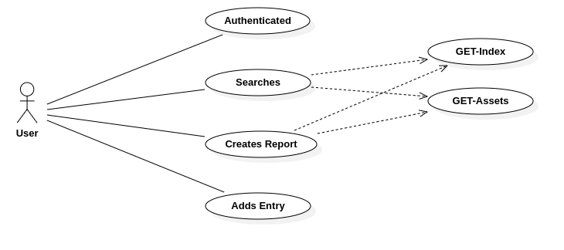

Figure 2 Use Case Diagram

The system’s requirements are being generated:

As the user, I have to:

* be authenticated using predefined credentials,
* Search the databases,
* create reports containing a combination of both Index and Assets data,
* create entries to both Asset’s and Index’s databases

To inform the High-Level Architecture diagram, which due components number and complexity, it is segmented into two distinct stages.

* The first stage demonstrates the services are providing the back-end functionality.

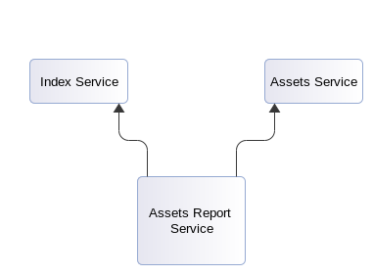

Figure 3 Back-End System

* And the second illustrates the distributed components are forming the application.

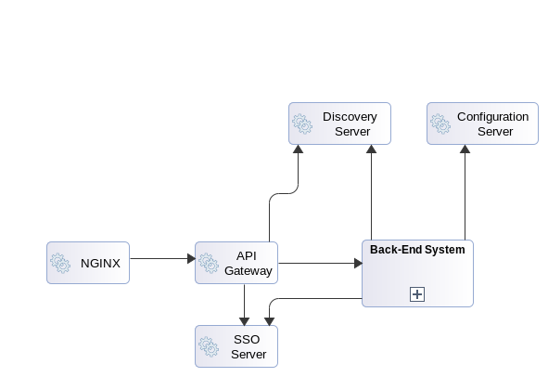

Figure 4 The entire structure

The components communicate via the REST functions performed, for the required data to be obtained, by the interaction of which the expected functionality, is launched. As briefly demonstrated below:

* Index service communication sequence.

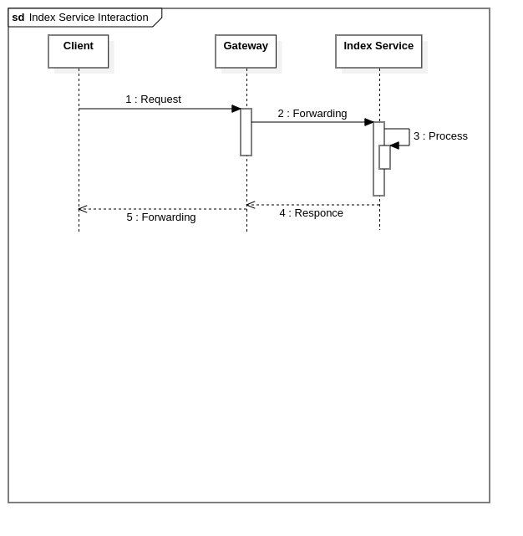

Figure 5 Index Interaction

The request is initiated and being transmitted to the API Gateway, that routes the incoming traffic to the Index micro-service. As long as the request hits its target, the operation defined in Header is applied, and the response is being created and re-transmitted.

* Assets Service communication sequence.

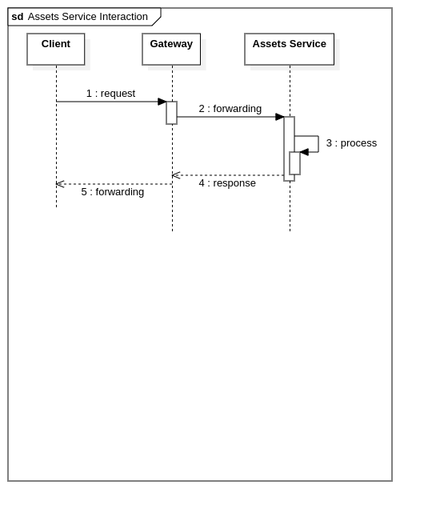

Figure 6 Assets Interaction

* And the Composition pattern Service interaction.

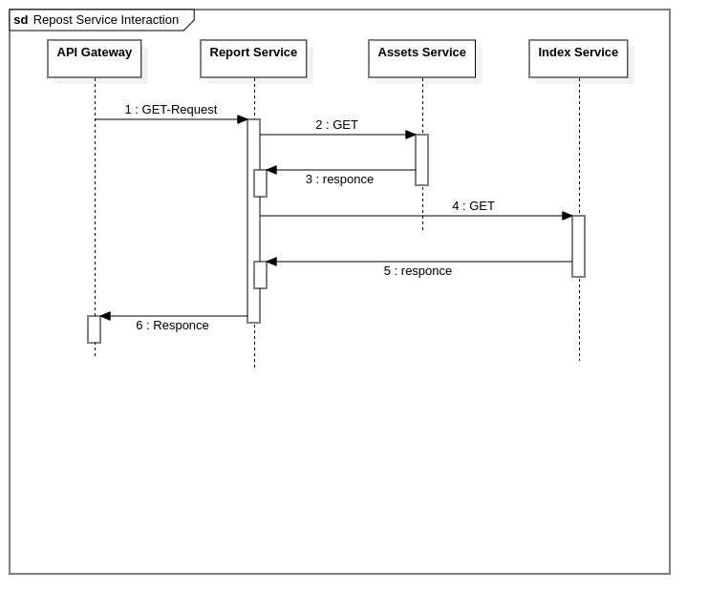

Figure 7 Compotition Patter’s interaction

The request is initiated and is forwarded by the API Gateway to the service. The service request’s the required information by both the Index and Asset’s service, from the responses composition of which the report is being formed.

**Technical Context**

Services should be developed leveraging the Spring Boot framework, which simplifies the applications development process, by enabling the implementation of production-grade micro-services, via the provided capabilities, of:

* stand-alone Spring applications development,
* Tomcat, Jetty, and Undertow direct embedding,
* Maven’s configuration simplicity , via starter POM’s provision,
* Automate configuration,
* XML configuration requirements abstraction,
* as metrics, health checks, and externalized configuration features provision.

Which, alongside the Spring Cloud libraries, provide the required tools for standard distributed systems patterns encapsulation.

(Indrasiri and Siriwardena, 2020 ; Christudas, 2019)

**Coding Approach**

The approach utilized for micro-services construction is that of the RESTFull architectural style, which partitions the service into well-defined components the interaction of which provides the functionality required.

Thus, the basic pseudo-code of a RESTFul service, for the GET requests to be handled and the required endpoints to be exposed using the Spring Boot framework, will be:

* The domain entities:

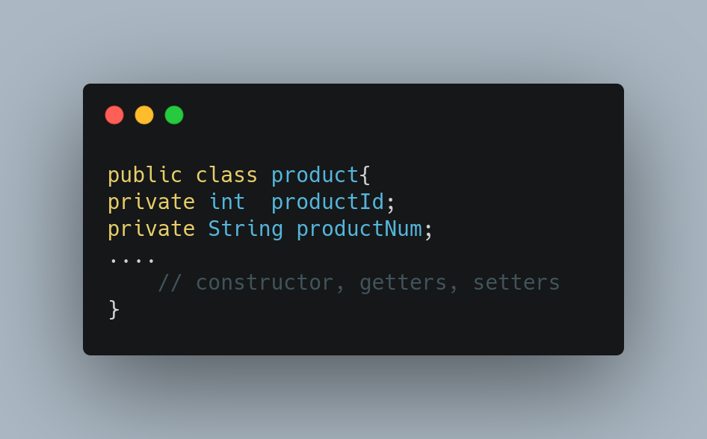

* the repositories communicate with the databases:

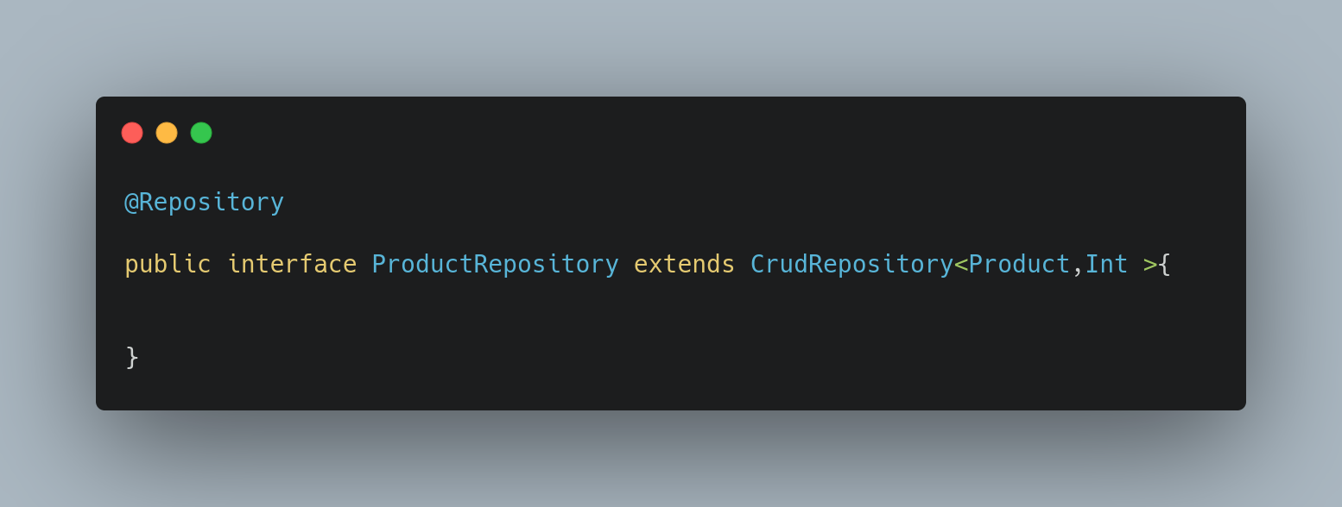

* And the controller class that exposes the endpoint and serves the incoming requests:

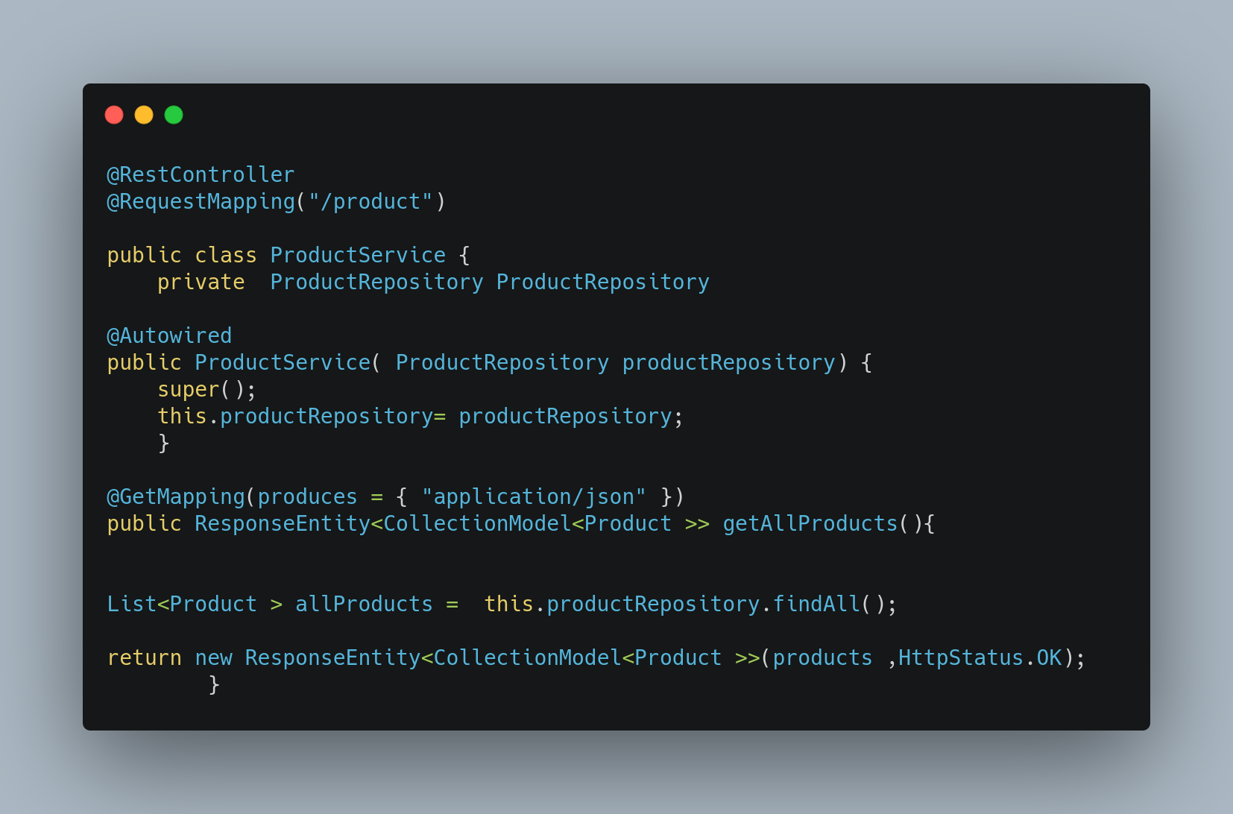

The process utilizes the @RestController and @RequestMapping Spring annotations, to identify the controller, expose the endpoints, and map the incoming web requests to the methods.

(Indrasiri and Siriwardena, 2020, Christudas,2019, *Spring.io. 2020a**)*

**Artifacts Metrics**

The prototype is measured via the metrics distilled by the appropriate monitoring tools, such as:

* Prometheus: which is an Open Source system for monitoring and alerting, used to gather services metrics via predefined endpoints.
* and Grafana, which is the tool utilized in analytics and monitoring specialized in visualizing the data collected, that can be integrated with Prometheus.

Are utilized to provide the required compatibility, functionality, and integration simplicity.

(Indrasiri and Siriwardena, 2020)

**Testing**

The artifact should be tested partially in regard to the formation services, by testing each service separately utilizing the *JAVA* *Junit and Mockito* framework. Throughout a set of automated testing units that are created according to the RESTFul Spring services components.

These tests , which are out of the scope of this project, should be applied both *on* code and dependencies, to check the class’s state in isolation and interaction. While follow the services components based structure, to check the databases connectivity, entries conversion into DTO’s capabilities, and API’s and interactions functionality.

(LinkedIn. 2020)

**Results**

The anticipated results of the product produced should be a set of components that provide the functionality expected. More specific, the user's requests should be served by the application and the required information should be communicated.

While the external interactions required should be applied throughout the NGINX reverse proxy and Gateway, which their main tasks are to route and filter the packets between the clients and inner structure . The NGINX proxy is not being applied as the administrative tasks are out of the scope of this project.

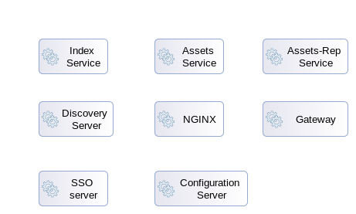

Figure 8 Systems Components Required

* 1. Chapter Summary

The chapter provides a description of the research approach used within development process. And demonstrates the details of the design process upon which the artifact’s development is based.

# Implementation (Realisation)

* 1. Chapter Introduction

The chapter intends to dive deeper into the development process, providing a detailed explanation about the research procedure, that is applied to uncover the whole range of issues, requirements and components, through which the artifact is being created.

* 1. Details of the Implementation

The solution is applied in a way through which the problem's component-based nature is reflected, which means that the procedure is followed divides the problem into well-defined sub-problems. They are treated as individual tasks requiring solution being achieved throughout the repeatable segmentation and data collection and analysis processes are leveraged.

* + 1. Problems Segmentation

More specific, the entire process is initiated via the initial problems analysis and segmentation activities applied. From which the main sub-topics, of :

* micro-services patterns utilization,
* security, as
* application's cloud-native nature,

are being extracted

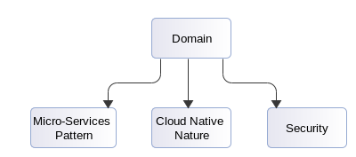

Figure 9 Problems Partitioning

Are consisting the reference point from which the process’s deployment occurs throughout the sources investigation procedure generated. The activities applied in this stage result in collecting a number of raw data via documents, cases, and audio-visual material investigation, primarily organized regarding the main topics defined. And being analyzed for encapsulated factors, sub-topics, requirements, and issues clarification. While are realized as the instrument throughout the domain’s multiple perspectives are being distilled to support the basic analysis procedure.

* + 1. Components identification

The stage's outcome is being leveraged throughout the entire development attempt, as the output produced is a complete map demonstrated in a tree form. That intends to simplify the aspects definition and partition the problem in such manner through which the focus navigation and details clarification, according to the specific cases are studied, are enhanced.

The entire process can be perceived as the repeatable partition, data acquisition and filtering activity, is applied in parallel. And intends to distill the issues and requirements are encapsulated to support a template's production, that house’s and categorize’s the information accordingly.

More specific, the collected sources are further being analyzed for their content to be extracted, through which the primary template's form is being created. Being followed by the additional information's gathering and filtering processes are being applied for the required partition activities are leveraged to be supported. And the complete version of the structure, which properly demonstrate’s the components, issues and requirements are encapsulated, to be constructed.

As soon as the final version is resulted , the filtering activities are being re-applied to the entire set of the sources are obtained, for the chunks of interest and details required to be extracted and categorized according the nodes produced.

Thus, the resulted outcome, which covers the range of the entire aim in the context of the components identified and related justification sources , is being developed. To provide a coherent sequence, which demonstrates the variety of the building blocks defined regarding the task investigated. For example, the task of:

**Micro-services Pattern’s Utilization**

The extracted data are obtained via the the process's application, inform that for pattern’s appropriate utilization, a primary set of tasks are identified consisting of the:

* design tasks application
* interaction issues clarification
* as, services implementation details determination,

Have to be accomplished. Thus, generating additional iterative process's application requirement, are being applied in such manner, for the nodes are defined to be individually analyzed and segmented as required.

This clarification procedure results in an analysis sequence, which states that applications architectural design, utilizing micro-services pattern.

* Is being defined throughout the Domain-Driven Development's principles application, which are utilized to identify the domains bounded contexts are encapsulated. Being followed by a requirements extraction and translation into functions process, is applied in parallel. For the partition activities are applied to each context separately to be supported and the full range of sub-contexts are encapsulated to be identified and assigned adequately to the services. (Newman, 2015 ; Richardson, 2019)

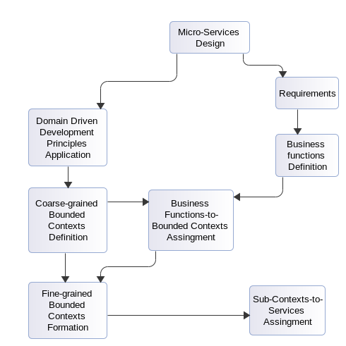

Figure 10 Micro-Services Design Concept.

* And is being completed by the components interaction determination, that defines the topology, mechanisms, and techniques are applied regarding the functionality expected.

More specific, the communication options available are being identified.:

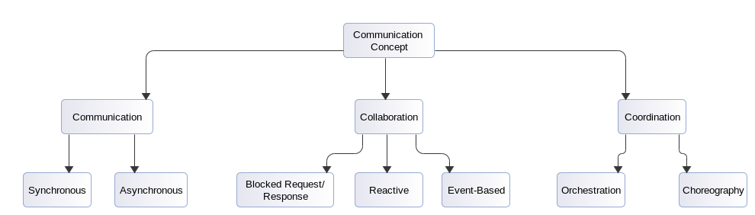

Figure 11 Services Interaction Concept

And the application’s interaction requirements are being defined, for the patterns and techniques are leveraged to be determined:

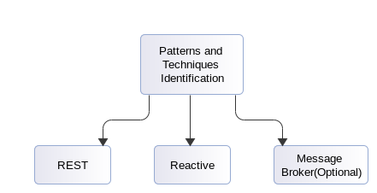

Figure 12 Patterns and Techniques

Thus, determining the implementation details through which the services and architecture are being developed:

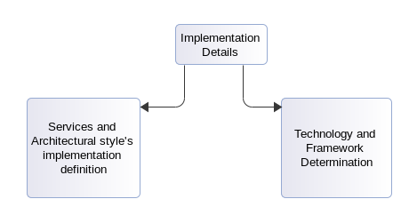

Figure 13 Implementation Details

(Christudas, 2019 ; Indrasiri and Siriwardena, 2020 ; Newman, 2015 ; Richadson, 2019)

**Applications Cloud Native Nature**

The applied process’s outcomes are obtained inform that the applications cloud compatibility is expected, being achieved via the well-defined patterns and techniques are encapsulated for the specific set of requirements to be satisfied.

The procedure follows is primary identify’s the generic cloud-native characteristic, for the applications specific cloud requirements to be determined, and the patterns and techniques are utilized to be defined.

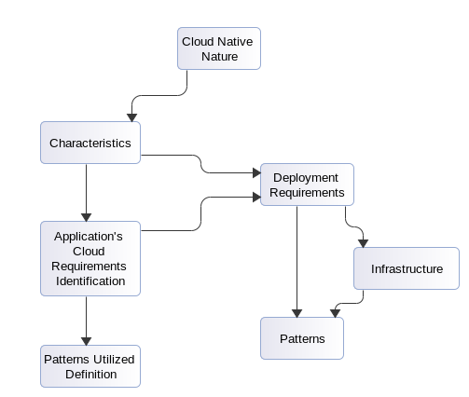

Figure 14 Application’s cloud accomplishment

For the development and deployment attempts, that intend to encapsulate the components and techniques are required, to be supported.

More specific, throughout :

* The cloud’s native generic characteristics, such as containerization, dynamic orchestration, and micro-services orientation. :

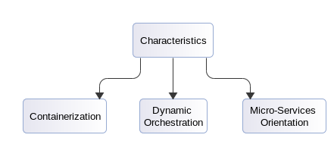

Figure 15 Cloud Characteristics

* the specific application’s cloud native requirements, such as: 1) automation, 2) monitoring, 3) independence, 4) scalability, 5) testing, and 6) fault tolerance and recovery issues, are being distilled:

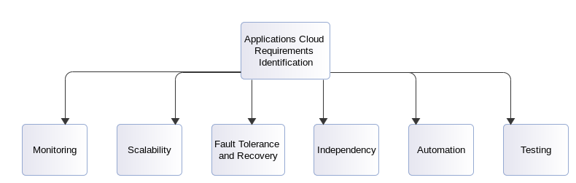

Figure 16 Cloud Requirements

* For the patterns and techniques required to be determined. Informing that even if the development and deployment attempts are two interrelated tasks, should be treated as separate activities. Due the differences generated in the application level.

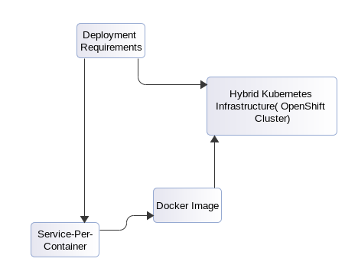

Figure 17 Deployment Requirements

(Newman, 2015 ; Indrasiri and Siriwardena, 2020 ; Christudas, 2019 ; Richardson, 2019 ;  Gannon, Barga, and Sundaresan, 2017 ; Jaramillo, Nguyen, and Smart, 2016)

**Security**

The process applied results the realization that due applications component-based nature and infrastructures complexities. The security requirements concept should in details be investigated, for all the contained sub-concepts to be clarified and the required patterns are being encapsulated and techniques are being utilized to be identified.

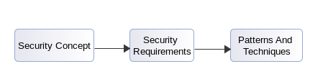

Figure 18 Security Concept

Initiating an iterative process through which the security tasks are being categorized into three different sub-concepts, regarding the level are applied.:

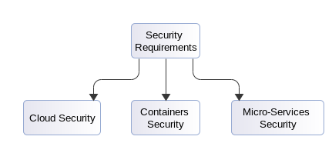

Figure 19 Security Requirements

The analysis of which intends to support the implementation processes follows, stating that:

* The cloud security concept introduces data, communication, and deployed pods security requirements. :

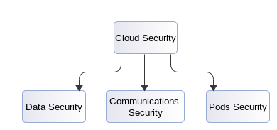

Figure 20 Cloud Security Concept

Addressed throughout the SDN, VNF, Data encryption both at rest and transit, and isolation techniques used.

* The micro-Services security requirements that are being tackled by the edge and service-to-service communications security as of the security components are encapsulated, being applied both within flow and services, accordingly:

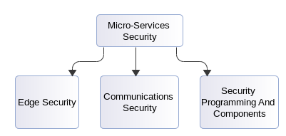

Figure 21 Microservices Security Concept

Addressed via the single-entry point, SSO server, and encryption certificates utilization , Throttling, filtering, access control , and observation techniques are leveraged.

* And the containers security requirements that are resolved throughout the secure build and the verification mechanisms are applied:

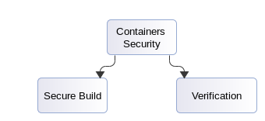

Figure 22 Containers Security Concept

Addressed with the Secrets Managements, docker images verification, access control methods, and Service Mesh pattern are applied:

(Fazio, et all, 2016 ; Indrasiri and Siriwardena, 2020, Christudas, 2019 ; Esposito, Castiglione, and Choo, 2016 ; Siriwardena and Dias, 2020)

* 1. The IT Artefact

The prototype being developed is a land-registry application demo, which primarily focuses on individual and assets records management. Is Intending to provide the required functionality for the information storage as search activities to be supported.

Expanding our introduction and for demonstration purposes, the analysis process will be applied to one bounded context only that is being formed by the composition of three different services, such as:

* Index Service: that collect and manage individual entries,
* Assets Service : that collect and manage assets entries,
* and, Assets Report Service, being developed to communicate the data both to the clients and other contexts as needed.

With each of which to be structured by a number of main building blocks, the cooperation of which provides the functionality required. These components, which align with the Hexagonal pattern's principals, support the implementation simplicity by partitioning the services development process into a set of four well-defined stages, consisting of:

* + 1. The main demo

**The Domain Models**

Perceived as the domain entities intend to represent the required data. As demonstrated below :

* For the Index micro-service, utilizes a relational MySQL table to store information, the main code created, is. :

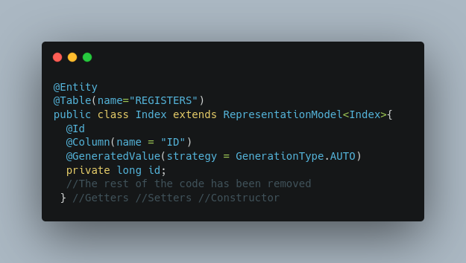

With the focus to be directed at the annotations "@" being utilized for both operational and simplicity purposes.

Thus, the analysis applied provides the conclusion that for the information to be stored in the database. The Index class must be declared as a JPA entity using the @Entity for a table stored in the database, with a specific name defined by the @Table(name=""), to be represented. The additional properties configuration are required, such as the primary key and attributes-to-table columns representation. Are being defined making use of the @id and @GeneratedValue annotations, that are utilized to specify the key and its generation strategies, accordingly. As of the @Column(name ="") that is leveraged to align a class variable with a table's column :

@entity: used to declare the class a JPA entity, to represent tables stored in a database.

@Table(name="REGISTERS") : specifies the name of the table utilized.

@Id : defines the primary key which uniquely identifies an entity.

@GeneratedValue: specifies primary key's generation strategy.

@Column(name = "ID") : specifies the additional details of the tables columns .

* and for the Asset Micro-service domain model , which leverages a NON-Relational MongoDB document used to store property data, the main code will be:

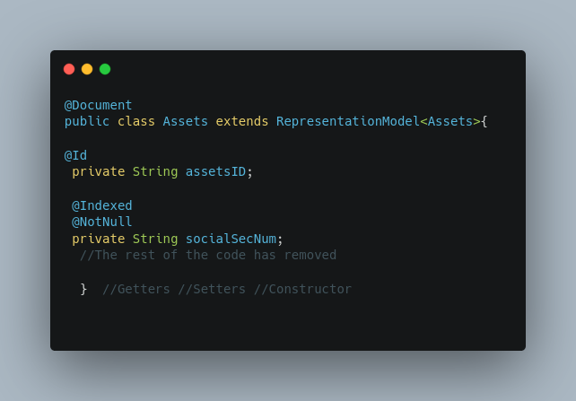

The annotations being used in the use case above differ from the previous one due to the database's differentiation. Thus, the analysis applied identifies that the class-level @Document annotation used to mark the class as a document can be persisted in the database. While the @id, @Indexed, and @NotNull are utilized to specify the document's key property. As declare the not null indexed fields, for search functions simplicity.

@Document : Marks the class as a document that can be persisted in the database

@Id: Specifies the document's ID property

@Indexed: Defines an indexed field

@NotNull: Specifies attributes value characteristics

* While the models for the composite AssetsReport Micro-service, which obtains and merge Index’s and Assets’s data will be:

Index’s data obtained representation model:

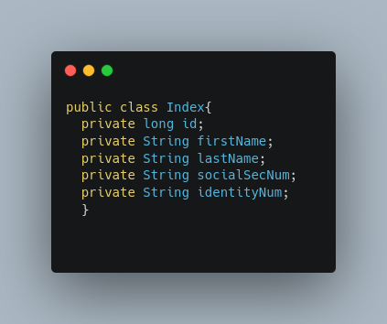

Assets’s data obtained representation model:

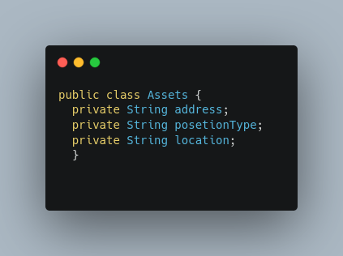

And the composition class:

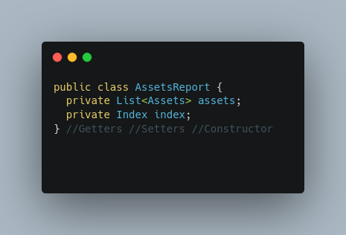

As noticed the annotations utilization is absence, while all the data functions are required being applied internally.

**The Controllers.**

Perceived as the service’s doorway and are utilized to expose the endpoints as map the data from the incoming requests to the Java methods, for the responses to be produced.

Thus, the case demonstrated raises the need for three Web Controllers , according the services developed, which will be:

* The IndexWebController: The /index API, which exposes HTTP functionalities, throughout defined end points.

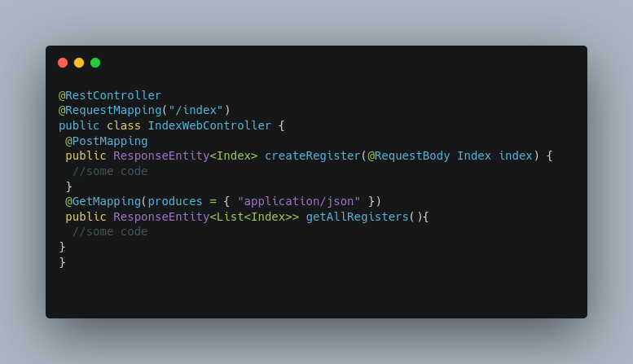

* AssetsWebController: the /assets API

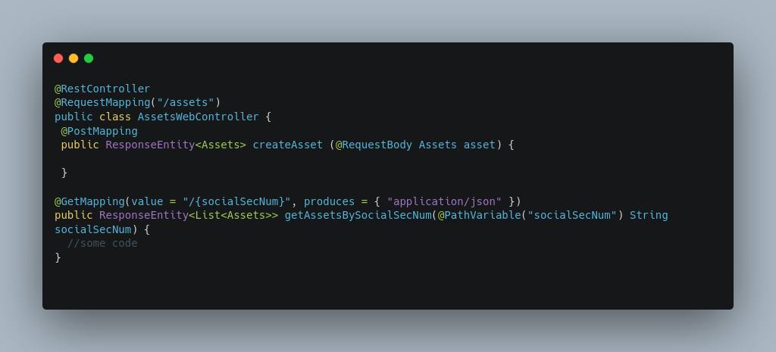

* *And the* *AssetsReportWebController, through which the search and report acquisition functions are applied.*

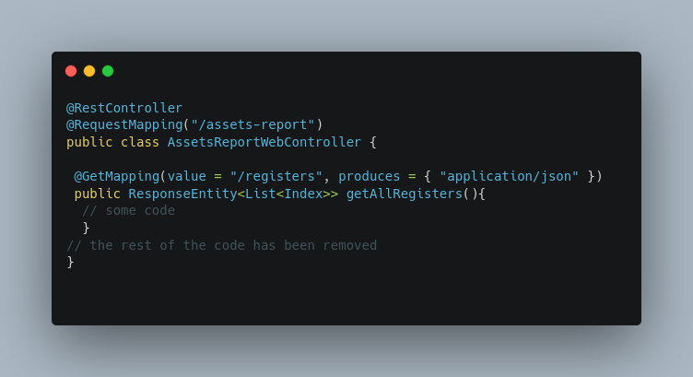

As realized, all the distributed interaction is being achieved via the annotations are applied, which are, the:

@RestController: to manage that every request handling method in the class will be automatically write the return value into the HttpResponce

@RequestMapping(“/”): to define the HTTP endpoints through which the functionality will be exposed and the requests will be handled

@GetMapping : that identify’s the method as an HTTP GET to retrieve objects.

**The Services**

Which are the locations where the actual implementation occurs. These classes house the code through which the expected functionality and data management operation are applied. For the use case analyzed the service classes are developed , are:

* The Index Service:

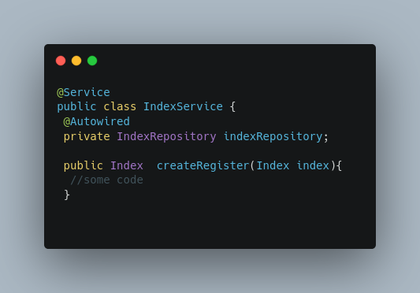

* The Assets Service:

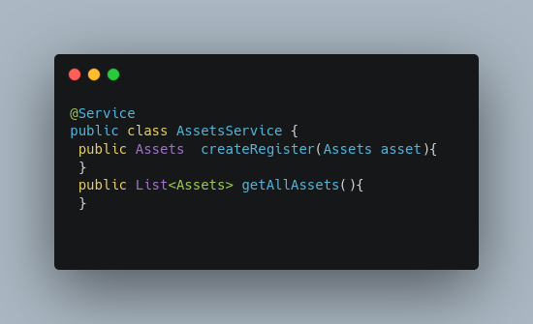

* And the Assets Report Service:

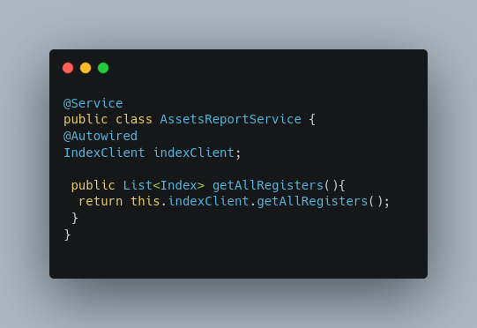

Then again all the required functionality occurs via the set of annotations applied, consisting of the:

@Service: That annotates the class at the service layer to indicate that is holding the business logic, and the

@Autowired: which automatically injects the dependencies.

**The Repositories**

Being the interfaces responsible for service-to-database interactions. Their main functionality is to enable the basic crud operations and being perceived as the bridge between the main logic and the database. Thus, the repositories are created, are:

* index and Assets interfaces:

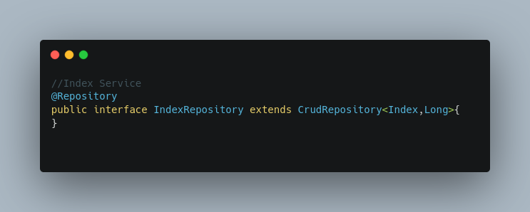

And:

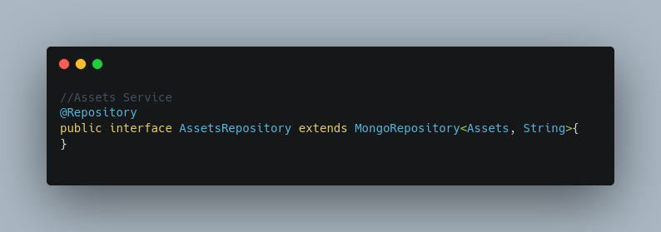

accordingly. Which are marked with the @Repository annotation to act as database repositories.

* While for the Assets Report Service, where no database interference is required and the main functionality are the data gathering and composition tasks being applied. The approach is utilized differs from the above in the fact that instead of repositories direct interacting with a table, the Feign client interfaces are being used, are applied though the :

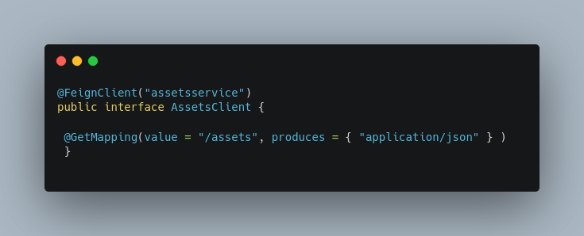

and the:

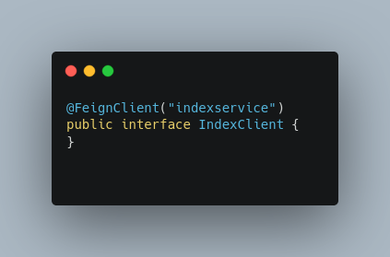

The approach is being enabled via the @FeignClient(“services specific name”) annotation and simplifies the inter-service calls, via the details abstraction. While specify’s that the requests are being made target only the service provided as argument

(LinkedIn. 2021b ; LinkedIn. 2021c ; Christudas, 2019)

* + 1. Cloud Configuration Requirements

In the context of micro-services, the stand-alone services are produced, will be proven ineffective, regarding the functionality is expected. If the appropriate mechanisms are not being set, for the additional requirements are generated by the ecosystems distributed nature to be tackled. Throughout the encapsulation of a standard set of key components, consisting of:

**The Externalized Pattern:**

The externalized configuration pattern leverages the Spring cloud Configuration Server solution. Used to centrally store and on-demand distribute services configuration properties required. While offers a number of multiple different configuration data storage implementations.

More specific, the steps are required for a basic functionality to be obtained, are:

* the Config server dependency within the pom generated file must be included,:

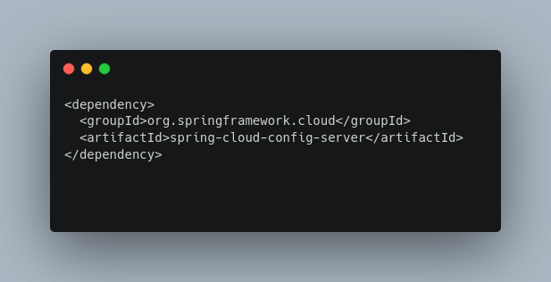

* the @EnableConfigServer annotation in the main bootstrap class must be defined, for the expected behavior, by acquiring the settings required, to be inherited.

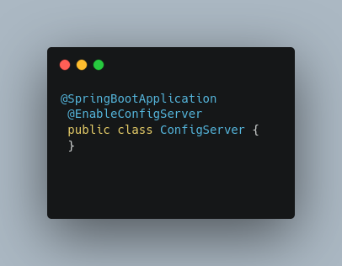

* And the appropriate properties within the bootstrap properties file must be declared, for the services name, listening port, and configuration files repository utilized, to be defined.

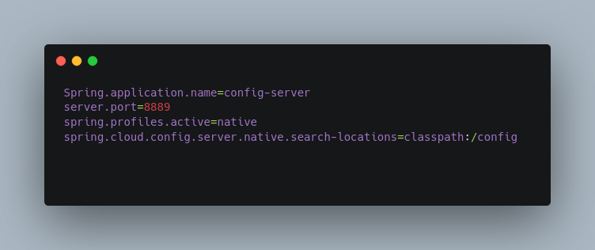

The most interesting part of the configuration is the one determines hosted data repository. Which in our case is an inbound folder used to house the *.yaml or *.properties configuration files.

**Discovery Server**

The Discovery Server is being implemented utilizing the Netflix Eureka solution, which enables services discovery, by registering and communicating instantiated services locations. It is implemented by a set of well-defined steps applied both in the server configured and services.

Thus, the procedure followed in server-side, consists of :

* the addition of the Eureka server dependency, within generated POM file:

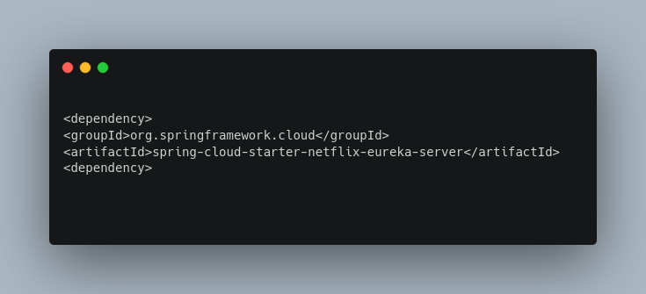

For the expected behavior, in regard to the discovery server’s functionality, to be obtained.

* the inclusion, within the @SpringBootApplication bootstrap class, of the @EnableEurekaServer annotation, for the discovery behavior to be enabled.

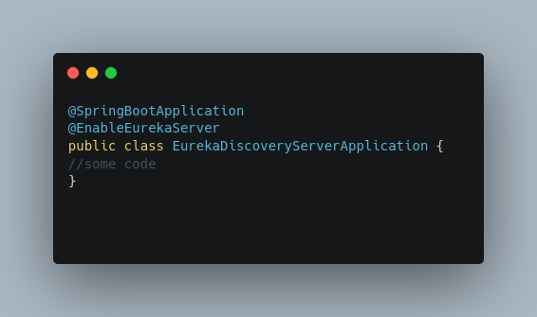

* And the addition of the appropriate properties, within configuration file.

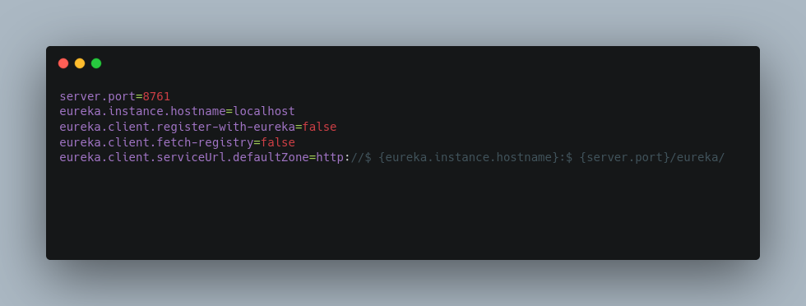

With which the listening port and hostname are being set, as the built-in Eureka client is being configured in such manner, for the services registration and registry cache functionality to be disabled.

While, those applied in clients side utilize a similar approach, as presented below:

* The Eureka client dependency is included within service’s POM.xml, for the interaction with the Discovery server to be enabled

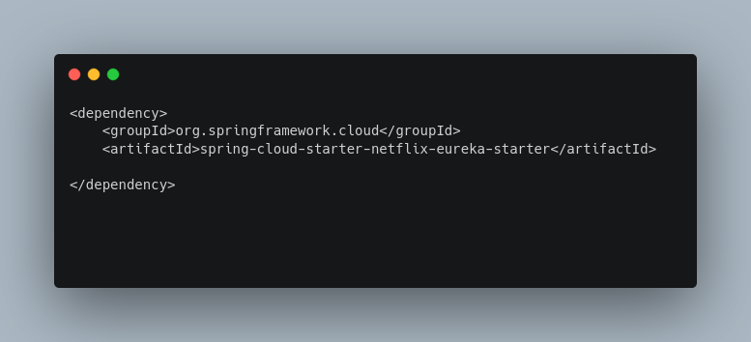

* the @EnableDiscoveryClient annotation must be added to the main bootstrap class. To inform about the Eureka server’s utilization, registry's acquisition, and registered name’s provision requirements, for services discovery process to be enabled.

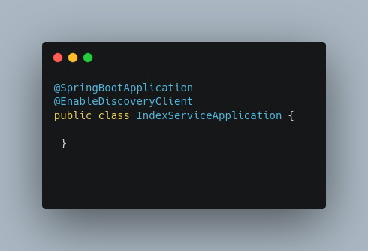

* And the appropriate additions to the configuration file for a unique application’s name to be determined, leveraged as the identification pointer within the Eureka discovery list. As the discovery process’s details to be clarified, by determining registry’s fetch location and registration’s type, for scalability purposes.

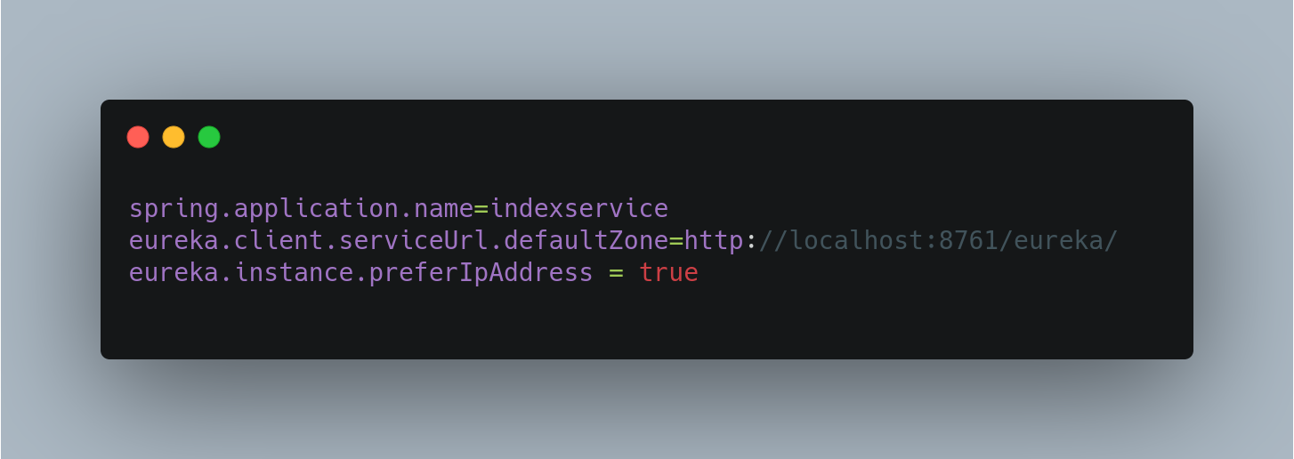

**API Gateway**

The API gateway server is implemented the Spring Cloud Gateway solution, to enable a single-entry point through which the communication between clients and application is occurred. And provides additional capabilities regarding the packets routing and filtering functionality contained.

More specific, for the functionality to be applied, the steps should be followed, are:

* The Eureka Client, Config Client, and Gateway dependencies must be included within the POM.xml generated, are utilized for both config and discovery server interaction, as gateway’s behavior implementation.

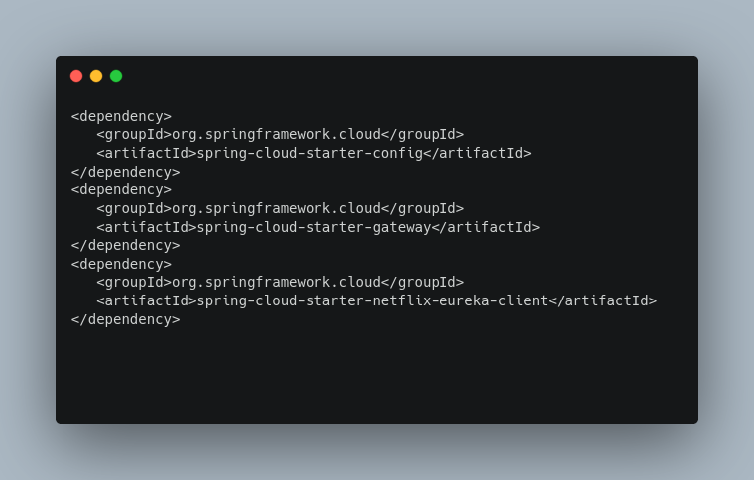

* The @EnableEurekaClient annotation should be added in the main bootstrap class:

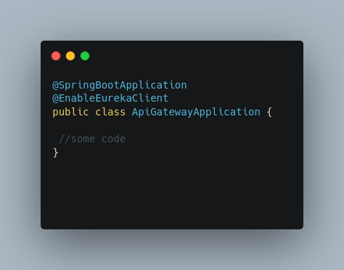

* and the appropriate properties should be added within configuration file, for the routing functionality to be applied, by enabling the gateway to automatically create the routes, based on the discovery registry fetched. More specific, the requests being routed utilizing service’s registration IDs.

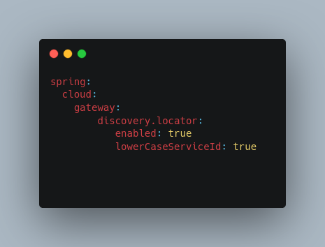

**Client-Side load balancing**

For the requests to target only the healthy instances, using the Discovery registry. Throughout:

* Ribbon’s disabling statement within *.properties file.

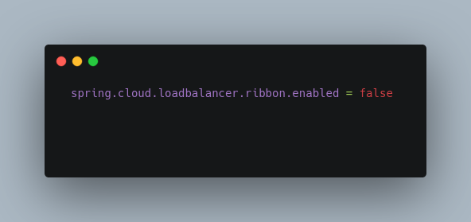

* And spring cloud load balancer’s library inclusion to the services POM’s.:

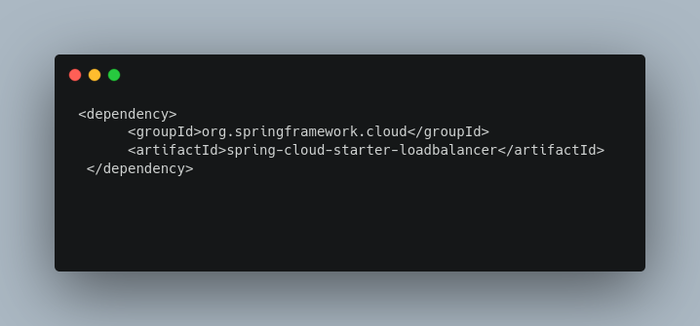

The method above scales the service’s calls to be fairly distributed to only the optimized instances running. By checking the local registry obtained and forwarding the requests based on optimization algorithms applied.

**Resilience Pattern**

Utilized to prevent services from crashing when errors and performance issues occurred. By enabling resources consumption mitigation and occurred problems isolation techniques. Applied throughout the Resilience4j component , which is a fault tolerance library.

Implemented via the below services POM declarations :

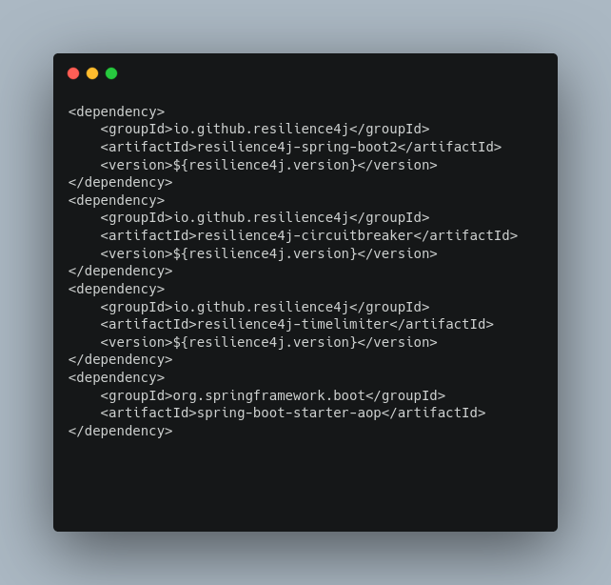

And enables a set of functionality to be provided, consisting of the :

* circuit breaker: utilized to stop requests invocation to a failing service, implemented via @CircuitBreaker(name = "...") addition to the calling method.

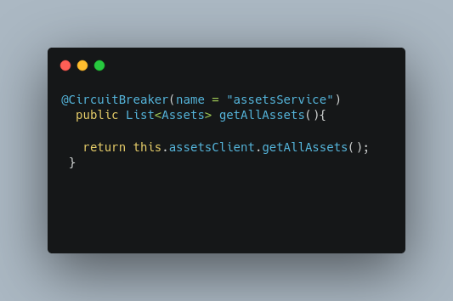

Followed by the required configurations applied within *.yml file used, to determine instances name (A) and exposure policy(B). As to define buffer sizes (C,D), wait durations(E), and failure rates(F) between object’s different states.

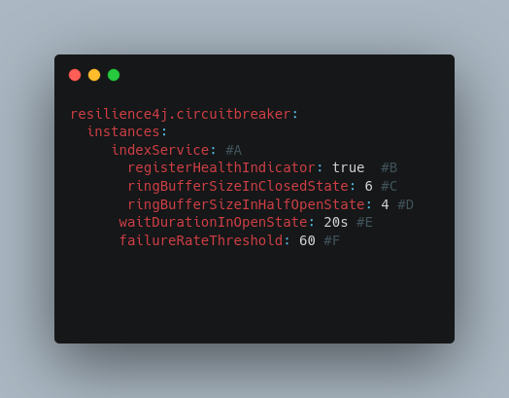

* Fallback: used to enable an alternative path that should be followed, when a request is failed. Applied throughout the @CircuitBreaker(name = " some name ", fallbackMethod ="alternative method called") :

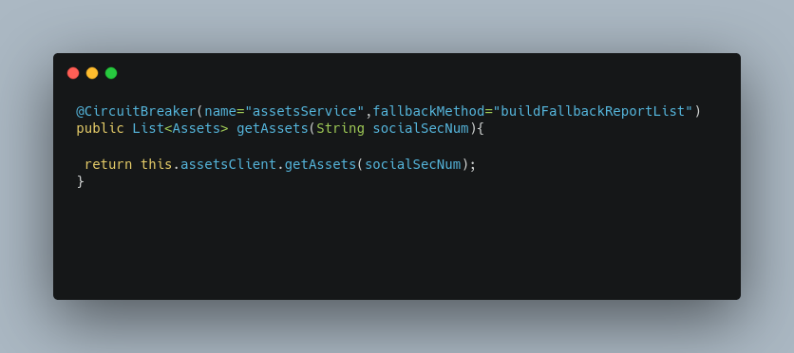

And defines an alternative method that will be called when primary method fails.:

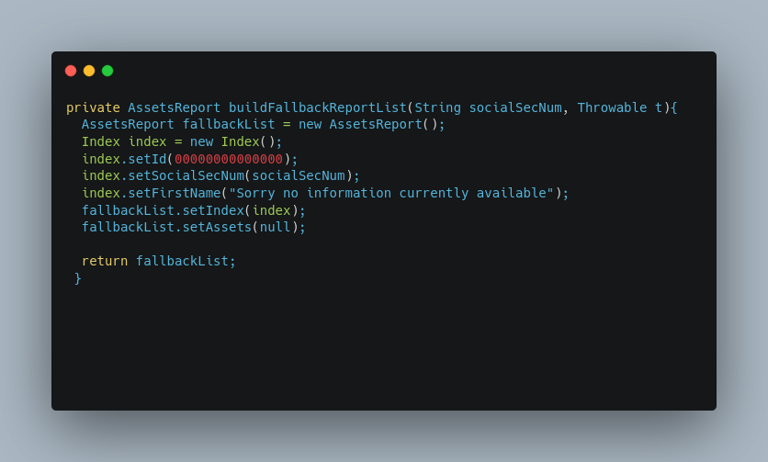

In the example above the method invoked creates an error message, utilized for demonstration purposes only. But a healthy service or a Reddis registry can be called as well, in order for the applications functionality to be preserved.

* Bulkhead: leveraged to filter the number of external requests, for the overloading to be avoided.Applied by utilizing the @Bulkhead(name = " ...",fallbackMethod = "...") annotation on methods declaration:

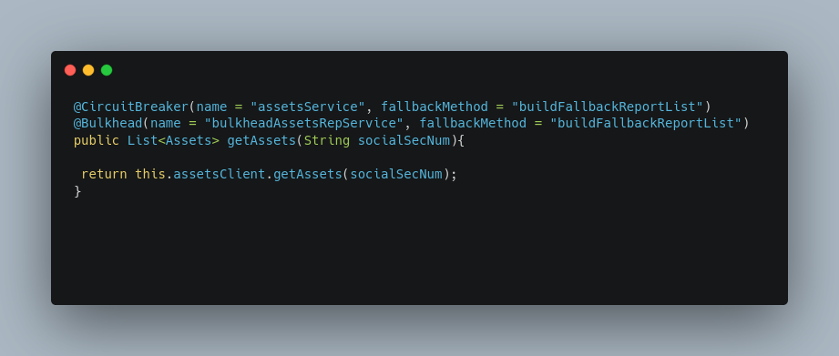

Alongside the appropriate configuration statements within config file used, which define the blocking time amount (A) as concurrent calls maximum value (B).

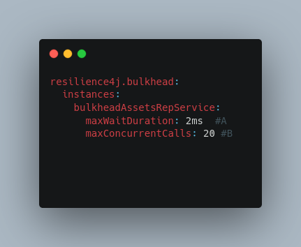

(LinkedIn. 2021b ; LinkedIn. 2021c ; Christudas, 2019 ; Docs.spring.io. 2021a ; resilience4j. 2021 ; GitHub. 2021a )

* + 1. Performance

In a distributed environment the synchronous request/response communication style utilized, which blocks a server thread per request. Can cause, under increased load:

* scalability issues, due to resources consumption requirements,
* cascading effects ,are resulted by system components failures,
* as deployment’s failures and loads management automation problems.

Which can impact the overall systems performance and functionality, while generate different communication’s style utilization requirements.

The solution demonstrated below, for systems performance enhancement, uses the reactive approach, by providing a standard *for asynchronous stream processing with non-blocking back pressure*. Introducing a few modifications, must be applied to every architectural component used.

To result an updated structure, consisting of the modified services components, such as the:

* controllers:

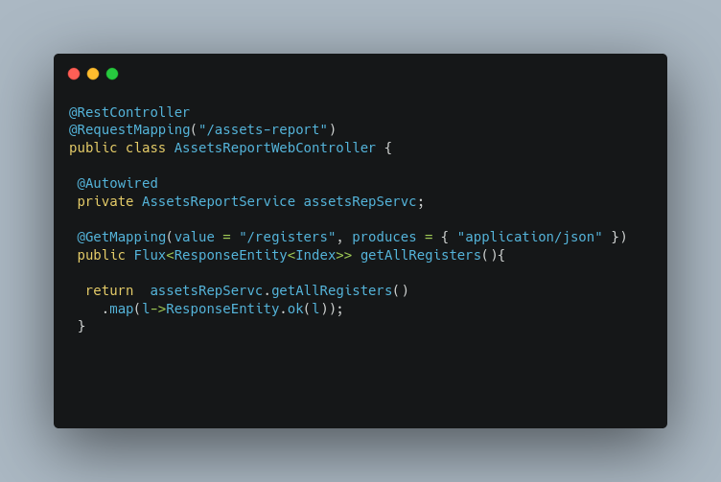

* and services:

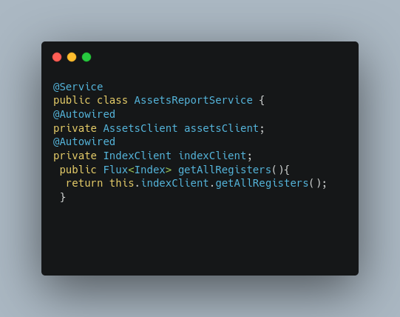

Which inject into the big picture the concepts of Mono and Flux objects, being the reactive types of domain and collection objects representation, accordingly.

* As the interfaces(APIs) implementing the feign pattern.:

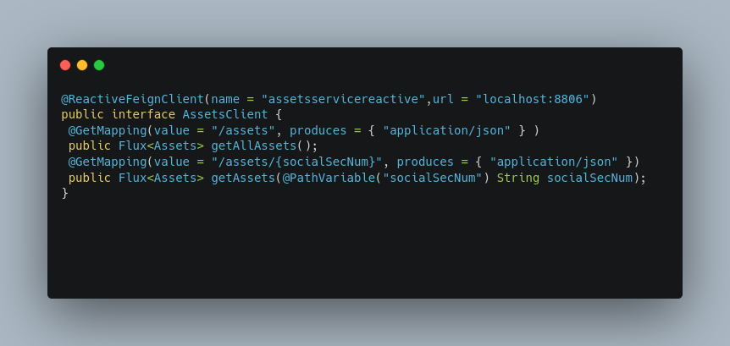

The entire modifications set is being completed by the declaration of the project reactor and reactive feigh libraries within the service’s POM:

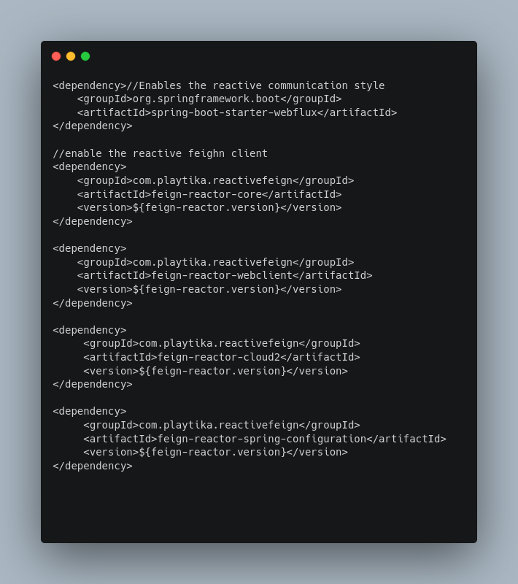

Alongside the required bootstrap class’s additions.:

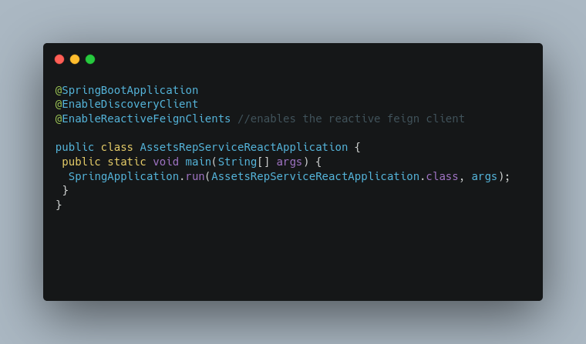

The utilization of the reactive paradigm introduces a set of, worth mentioned simplification , consisting of:

* The process is being applied on the top of the existing REST framework.
* The entire communication mechanism is remain intact.

While enables the implementation via the minimum set of modification’s application, such as libraries declaration and objects exchanged conversion.

(Walls, 2019 ; GitHub. 2021b ; GitHub. 2021c )

* + 1. Observability

One critical factor on the micro-services deployment, which is formulated by a number of distributed services, is systems behavior observation. Consisting of the subsections of:

* Monitoring, which is the process of services data acquisition, analysis, storage, and visualization.
* And distributed tracing,that deals with related distributed transactions tracing and analysis issues. Using the zipkin and sleuth techniques.

Utilized to support a variety of deployments aspects such as:1) debugging, 2) performance and 3) security.

For demo’s purposes, only the monitoring subsection should be demonstrated , in which the related services metrics are being obtained and visualized. Throughout the Prometheus and micrometrics gathering, and grafana display technologies.

The entire implementation requires the declaration of the Actuator, Prometheus, and Micrometrics libraries within services POMs.:

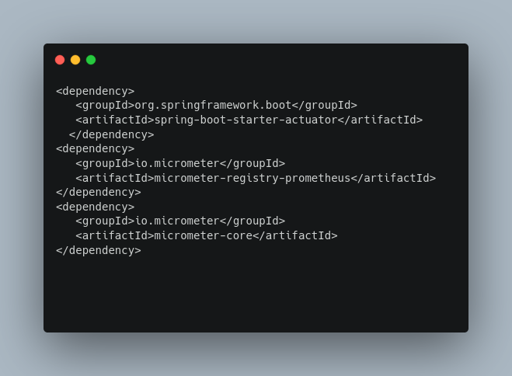

Followed by the appropriate properties configurations in the *.properties config files, for the default actuator endpoints to be exposed and the required data to be exported to the monitoring console.

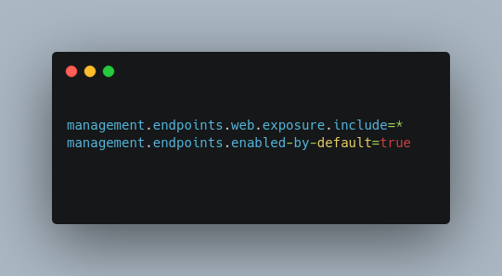

Alongside the utilization and the appropriate configuration, of Prometheus data acquisition endpoints,:

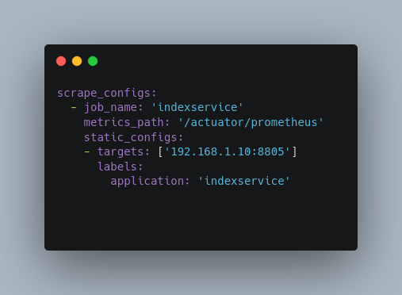

as the grafana’s data source,

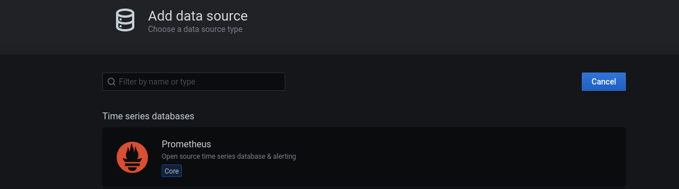

and dashboard’s.

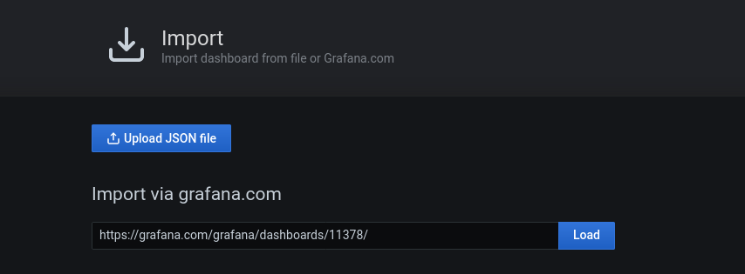

For the expected metrics to be obtained, for the scalability, performance and availability requirements to be enabled:

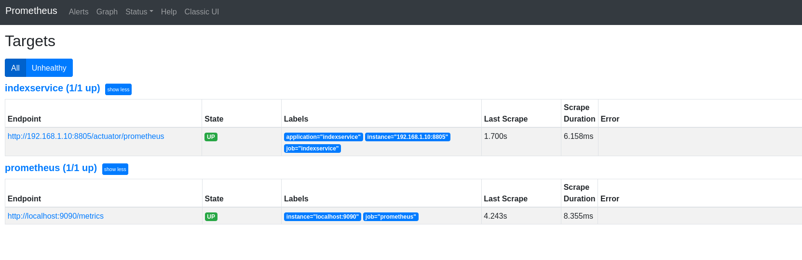

and properly visualized:

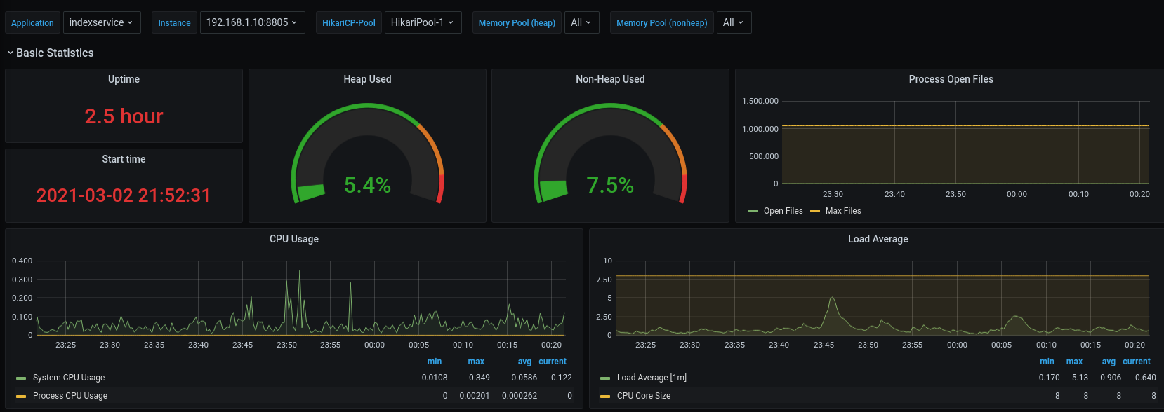

* + 1. Security

The concept of security is considered one of the most critical, due to the number of the entry points introduced and distributed vulnerabilities consequent. Being tackled, among others, throughout a set of sub-concepts consisting of the :

* edge and service-to-service communication ,
* as deployed containers and infrastructures security

mechanisms and patterns being applied.

The presentation follows, consists of only the basic components required in order for a complete overview of the security mechanism to be demonstrated. Throughout the steps being applied and components interaction are generated, analysis.

**OAuth2.0 Server**

Thus, the network is created, as demonstrated on the diagram below, utilizes three services, such as the: 1) Gateway, 2) Keycloak OAuth2.0 with OpenId functions , and 3) Index micro-service.

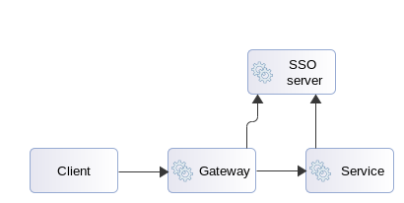

Figure 23 Basic Security Mechanism

The resources of which is attempted to be secured, throughout the building blocks behavior observed, consisting of:

* user request’s /index
* Gateway redirects to Keycloak
* User authenticates, authorizes the app and receives a JWT token
* Request with encapsulated JWT is being sent to the Index resource server
* Index service validate Header contains JWT token.

As realized, the main intention is to hide our micro-services ecosystem behind a single entry point, which serves as the filtering doorway and reverse proxy, in the top of which the entire security process is based. Thus, this role is assigned to the Gateway, which after the modifications are being applied, within:

* Service’s POM :

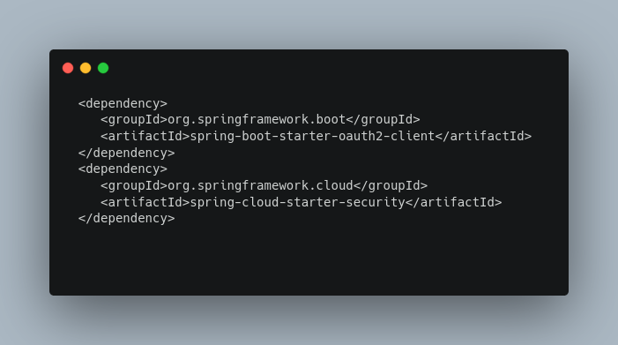

* and *.yml properties file, for the header cookie to be replaced by the obtained JWT , that is being passed to the downgrade route via the token relay filter.

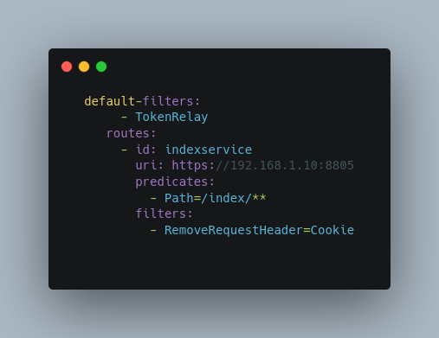

* And the SSO server’s interaction configurations to be determined

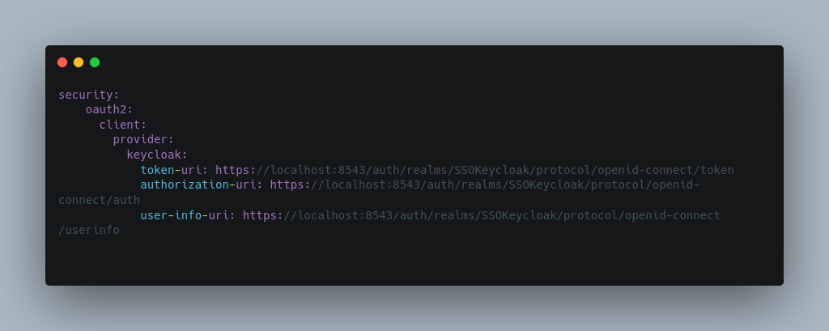

* As service itself, with the addition of a configuration class containing the below fragment of code.:

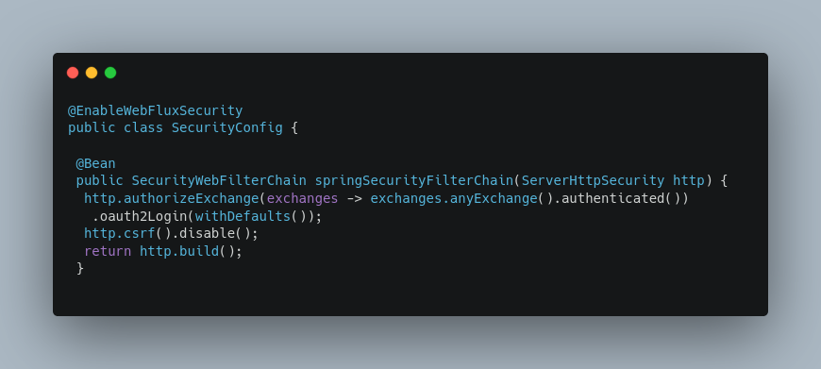

For the Spring security framework’s and oauth client functionality’s , that supply the required flows inspection and redirection, and the tokens validation and relay mechanisms to be appropriate configured and enabled.

And the required security functionality to all the requests hit its interface, alongside the additions being injected within Index resource service’s:

* POM:

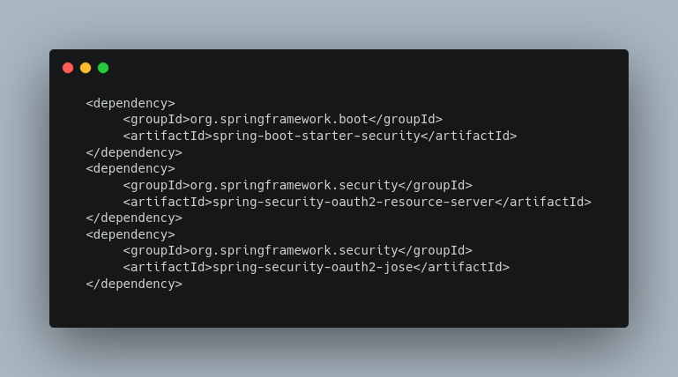

* *.properties configuration file:

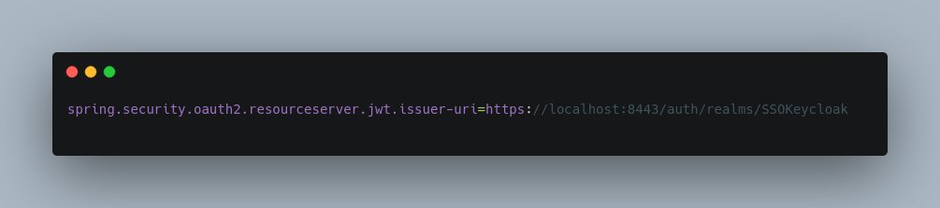

* And the main body :

configuration:

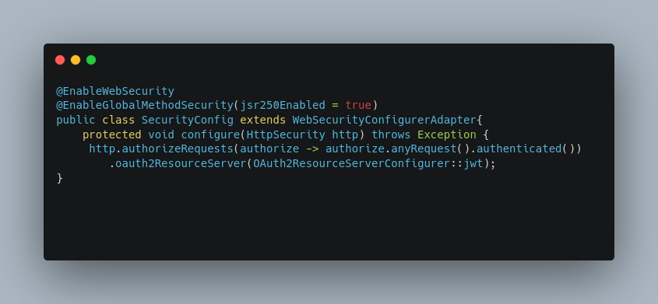

and controller methods additions:

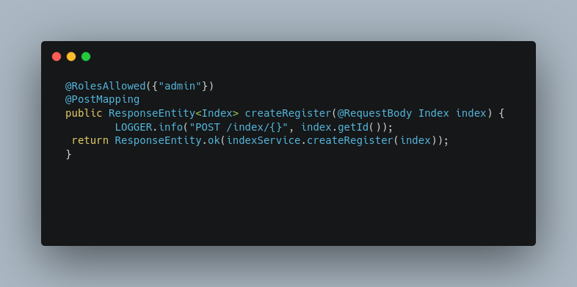

For the security and token validation mechanisms to be enabled, as authorization and access control functionality to be applied, to all of the incoming requests.

Along side the SSO Keycloak OAuth2.0 server’s instantiation and configuration, which is used in the concept of the Spring Security framework.:

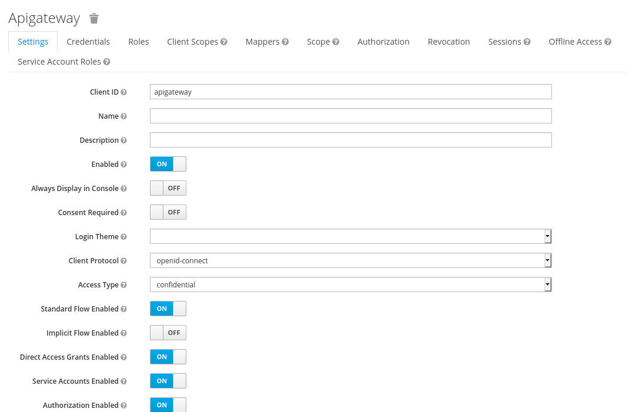

For the redirected streams to be authenticated and the JWT token to be supplied and validated, as of the access control mechanisms to be enabled.

Thus, completing the edge security concept, by enabling the authentication mechanisms.

(GitHub. 2021a ; Wilcock, B., 2021 ; Software Development, 2021 ; Docs.spring.io. 2021b ; Docs.spring.io. 2021c)

**MTLS**

The issues are generated by the approach above , are the vulnerabilities are being introduced due to the bearer token is exchanged, as of the policies enforcement to a single entry point only. Being tackled by the introduction of the mTLS solution, which, enables the services communication to be applied via secure encrypted channels throughout a single entry point, while communicating information about both the client and server are interacting . Utilizing the certificates are provided by a common accepted authority.

The entire process is implemented, throughout the:

* CA server’s instantiation:

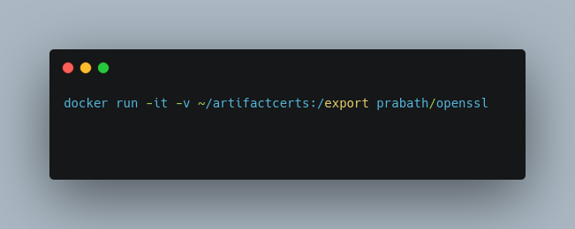

* For the appropriate certificates generation, utilizing a certificate authority:

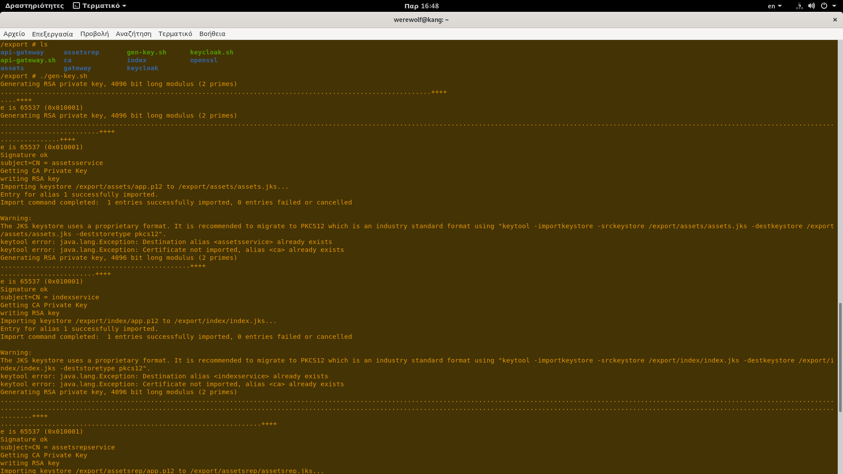

* and the encapsulation within the services created, by transferring the keystore being produced.:
* As the techniques declaration, via configuration’s additions applied to both:

the properties configuration files :

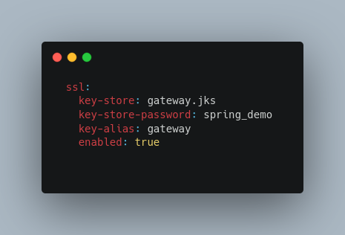

and the services itself:

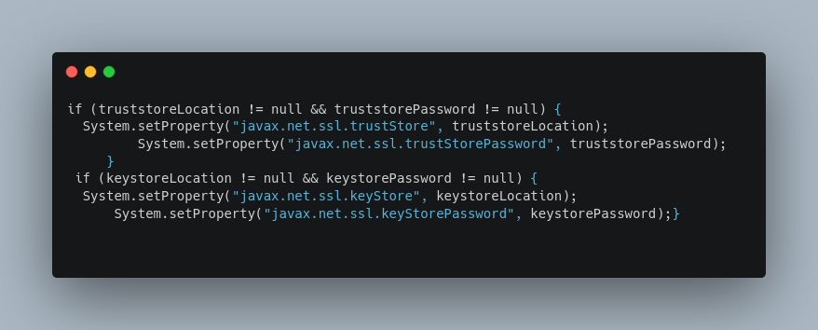

For the ssl authentication technique to be enabled, and the certificates locations , passwords and specifications to be determined. As the netty server utilized by the Spring cloud gateway to be properly configured,

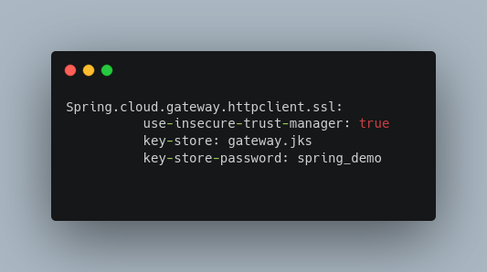

For the certificates to be accepted, and the hostname’s verification failures to be avoided:

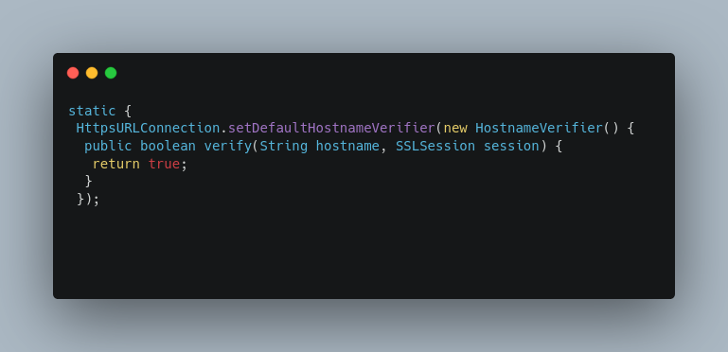

(Siriwardena and Dias, 2020 ; Indrasiri and Siriwardena, 2020 ; Cloud.spring.io. 2021)

**Throttling**

Throttling is the process with which the number of the request are allowed within a particular time frame, are being filtered, for DDoS and resources consumption mitigation purposes. In our example, and for demonstration purposes , the technique is applied to the Gateway only, in the form of a filter targeting a specific route.

The entire implementation requires the:

* declaration of a custom gateway filter class:

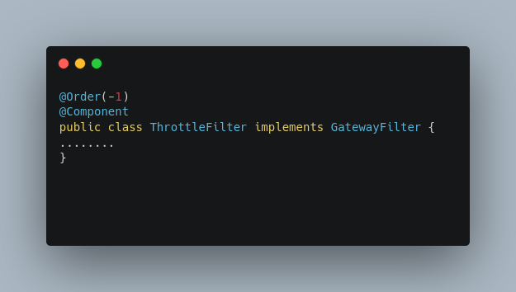

with a method that implements the actual filter, utilizing a token backet algorithm. That inspects the flow, based on predefined variables.

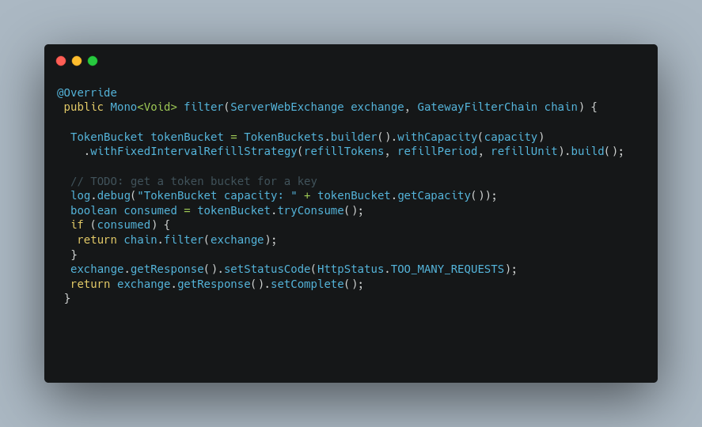

and applies it to the communication routes:

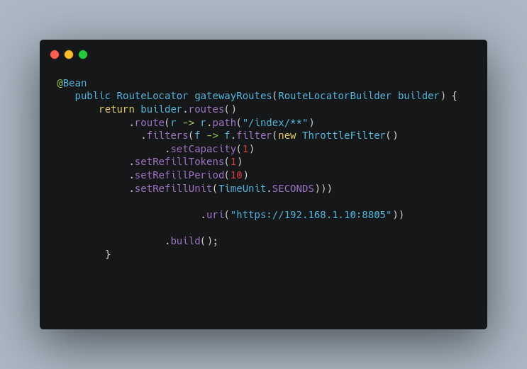

(GitHub. 2021d)

* + 1. Deployment

Deployment is the process in which the micro-services are created being loaded to a cloud infrastructure for the inherited benefits and application’s cloud native nature to be reached. For our example demonstrated the procedure being followed encompasses a hybrid approach, through which the Kubernetes solution is provided as a service, by the OpenShift container platform. Mainly selected for the simplicity, automation, and security purposes. The entire process is initiated be removing all by the load balancer patterns are demonstrated within chapter 4.3.2

**Infrastructure**

The entire method is being generated ,

* by the declaration of the appropriate Dekorate libraries within services POM’s:

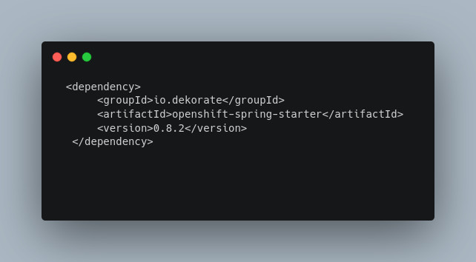

for the automation process to be enabled, via a set of

* annotations are used for the Kubernetes/OpenShift manifests decoration and generation, being applied within the main bootstrap class.:

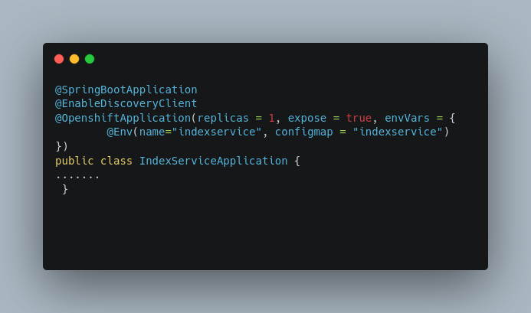

Thus, determining pods numbers, network, and configuration acquisition policies and file name.

And completed by building the service’s with both the deploy and build mode enabled. :

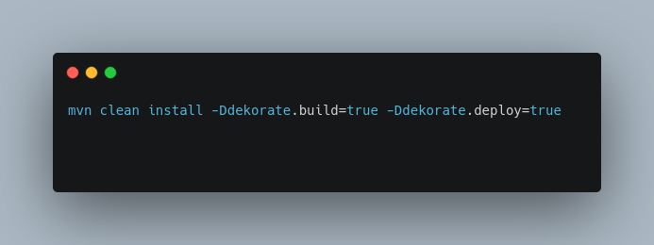

That automatically produces the OpenShift manifests, generates and properly configures the required set of resources, consisting of the:

* services, and routes network objects.

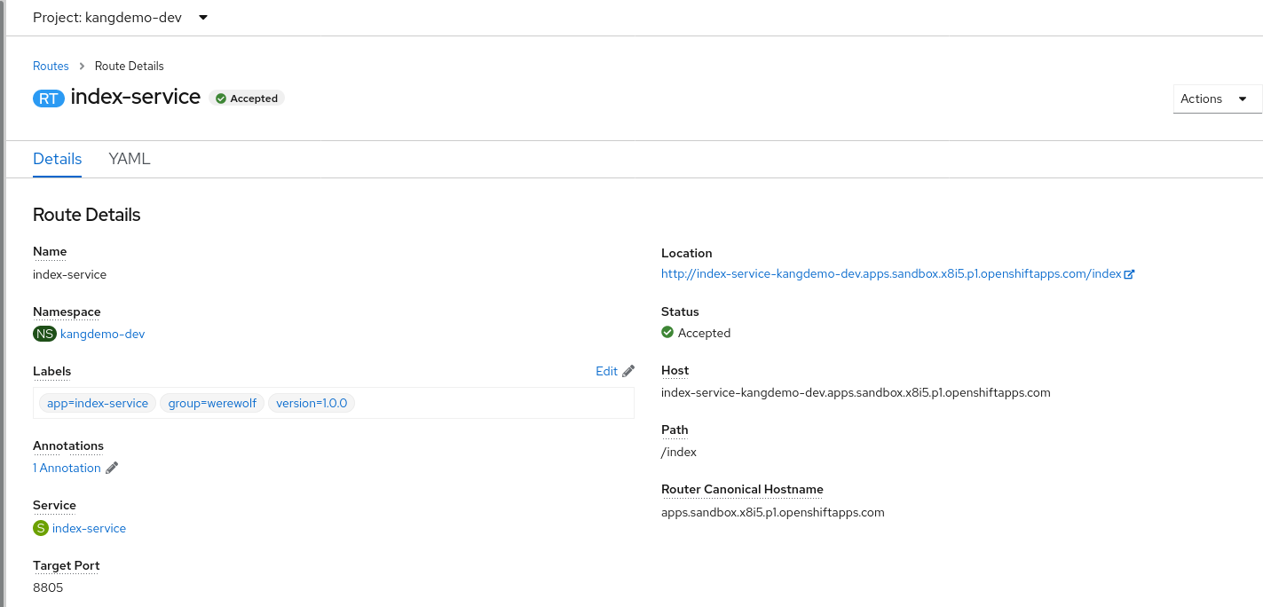

* And the ImageStreams, BuildConfigs, and Deployment Config resources

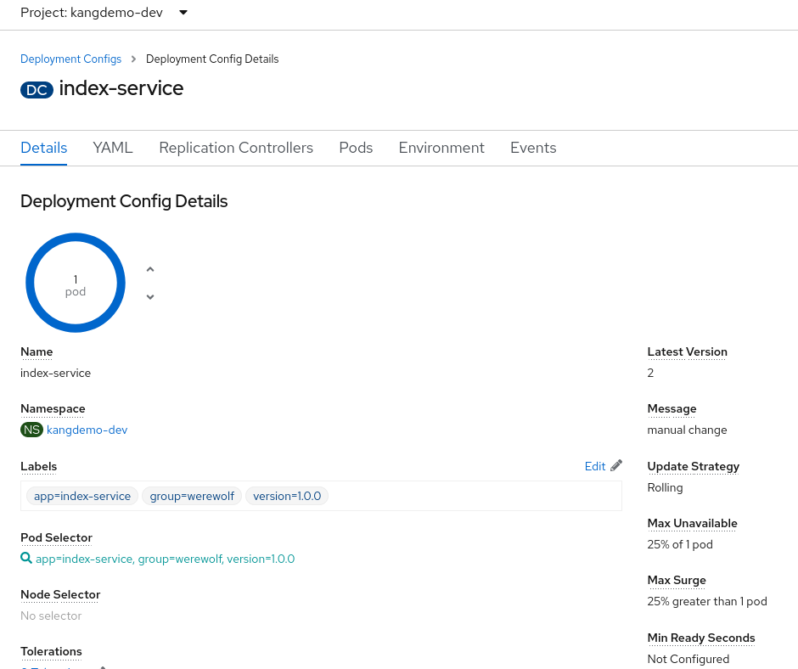

While push’s the containers image to the cloud for instantly pods generation.

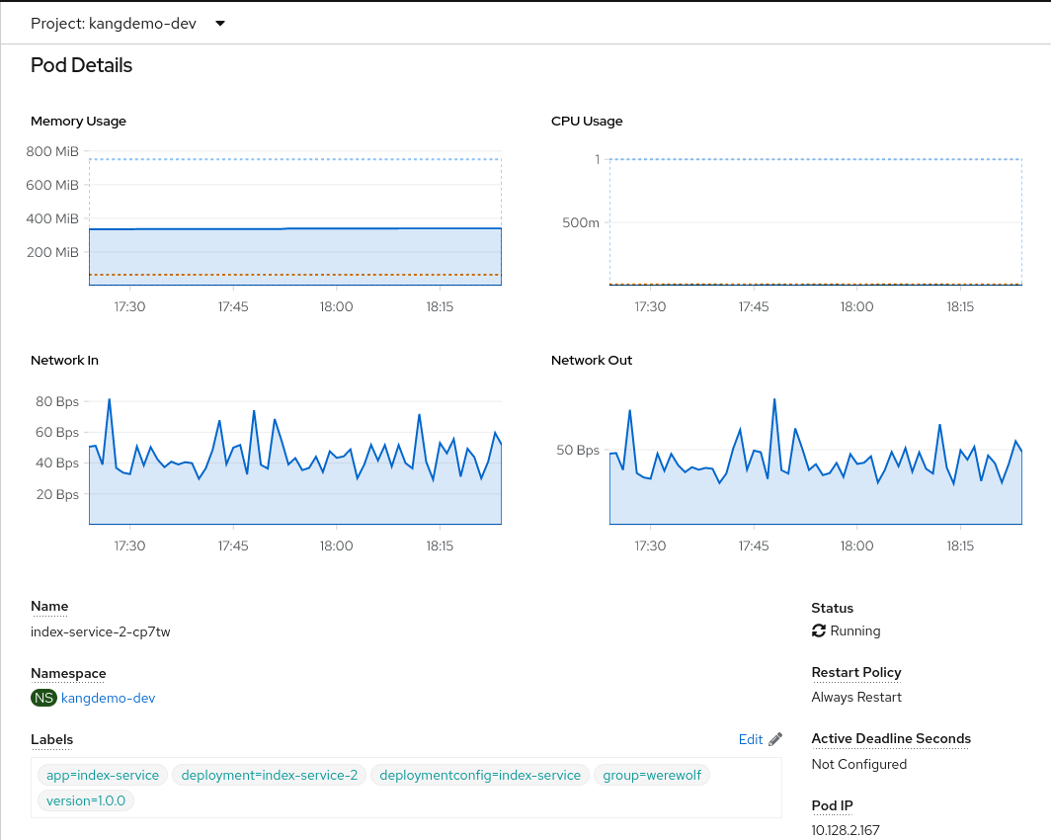

The underlining security functionality being inherited via the infrastructure’s provided functions, third-party solutions and pod’s resources cooperation. That enable the authorization/authentication, access control, pods and image’s registy isolation, communication encryption, and network’s security configuration mechanisms.

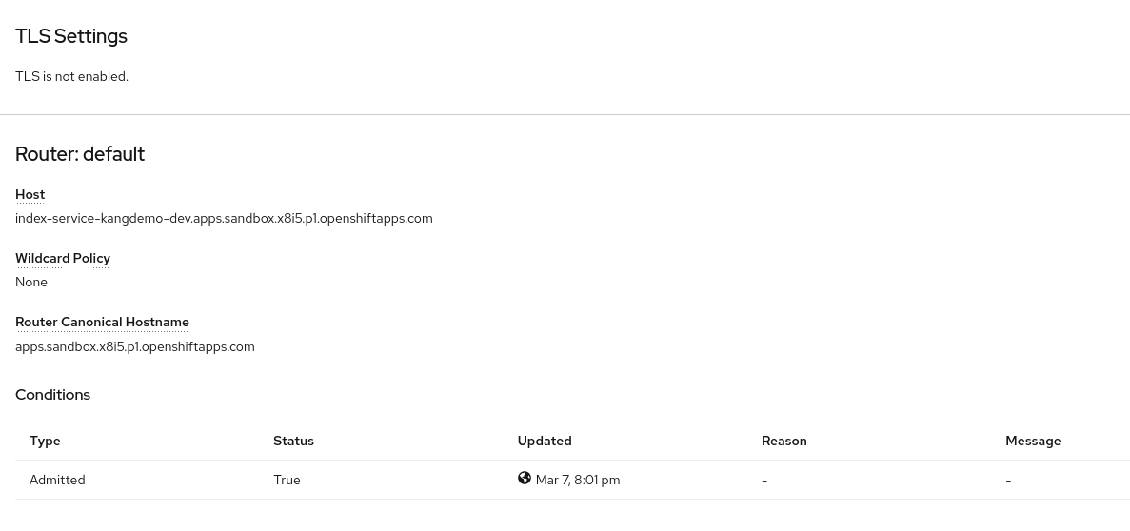

While the load balancing functions being defined within service resources are generated.

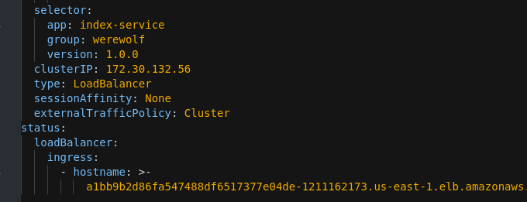

(Red Hat Developer. 2021 ; Docs.openshift.com. 2021a)

**Network Behavior Manipulation Functions**

The factors advocate to approaches selection, beneath the simplicity and default security mechanisms inherited. Are the reach set of network functionality is provided,consisting among others, of:

* egress’s firewalls

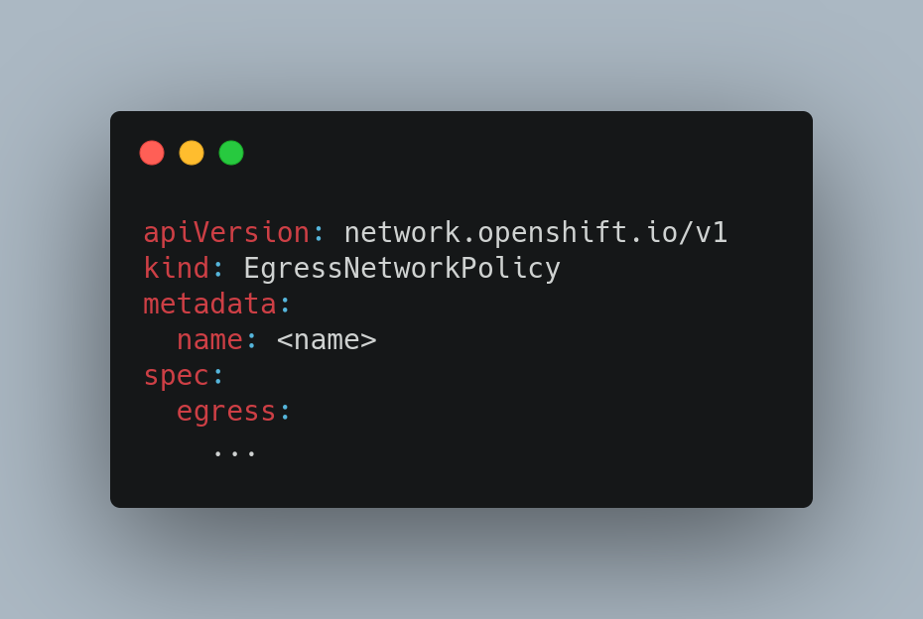

* gateway routers

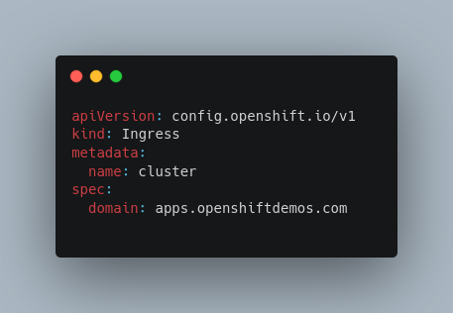

* network’s isolation techniques
* and bridged networks

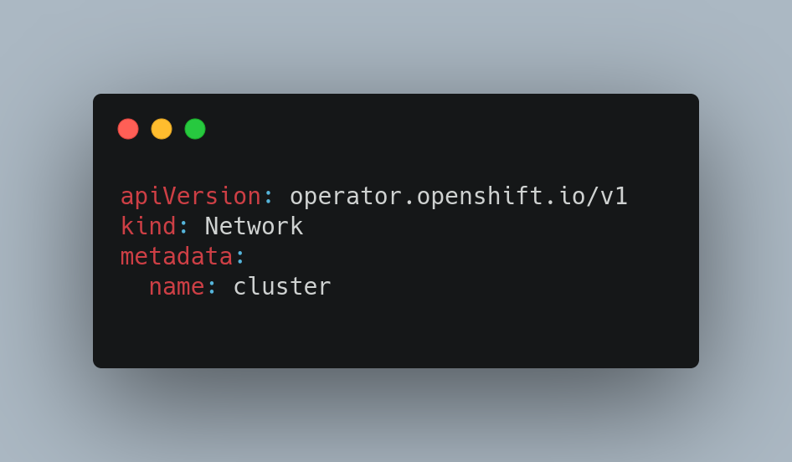

through which the network manipulation activities are enabled.

For the purposes of this demo, only a gateway router object is being implemented :

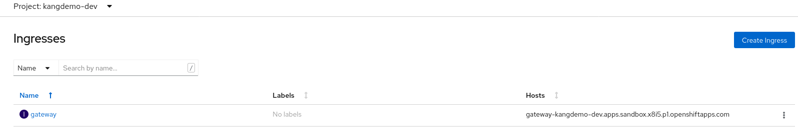

and slightly modified:

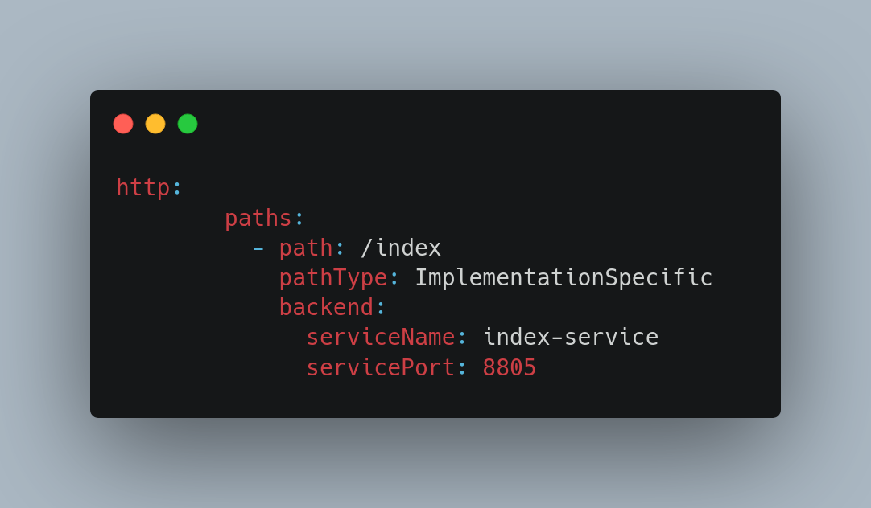

for the routing and single entry points capabilities to be provided. As being integrated with the appropriate network policies:

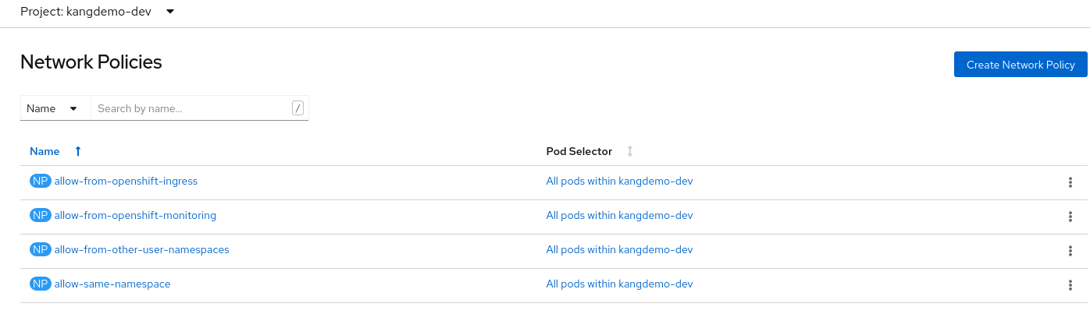

for the fire-walling functions be enabled .

(Docs.openshift.com. 2021a ; Docs.openshift.com. 2021b ; Docs.openshift.com. 2021c ; Docs.openshift.com. 2021d ; Docs.openshift.com. 2021e)

Chapter Summary

The chapter demonstrates the deployment process being followed and the issues are generated , for a service to be loaded in the cloud infrastructure . By which a set of functionality is inherited. More specific, the packaging and deployment process are analyzed, and the requirements raised are being tackled. By the demonstration of the components provided, that are appropriate configured and integrated.

# Results and Evaluation

* 1. **Chapter Introduction**

The chapter will demonstrate demo’s evaluation processes which are applied in the context of real-time functionality.

* 1. **Evaluation of IT Artefact**

The evaluation of the artifact will be conducted , in regard the original goals, which are the creation of a cloud native web application utilizing the micro-services architectural pattern, with an emphasis on the security concept. Against functionality provided throughout the requests/response client -> | API -> Service -> Repository | sequence,:

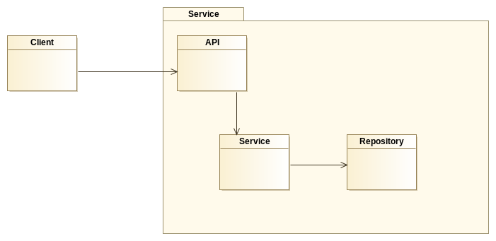

Figure 24 Evaluation Approach

as demonstrated in the diagram above.

The entire process will be initiated by partitioning the initial aim into a set of three well-defined sub-concept, consisting of:

* + 1. **Microservices Patterns Implementation**

Assessing pattern’s utilization within artifact created, which partitions an application into well-defined business domains, according business functions encompassed. While communicate required information via shared models.:

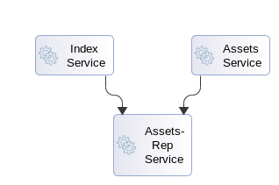

Figure 25 Bounded Context

Applied, in our case, throughout the three main services created, which provide the domain functionality while communicate the reports required, by other contexts , via the Assets-Rep service only. Thus, the domain formed, consists of the Index, Assets, and Asset-Rep services, the cooperation of which generates the functionality required.

More specific, when the clients requests hit :

* the end points exposed by the Controller API’s.
* The actual functionality is generated, via the Service’s instantiation, and the Repositories are being invoked, for the required data to be obtained. As the responses, containing the obtained data within their body, to be formulated and re-transmitted back to the client:

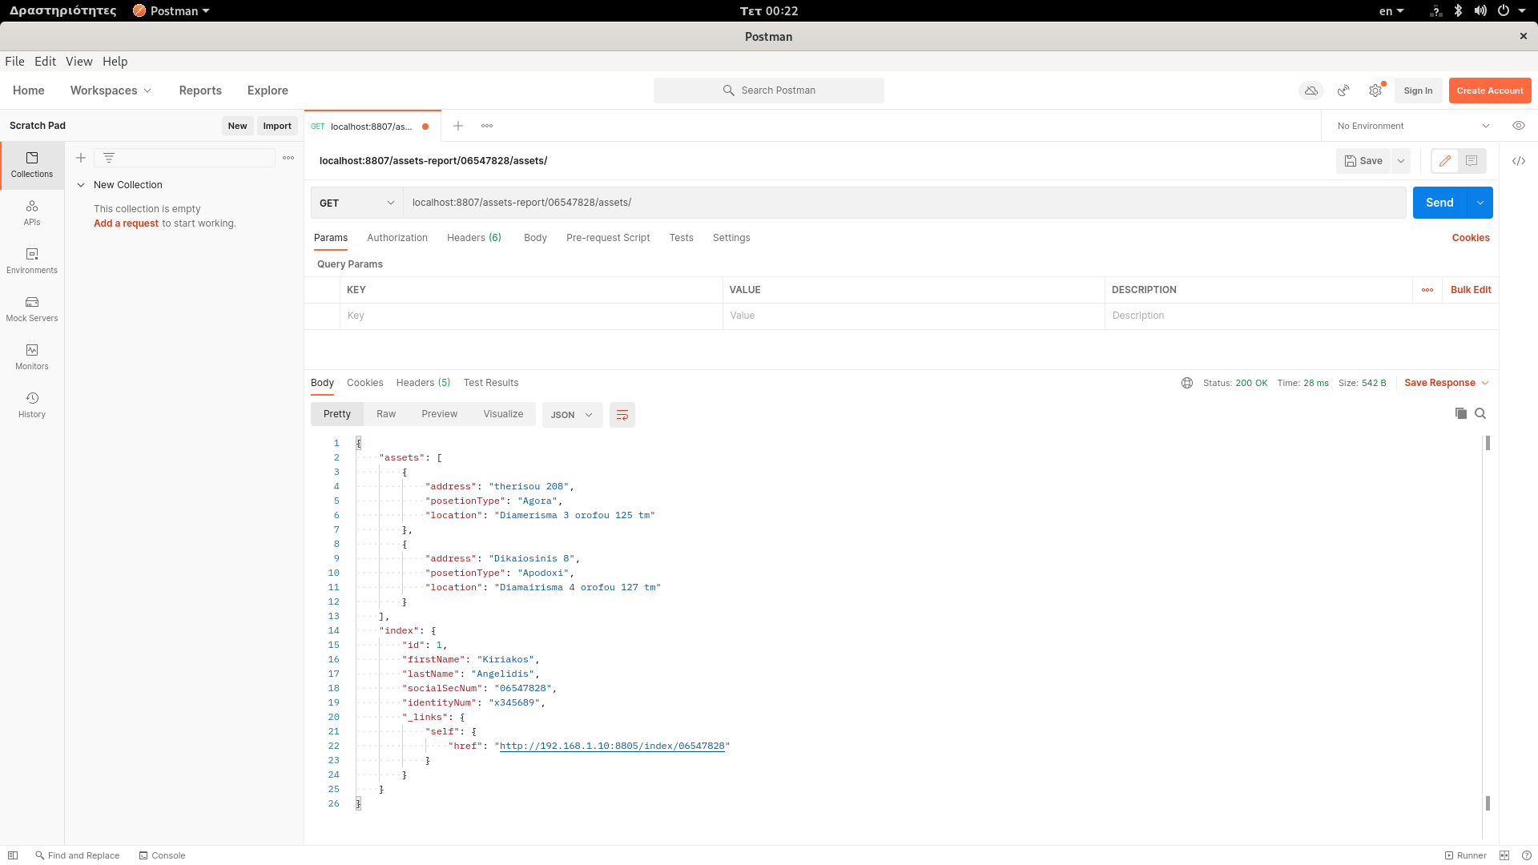

* + 1. Applications Security

The main goal in this phase is to evaluate the security functionality is provided,

such as:

* clients authorization and authentication mechanisms,
* communications encryption,
* JWT tokens generation and provision,
* as ecosystems access restrictions

Then again, the process is generated by the time clients request hits the gateway and redirected by the :

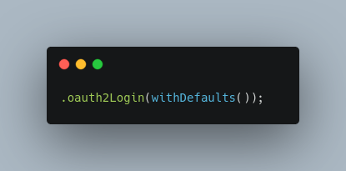

oAuth2 Login framework:

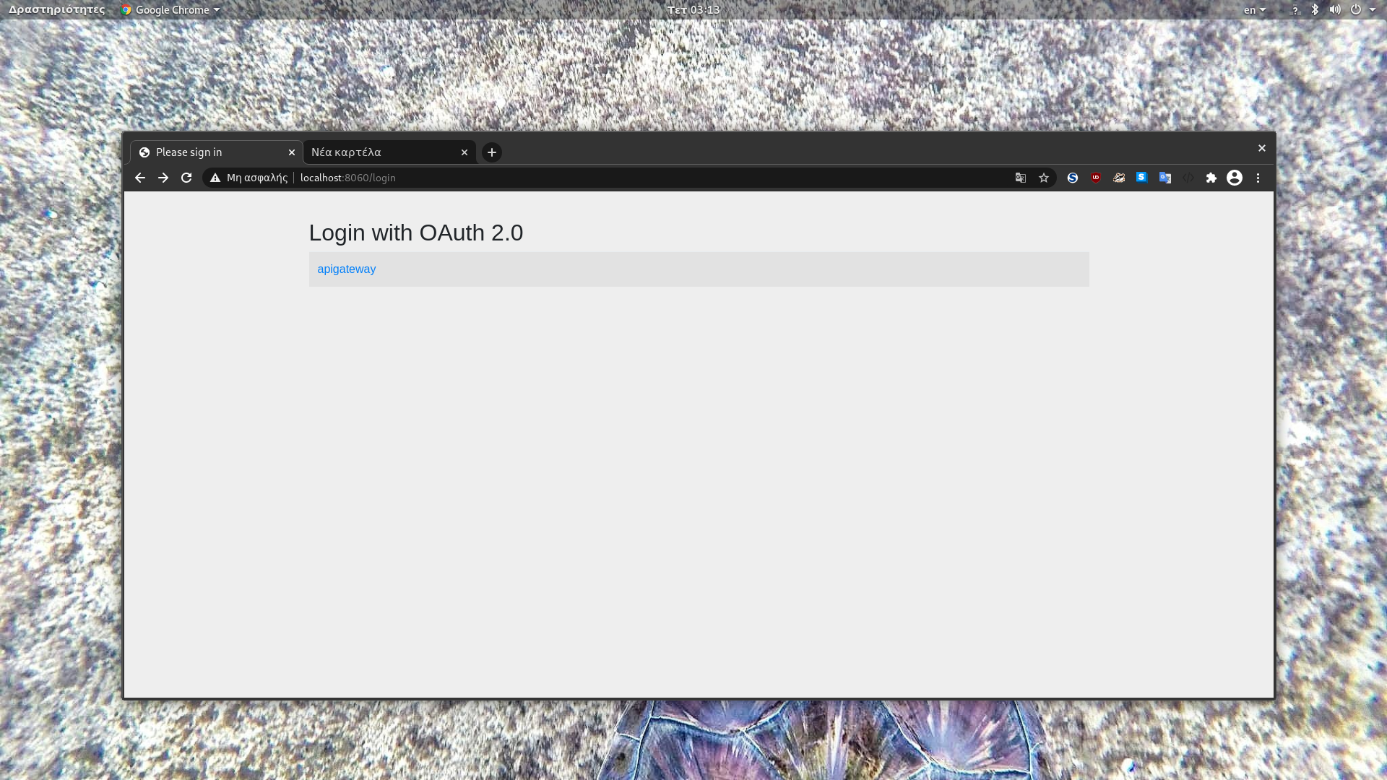

to the SSO server for authentication.:

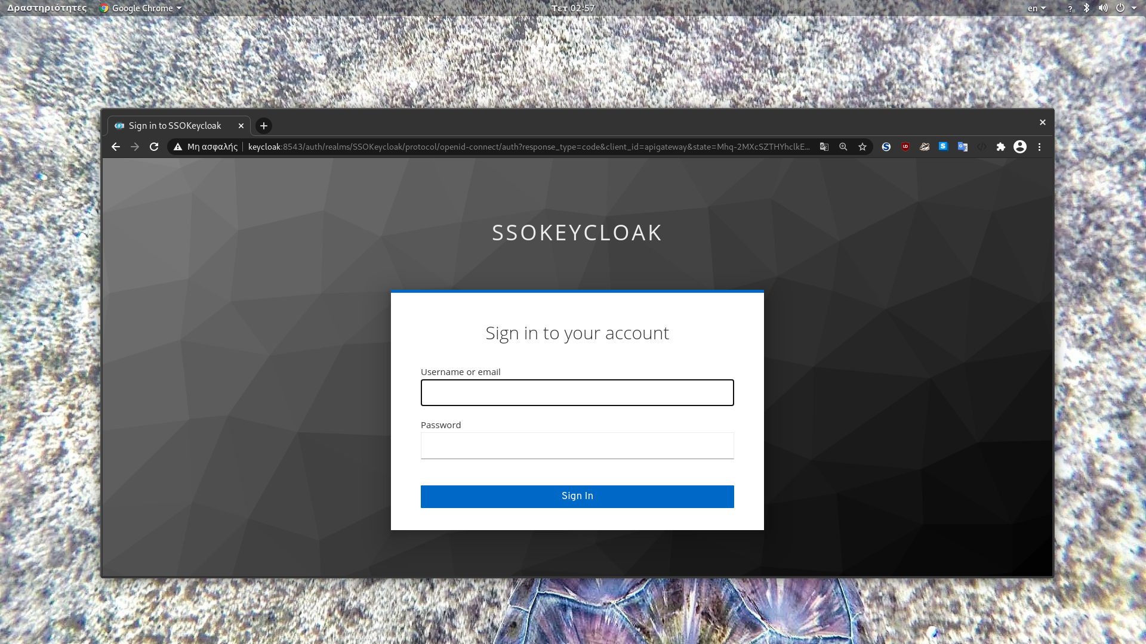

As long as the client verify’s its credentials, a JWT token is generated and passed to the response header, for the required resources to be accessed.:

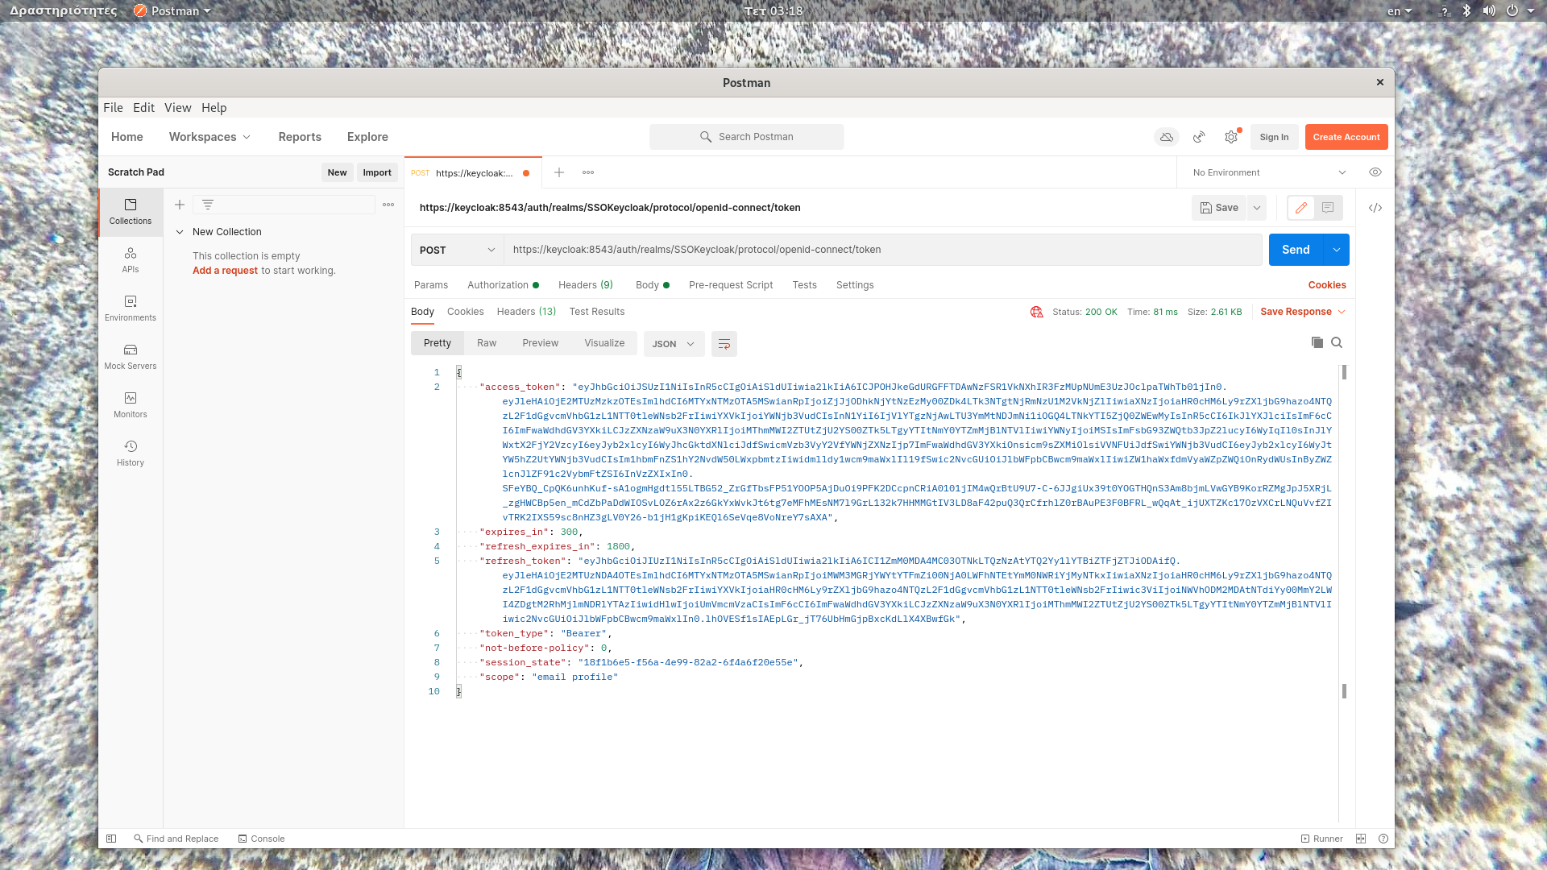

By the time the JWT token is obtained, it is encapsulated within the request’s Header for the additional validation and authorization purposes. Applied both by the gateway, in order for the request to be routed and the token to be relayed, as the services it is target.

* + 1. Cloud Native

The last stage evaluates application’s cloud native nature assessing services Pod’s behavior to the hosted environment . The task here is to demonstrate the distributed behavior is generated via the packets, travel from the browser-to the gateway-to the pod , interaction:

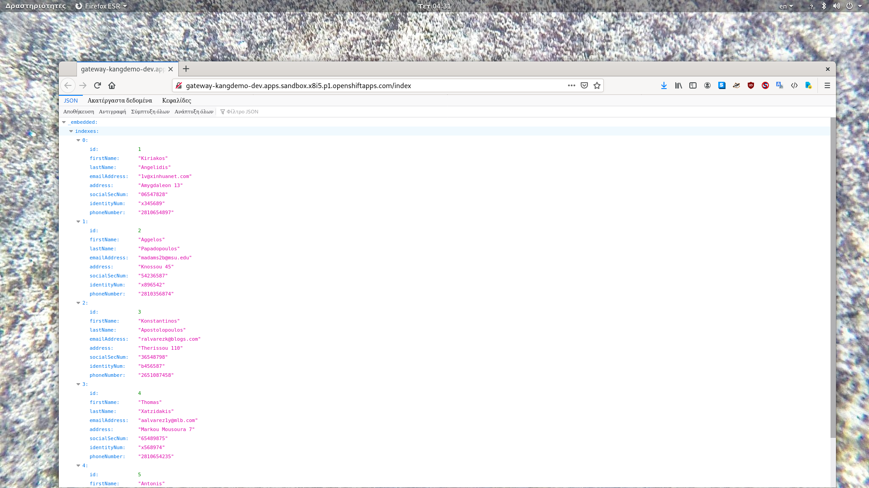

The request hit ingress’s route resource:

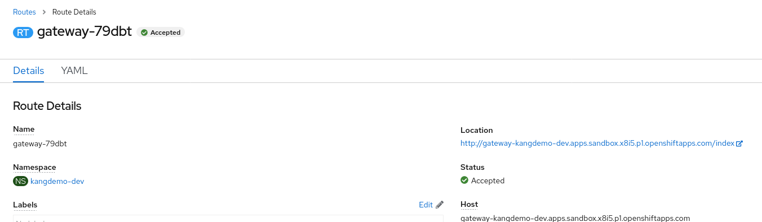

and being forwarded to the requested POD via the ingress object’s configuration.

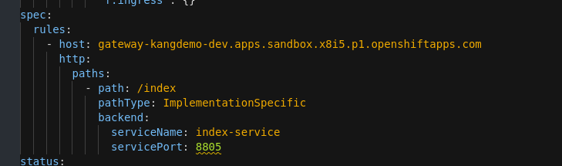

Only if the conditions defined by the network policies are being satisfied.

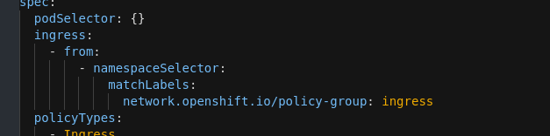

Additionally, it enables availability and performance non-functional requirements, by providing the automatic inherited functions, such as:

* scalability

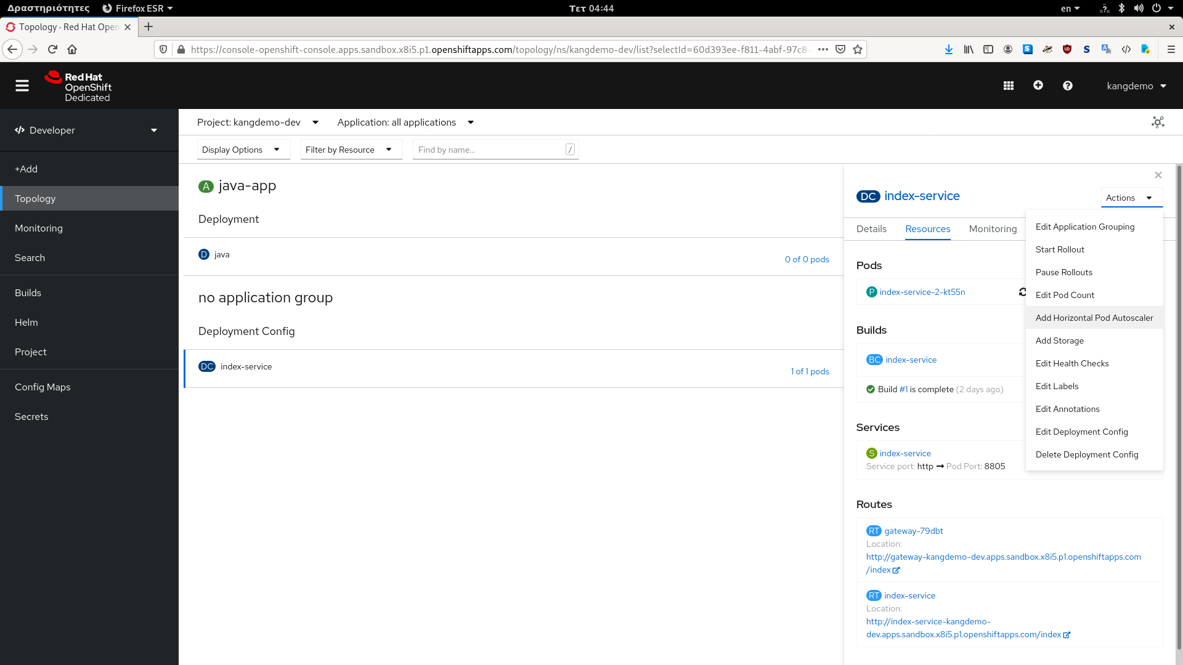

* and health checks

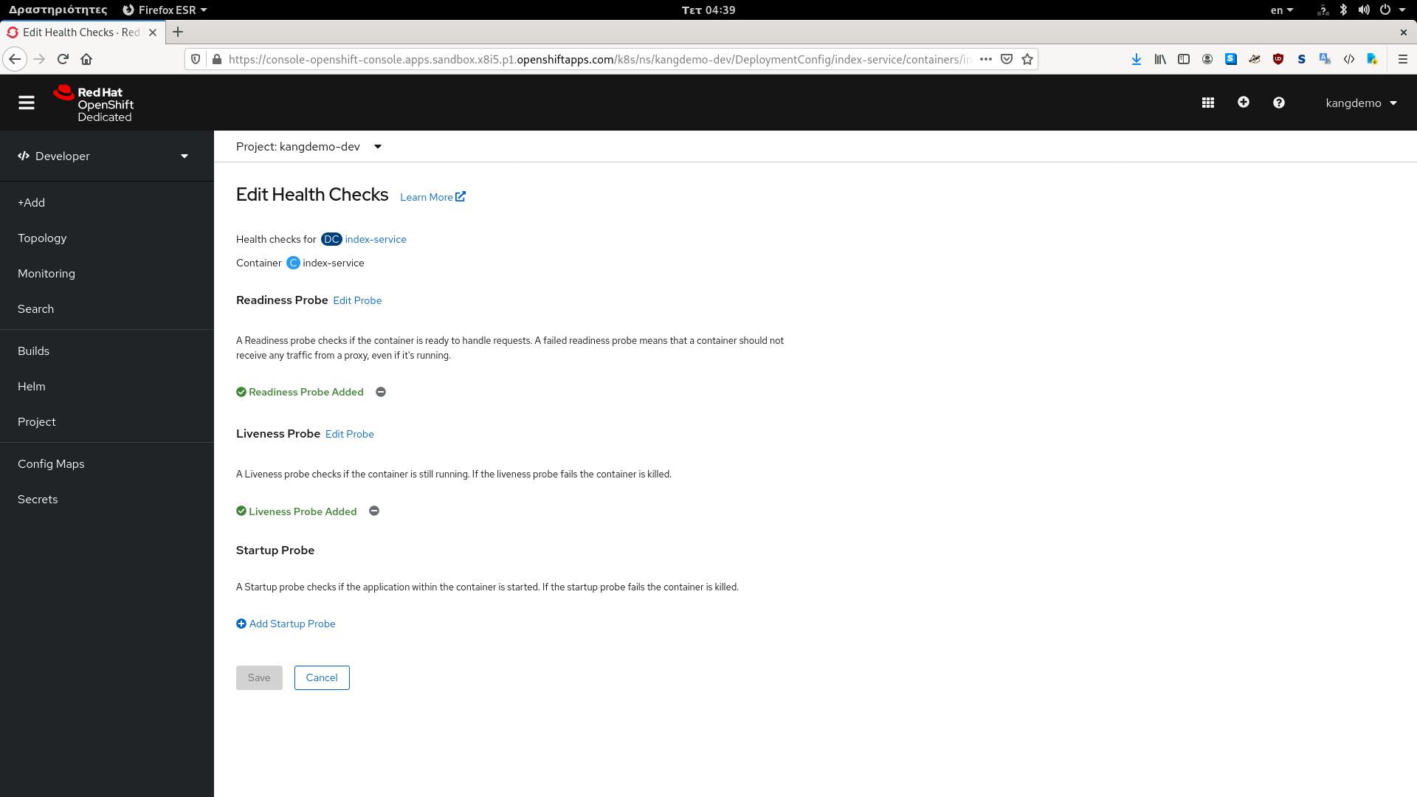

Throughout the metrics are obtained by actuator endpoints and the appropriate configuration of the resources consumption limits.

* 1. Chapter Summary

The chapter demonstrates the evaluation of the artifact produced, regarding the functionality provided. Throughout the sub-concepts of security, micro-services implementation and cloud deployment, in the concept of the mechanisms utilized, analysis. With which the original questions being answered.

More specific, for the expected functionality to be enabled, the micro-services pattern is being implemented and the encapsulated requirements and issues raised being resolved. The security mechanisms are used for the application’s security problem to solute and the issues raised to be resolved are being applied. And the services are being secured containerized and deployed in the cloud throughout the benefits provided are inherited.

# Conclusions

* 1. Chapter Introduction

The chapter demonstrates the conclusion are being extracted by the project developed as the research methodology being applied. And provides a critical view of the results in the concept of achievements and limitations, while presents a set of suggestions being obtained throughout investigation and implementation processes conducted.

* 1. Lessons Learned

The research is applied to enable understanding enhancement throughout the concept’s extensive investigation. Which was conducted in such a manner, uncovering the full range examined.

More specific, the initial steps being followed, that partition the aim into sub-aspects and divide aspects into issues , enable the realization that the solution is applied should align with concepts multidimensional nature. From this point on the entire approach was an iterative procedure implemented in each aspect individually.

Thus, following the sequential methodology, the information related to Micro-services pattern was gathered and analyzed, for the concept to be acknowledged and the variety of requirements and issues raised, by its nature, to be clarified. Consequent the guidelines on which security as cloud deployment concepts investigation were conducted.

The theory fragments of chapter 2 is a result of this approach, which presents the aim’s extracted issues in a categorized form. While simplifying components identification and resolution processes regarding the use case implemented. For the design and construction activities to be applied. In such manner, through which even if patterns utilized are deprecated or unknown. The application principles, that remain intact, can still be applied.

* 1. Strengths and Weakness of the Project

The project conducted attempts to investigate the aim, for the required understanding as knowledge enhancement situations to be occurred . Following a qualitative use case approach, which was selected, due concepts distributed nature, as different components,issues and requirements contained variety. For the full range to be clarified, and an extensive simplicity, especially during the theory acquisition and design stages, to be enabled .

Thus, utilizing the approach within the project's development process, the realization being made was its complete alignment with micro-services pattern’s distributed nature.

Factor especially useful during the literature review and application’s design stages. But its main weakness as well, being generated by the number of solutions are identified, for the same implementation.

A condition that could have been avoided if a quantitative approach would be followed, instead, being applied on the identified patterns repository, for the best-fitted solution according to the use case investigated, to be defined.

To translate the above statement in the research applied, some of the issues raised were:

* the performance solution being utilized,
* the deployment infrastructure being selected,
* and the design being implemented.

Which even if theoretically are perceived as the best-fitted solutions, the verification mechanisms abstracted, introducing a variety of questions and doubts, which are unable to be addressed.

* 1. Academic Application and Limitations

From an academic perspective, the project constructed intents to provide a coherent resource combining and demonstrating the range of issues, requirements, and components encapsulated. And to be utilized within any research attempt that targets the micro-services concept.

More specific, by partitioning the initial aim into a set of well-defined sub-concepts, treated as unique problems. And iterate the process until all the issues are contained to be clarified. The categorization activities required are being achieved, and the generic principles and guidelines that should be followed are being set. Thus, supporting the researchers focus on targeting specific aspects according to the use case investigated.

The main disadvantages are realized, are the number of the aspects are demonstrated and the amount of data managed. Which limit the outcome to scratch only the surface of the problems researched. While generate additional investigation and identification requirements, in regard the in-depth investigation and identification processes required, especially throughout the implementation and development stages. That can be tackled by mitigating the research to one sub-concept only. Thus, maximizing the level of details investigated as aspect knowledge and understanding.

* 1. Business Application and Limitations

From a business perspective, the outcome being developed can support any development attempt as mitigates the investigation time, while provides the required implementation. And it can be leveraged , after slight modifications, within any application constructed. The partitioning method utilized enables the developers to focus on specific aspects and utilize only the patterns are required regarding the use case developed.

Additionally, patterns and techniques are being applied within the demo constructed, so that the theory investigated to be practically demonstrated. Thus, enabling the required understanding and consequently, simplifying the patterns encapsulation and modification processes. Being applied by developers, which can use the project as a road-map that provides the solutions required.

The main limitations are the number of data and concepts introduced, which limit the in depth investigation of the solutions. Raising additional investigation requirements regarding the modification and pattern's utilization activities applied.

* 1. Recommendations / Prospects for Future Research / Work

Even if the outcome answers the main questions are raised in regard to the patterns utilization. Additional requirements was generated as the investigation, and implementation procedures being applied.

For instance, due to the technological advances, further research has to be conducted into an entirely new set of concepts, consisting of the:

* new security solutions and techniques,
* infrastructure’s concept and specifications
* reactive development, replace the REST approach
* as patterns design and utilization, directly affected by the introduction of the new solutions applied.

For the development attempts to be valid.

Additionally, throughout projects implementation a variety of issues raised, which in my opinion can supply future researches. These subjects, among others, are:

* The utilization of additional custom security filters encapsulated both in the single entry point and the services.
* The investigation of the project reactor security functions and custom filter can be utilized within invoking methods and their applications.
* The in-depth investigation of the cloud’s network resource as well as the network policies manipulation functions.
* the methods and techniques can be encapsulated within DDD principals for the security functions to be enhanced.
* The encapsulation of the reddis database within the reactive architecture for performance's enhancement.
* The encapsulation of the individual bounded contexts within clusters, and their deployment on the a cloud provider. The technique aligns with DDD principles and is suggested for the enhanced security measures are inherited.

6.7 Chapter summary

The chapter provides an analysis of the results by analyzing the information being communicated about the initial aim. And describes the advantages and disadvantages to the approach being followed. Additionally, provides the attempts and limitations in the concept of both academic and business application. And briefly analyzes the set of issues being raised throughout the development attempt, that can further be investigated. To tackled the -as-a-service provision requirements of the modern development process.

REFERENCES CITED

Fowler, M. and Lewis, J., 2020a. *Microservices*. [online] martinfowler.com. Available at: <https://www.martinfowler.com/articles/microservices.html> [Accessed 1 November 2020].

Fowler, M. and Lewis, J., 2020b. *Microservices Guide*. [online] martinfowler.com. Available at: <https://www.martinfowler.com/microservices/> [Accessed 1 November 2020].

Newman, S., 2015. *Building Microservices*. 1st ed. Sebastopol, CA: O'Reilly Media.

Rademacher, F., Sorgalla, J. and Sachweh, S., 2018. Challenges of Domain-Driven Microservice Design: A Model-Driven Perspective. *IEEE Software*, 35(3), pp.36-43.

Stenberg, J., 2014. *Exploring The Hexagonal Architecture*. [online] InfoQ. Available at: <https://www.infoq.com/news/2014/10/exploring-hexagonal-architecture/> [Accessed 1 November 2020].

Cockburn, A., 2005. *Hexagonal Architecture*. [online] Alistair Cockburn. Available at: <https://alistair.cockburn.us/> [Accessed 1 November 2020].

Evans, E., 2004. *Domain-Driven Design*. 1st ed.

Sill, A., 2016. The Design and Architecture of Microservices. IEEE Cloud Computing, 3(5), pp.76-80.

Torkura, K., Sukmana, M., Cheng, F. and Meinel, C., 2017. Leveraging Cloud Native Design Patterns for Security-as-a-Service Applications. 2017 IEEE International Conference on Smart Cloud (SmartCloud),.

Christudas, B., 2019. *Practical Microservices Architectural Patterns*. 1st ed. Apress.

Fazio, M., Celesti, A., Ranjan, R., Liu, C., Chen, L. and Villari, M., 2016. Open Issues in Scheduling Microservices in the Cloud. *IEEE Cloud Computing*, 3(5), pp.81-88.

Indrasiri, K. and Siriwardena, P., 2020. *Microservices For The Enterprise - Designing, Developing, And Deploying | Kasun Indrasiri | Apress*. [online] Apress.com. Available at: <https://www.apress.com/gp/book/9781484238578> [Accessed 1 November 2020].

Gray, K. and Nadeau, T., 2016. *Network Function Virtualization*. Cambridge (Estados Unidos): Morgan Kaufmann.

Jaramillo, D., Nguyen, D. and Smart, R., 2016. Leveraging micro-services architecture by using Docker technology. *SoutheastCon 2016*,.

Esposito, C., Castiglione, A. and Choo, K., 2016. Challenges in Delivering Software in the Cloud as Microservices. *IEEE Cloud Computing*, 3(5), pp.10-14.

Khan, A., 2017. Key Characteristics of a Container Orchestration Platform to Enable a Modern Application. *IEEE Cloud Computing*, 4(5), pp.42-48.

Hannousse, A., Yahiouche,S., 2020. Securing micro-services and micro-services architectures: A systematic mapping study. DOI. [online] Available at: <https://arxiv.org/pdf/2003.07262.pdf> [Accessed 25 March 2020].

Yarygina, T. and Bagge, A., 2018. Overcoming Security Challenges in Microservice Architectures. *2018 IEEE Symposium on Service-Oriented System Engineering (SOSE)*,.

Zhu, S., Scott-Hayward, S., Jacquin, L. and Hill, R., 2017. *Guide To Security In SDN And NFV*. 1st ed. Cham: Springer International Publishing.

Almeida, Washington & Monteiro, Luciano & Lima, Anderson & Rodrigues, Raphael. (2018). A Survey on Microservice Security–Trends in Architecture, Privacy and Standardization on Cloud Computing Environments.

Nehme, A., Jesus, V., Mahbub, K. and Abdallah, A., 2019. Securing Microservices. *IT Professional*, 21(1), pp.42-49.

MDN Web Docs. 2020a. *Web Security*. [online] Available at: <https://developer.mozilla.org/en-US/docs/Web/Security> [Accessed 25 November 2020].

Mode, D., Friedrich, M., Patrick, P., Woodford, D., MOHANAVEL, B., Vašut, M., Dar, S. and Woodford, D., 2020a. *HTTP Methods - REST API Tutorial*. [online] Restfulapi.net. Available at: <https://restfulapi.net/http-methods/> [Accessed 25 November 2020].

OpenStack. 2020. *Open Source Cloud Computing Infrastructure - Openstack*. [online] Available at: <https://www.openstack.org/> [Accessed 25 November 2020].

Restcookbook.com. 2020. *Are REST And HTTP The Same Thing? - The Restful Cookbook*. [online] Available at: <https://restcookbook.com/Miscellaneous/rest-and-http/> [Accessed 25 November 2020].

SearchAppArchitecture. 2020. *What Is Restful API (REST API)?*. [online] Available at: <https://searchapparchitecture.techtarget.com/definition/RESTful-API> [Accessed 25 November 2020].

Techopedia.com. 2020. *What Is Sandboxing? - Definition From Techopedia*. [online] Available at: <https://www.techopedia.com/definition/25266/sandboxing> [Accessed 25 November 2020].

Tools.ietf.org. 2020a. *RFC 1738 - Uniform Resource Locators (URL)*. [online] Available at: <https://tools.ietf.org/html/rfc1738> [Accessed 25 November 2020].

Tools.ietf.org. 2020b. *RFC 3986 - Uniform Resource Identifier (URI): Generic Syntax*. [online] Available at: <https://tools.ietf.org/html/rfc3986> [Accessed 25 November 2020].

Tools.ietf.org. 2020c. *RFC 5261 - An Extensible Markup Language (XML) Patch Operations Framework Utilizing XML Path Language (Xpath) Selectors*. [online] Available at: <https://tools.ietf.org/html/rfc5261> [Accessed 25 November 2020].

Tools.ietf.org. 2020d. *RFC 6749 - The Oauth 2.0 Authorization Framework*. [online] Available at: <https://tools.ietf.org/html/rfc6749> [Accessed 25 November 2020].

En.wikipedia.org. 2021a. *Intrusion detection system*. [online] Available at: <https://en.wikipedia.org/wiki/Intrusion_detection_system> [Accessed 13 March 2021].

En.wikipedia.org. 2021b. *Network function virtualization*. [online] Available at: <https://en.wikipedia.org/wiki/Network_functions_virtualization> [Accessed 13 March 2021].

En.wikipedia.org. 2021c. *Network function virtualization*. [online] Available at: <https://en.wikipedia.org/wiki/Network_function_virtualization> [Accessed 13 March 2021].

En.wikipedia.org. 2021d. *API*. [online] Available at: <https://en.wikipedia.org/wiki/Application_Programming_Interface> [Accessed 13 March 2021].

En.wikipedia.org. 2021e. *Virtual private network*. [online] Available at: <https://en.wikipedia.org/wiki/Virtual_Private_Network> [Accessed 13 March 2021].

En.wikipedia.org. 2021f. *Operating system*. [online] Available at: <https://en.wikipedia.org/wiki/Operating_system> [Accessed 13 March 2021].

En.wikipedia.org. 2021g. *Virtual machine*. [online] Available at: <https://en.wikipedia.org/wiki/Virtual_machine> [Accessed 13 March 2021].

En.wikipedia.org. 2021h. *Remote procedure call*. [online] Available at: <https://en.wikipedia.org/wiki/Remote_procedure_call> [Accessed 13 March 2021].

Auth2.0. 2020. *Get Started With JSON Web Tokens - Auth0*. [online] Available at: <https://auth0.com/learn/json-web-tokens/> [Accessed 25 November 2020].

Google Cloud. 2020. *Mutual TLS Authentication | Dialogflow ES | Google Cloud*. [online] Available at: <https://cloud.google.com/dialogflow/es/docs/fulfillment-mtls> [Accessed 25 November 2020].

MDN Web Docs. 2020b. *HTTP*. [online] Available at: <https://developer.mozilla.org/en-US/docs/Glossary/HTTP> [Accessed 25 November 2020].

MDN Web Docs. 2020c. *Working With JSON*. [online] Available at: <https://developer.mozilla.org/en-US/docs/Learn/JavaScript/Objects/JSON> [Accessed 25 November 2020].

Mode, D., Karl, Z., vahab, r., Hegde, H., Gentile, V., Wilson, S., Johnson, E., Ali, A., Godse, P., Kobbanna, S., Kumar, P., Brihan, S. and Patil, S., 2020b. *REST Architectural Constraints - REST API Tutorial*. [online] Restfulapi.net. Available at: <https://restfulapi.net/rest-architectural-constraints/> [Accessed 25 November 2020].

SearchSecurity. 2020. *What Is An Intrusion Prevention System (IPS)?*. [online] Available at: <https://searchsecurity.techtarget.com/definition/intrusion-prevention> [Accessed 25 November 2020].

Webopedia.com. 2020. *What Is Virtualized Network Function (VNF)? Webopedia Definition*. [online] Available at: <https://www.webopedia.com/TERM/V/virtualized-network-function.html> [Accessed 25 November 2020].

Wiggins, A., 2020. *The Twelve-Factor App*. [online] 12factor.net. Available at: <https://12factor.net/> [Accessed 6 December 2020].

LinkedIn. 2020a. Restful API Testing With Junit - Extending, Securing, And Dockerizing Spring Boot Microservices Video Tutorial | Linkedin Learning, Formerly Lynda.Com. [online] Available at: <https://www.linkedin.com/learning/extending-securing-and-dockerizing-spring-boot-microservices/restful-api-testing-with-junit-2?u=41910772> [Accessed 6 December 2020].

Spring.io. 2020a. Spring Boot. [online] Available at: <https://spring.io/projects/spring-boot> [Accessed 6 December 2020].

Gannon, D., Barga, R. and Sundaresan, N., 2017. Cloud-Native Applications.*IEEE Cloud Computing*, 4(5), pp.16-21.

Richardson, C., 2019. Microservices Patterns. 1st ed.

Cresswell, J., 2014. Research Design. Sage Publications.

Berndtsson, M., Hansson, J. and Olsson, B., 2008. Thesis projects: a guide for students in computer science and information systems. 2nd ed. London: Springer.

Tanasseri, N. and Rai, R., 2017. Microservices with Azure. 1st ed.

Di Francesco, P., Lago, P. and Malavolta, I., 2019. Architecting with microservices: A systematic mapping study. *Journal of Systems and Software*, 150, pp.77-97.

LinkedIn. 2021b. *Users and roles - Extending, Securing, and Dockerizing Spring Boot Microservices Video Tutorial | LinkedIn Learning, formerly Lynda.com*. [online] Available at: <https://www.linkedin.com/learning/extending-securing-and-dockerizing-spring-boot-microservices/users-and-roles?u=41910772> [Accessed 13 March 2021].

LinkedIn. 2021c. *Next steps - Spring: Spring Cloud Video Tutorial | LinkedIn Learning, formerly Lynda.com*. [online] Available at: <https://www.linkedin.com/learning/spring-spring-cloud-2/next-steps?u=41910772> [Accessed 13 March 2021].

Docs.spring.io. 2021a. *Spring Cloud Gateway*. [online] Available at: <https://docs.spring.io/spring-cloud-gateway/docs/2.2.6.RELEASE/reference/html/#gateway-request-predicates-factories> [Accessed 13 March 2021].

resilience4j. 2021. *resilience4j*. [online] Available at: <https://resilience4j.readme.io/> [Accessed 13 March 2021].

GitHub. 2021a. *ihuaylupo/manning-smia*. [online] Available at: <https://github.com/ihuaylupo/manning-smia> [Accessed 13 March 2021].

Walls, C., 2019. *Spring in Action, Fifth Edition*. 5th ed.

Docs.spring.io. 2021b. *Web on Reactive Stack*. [online] Available at: <https://docs.spring.io/spring-framework/docs/current/reference/html/web-reactive.html#webflux-http2> [Accessed 13 March 2021].

GitHub. 2021b. *Playtika/feign-reactive*. [online] Available at: <https://github.com/Playtika/feign-reactive> [Accessed 13 March 2021].

GitHub. 2021c. *kptfh/feign-reactive*. [online] Available at: <https://github.com/kptfh/feign-reactive> [Accessed 13 March 2021].

GitHub. 2021d. *spring-cloud/spring-cloud-gateway*. [online] Available at: <https://github.com/spring-cloud/spring-cloud-gateway/blob/master/spring-cloud-gateway-sample/src/main/java/org/springframework/cloud/gateway/sample/ThrottleGatewayFilter.java> [Accessed 13 March 2021].

Cloud.spring.io. 2021. *9. TLS / SSL*. [online] Available at: <https://cloud.spring.io/spring-cloud-gateway/2.1.x/multi/multi__tls_ssl.html> [Accessed 13 March 2021].

Wilcock, B., 2021. *Securing Services with Spring Cloud Gateway*. [online] Spring.io. Available at: <https://spring.io/blog/2019/08/16/securing-services-with-spring-cloud-gateway> [Accessed 13 March 2021].

Software Development | Product Engineering and Transformation Blog. 2021. *A Quick Guide To Using Keycloak For Identity And Access Management*. [online] Available at: <https://www.comakeit.com/blog/quick-guide-using-keycloak-identity-access-management/> [Accessed 13 March 2021].

Docs.spring.io. 2021c. *12. OAuth2*. [online] Available at: <https://docs.spring.io/spring-security/site/docs/5.2.x/reference/html/oauth2.html#oauth2login-sample-initial-setup> [Accessed 13 March 2021].

Siriwardena, P. and Dias, N., 2020. *Microservices security in action*. 1st ed.

Red Hat Developer. 2021a. *How to use Dekorate to create Kubernetes manifests - Red Hat Developer*. [online] Available at: <https://developers.redhat.com/blog/2019/08/15/how-to-use-dekorate-to-create-kubernetes-manifests/> [Accessed 13 March 2021].

Docs.openshift.com. 2021a. *Welcome | About | OpenShift Dedicated 4*. [online] Available at: <https://docs.openshift.com/dedicated/4/welcome/index.html> [Accessed 13 March 2021].

Docs.openshift.com. 2021b. *About network policy - Network policy | Networking | OpenShift Dedicated 4*. [online] Available at: <https://docs.openshift.com/dedicated/4/networking/network_policy/about-network-policy.html> [Accessed 13 March 2021].

Docs.openshift.com. 2021c. *Configuring an egress firewall for a project - OpenShift SDN default CNI network provider | Networking | OpenShift Container Platform 4.7*. [online] Available at: <https://docs.openshift.com/container-platform/4.7/networking/openshift_sdn/configuring-egress-firewall.html> [Accessed 13 March 2021].

Docs.openshift.com. 2021d. *Configuring a bridge network - Multiple networks | Networking | OpenShift Container Platform 4.7*. [online] Available at: <https://docs.openshift.com/container-platform/4.7/networking/multiple_networks/configuring-bridge.html> [Accessed 13 March 2021].

Docs.openshift.com. 2021e. *Understanding the Ingress Operator | Networking | OpenShift Container Platform 4.3*. [online] Available at: <https://docs.openshift.com/container-platform/4.3/networking/ingress-operator.html> [Accessed 13 March 2021].

APPENDICES

###### approved dissertation proposal

**Version 16 – April 2020**

**Student's Name:** Angelidis Kyriakos

**Student's Number:** H00067179

**Student's Email Address:** kyriakos.angelidis@online.liverpool.ac.uk **Project Title:** Investigation, implementation, and evaluation of a secure cloud native web application, using micro services-oriented architecture.

**Proposal Submission Date: 06*/05/2020***

**Version Number of the Proposal: 5**

**DA Class ID:** CKIT702 H00064268

**Name of DA:** Is-Haka Mkwawa

**RMT Class ID:** LAUR - 906

**Name of GDI:** Dr. Kathleen Kelm

**Ethics Approval Needed?** *No*

**Name of SSM:** Tawana Zavazava

**The Programme**: MSc in Software Engineering

**Domain:**  *Programming, Software/Systems Engineering*

**Proposal approved by: Is-Haka Mkwawa**

**Date of the approval:** 08/05/2020

**Date of approval confirmed by the Lead Faculty (Dissertation):** May 8 2020

**Sponsor's Details:**N/A

**Sponsor's Background:** N/A

**Sponsor's Agreement:** N/A

***The Project Aims and Objectives:***

Its main aims should be to investigate, describe, and develop a secure cloud-native web application. For the conducted layered development process demonstration and IT artifacts creation, deployment, and evaluation.

The project intents to investigate, develop, deploy, and evaluate a secure cloud-native web application, utilizing the micro-services architectural pattern.

Its objectives are, to:

* demonstrate the layered development process utilized, so it have to identify:
* micro-services decomposition patterns and implementation techniques, as of their application.

* interaction, security, transaction, messaging, and all required patterns solute raised micro-services utilization problems, as of their application.

1. Develop the application creating the services, so it have to:

* code the micro-services identified in the previous steps encapsulating required business logic and patterns.

1. Deploy the created IT artifact in a cloud environment, so it have to identify and apply:
   1. deployment methods and their security
   2. cloud infrastructures requirements and security.
2. Evaluate the micro-services, containers, and cloud environment, regarding security and relevant quality attributes.

|  |  |
| --- | --- |
| **Step** | **Short Description** |
| Dissertation Question(s) | How can micro-services architectural pattern be applied, for secure cloud native applications development.? What are the requirements raised and their solutions, from patterns utilization.? How can micro-services created be packaged and deployed within the cloud.? Why is security important and how can be achieved both in services created and the infrastructure? |
| Research Methods | Mixed qualitative/quantitative methodology using a variety of different methods, which in depth meant to explore and describe the different objectives required for IT artifacts creation, producing a descriptive applied project. |
| IT Artifact | Development and deployment of a limited number of micro services and databases encapsulating required patterns and attributes. Micro-services will be constructed containing security techniques. Forming an ecosystem supplied with NFV functions ensuring exchanged data and messages security, supplying orchestration process and services interaction with an additional security layer. While Load balance technique’s utilization will ensure availability and performance. Additionally, front-end functionalities will be kept in the minimum levels required for simplicity’s accomplishment |
| Evaluation | The evaluation of the prototype should be accomplished through demonstrated evidence of fulfilling requirements and quality attributes of interest.  More specific, the artifact will be a set of micro-services each of which should provide a specific back-end functionality implemented using security techniques , as constructed to manipulate private sensitive data. Additionally, the services have to be fully functional throughout specific hours, ensuring availability and performance. While simplicity is required to ensure non skilled end-users operation, thereby front-end interface will contain only the minimum functionalities required. Thus, evaluation should be conducted to:   1. each micro-service separately, 2. the infrastructure as an entity, 3. and the front-end interface,   in regard of security, privacy, availability and performance, and simplicity requirements. |

**Project Outline:**

Micro-services pattern’s utilization for software's development, raise a set of characteristics, consisting of the following essential features:

* the entire system can be organized around business capabilities
* automated deployment is enabled
* a variety of different technologies and languages can be combined
* endpoints can be properly modified reflecting specific requirements.

Allowing the design of flexible, modular, and easy to evolve systems. Enabling agility, continues delivery, multi-technology utilization, while best suited for cloud environments.

Therefore, the project will attempt to produce an output in which the development process of a secure cloud-native web application using the micro-services architectural pattern is demonstrated. Consisting of the following objectives, as it intents to: a) investigate micro-services pattern utilization for applications development, b) identify requirements raised from patterns implementation and their solutions, conducting the required investigation for communication, transaction, security, and interaction patterns identification, describing and demonstrating their application within the infrastructure. c) produce an IT artifact consisting of a limited number of micro-services and databases emphasizing in security. d) investigate and demonstrate secure services cloud deployment methods e) evaluate infrastructure’s and deployed services functionality, regarding security and relevant non-functional requirements.

**Literature Survey / Resources’ List:**

The list of articles presented, briefly demonstrates the directions in which output will be structured. Providing an overview of the different sub-domains need to be further investigated and accomplished, within examined domain for artifacts creation.

*1)*Arxiv.org. 2020. Securing micro-services and micro-services architectures: A systematic mapping study. DOI. [online] Available at: <https://arxiv.org/pdf/2003.07262.pdf> [Accessed 25 March 2020].

The article provides a systematic mapping on security threats raised by micro-services implementation. Conducting a broad investigation and filtering in a wide variety of related articles. To support researchers and developers in identifying main threats raised, and focus their efforts in specific solutions.

2)Di Francesco, P., Lago, P. and Malavolta, I., 2019. Architecting with micro-services: A systematic mapping study. *Journal of Systems and Software*, 150, pp.77-97.

The article is a road-map contain filtered articles that cover micro-services architectural aspect. It provides a classification framework of the state of the art on architecting with micro-services, simplifying investigation process.

3)Gray, K. and Nadeau, T., 2016. The Virtualization Layer—Performance, Packaging, and NFV. *Network Function Virtualization*, pp.155-189.

The article consists a part of a broader volume which discusses the utilization of NFV technologies providing:

* + a detailed overview of NFV,
  + discusses NFV appropriateness,
  + details relevant to virtualized NAT, fire-walling, IDS/IPS ,DNS, and software definition networks as of their implementation and encapsulation within an architecture, using virtualized environments,
  + details relevant to NFV standards.

4)Jaramillo, D., Nguyen, D. and Smart, R., 2016. Leveraging micro-services architecture by using Docker technology. *SoutheastCon 2016*,.

The article briefly introduces docker engine and the benefits acquired by its utilization in micro-services architecture development process. It discusses the benefits docker engine and containerization technology inherit in micro-services implementation, and presents a case study which demonstrates docker and agile methods utilization for micro-services development.

5)Raj, P., 2018. A Detailed Analysis of NoSQL and NewSQL Databases for Bigdata Analytics and Distributed Computing. *Advances in Computers*, pp.1-48.

*The above article consists a chapter of a wider volume which provides key insights and knowledge related to databases technology utilized by created micro-services for applications functionality accomplishment, in the distributed environment.*

*6)*Horstmann, C., 2019. *Core Java, Volume II-Advanced Features, 11Th Edition*. 11th ed.

The specific volume provides, among others, significant insights relevant to JAVA security domain required for services development, and particular it covers in details authentication, encryption, digital signatures, and permissions aspects.

**Scholarly Contributions of the Project:**

The project aims to develop and deploy a secure cloud-native web application utilizing micro-services architectural pattern, contributing to the academic body of knowledge by identifying, describing, and analyzing the steps and components required, from conception to deployment, throughout non-functional requirements accomplishment. It additionally, will demonstrate micro-services security and NFV functions implementation ensuring services interaction and exchanged data security. Specifically, the attempt will produce an output in which the procedure for:

* micro-services extraction from business logic and generated requirements, further investigating the sources introduced by Di Francesco et al., 2019.
* required patterns description and utilization, identifying and classifying the relevant sources contained within Di Francesco et al., 2019 article,
* security mechanisms application for services and infrastructures creation, utilizing the knowledge obtained by Gray and Nadeau, 2016 and Horstmann, 2019 research, and conducting further investigation to the content and sources introduced by Arxiv.org, 2020 article,
* services packaging within containers, containerization and infrastructures security, and their deployment process within the cloud, using techniques demonstrated within Jaramillo et al,. 2016 article,
* databases utilization required for data storage and manipulation activities, utilizing the knowledge gathered by Raj, 2018 research,

will be demonstrated in a coherent document. Which intents to present in details the sub-domains required for secure cloud-native web applications development, using micro-services technique, in respect of specific quality attributes.

Thus, output’s structure will be that of different sections, with each of which to cover and demonstrate specific objectives. Allowing their stand-alone utilization throughout any relevant development attempt. Additionally, applicable security techniques and functions will be further investigated and demonstrated, for both infrastructures and services security levels enhancement. Enabling their utilization into a variety of different situations, such as IoT ecosystems and relevant micro-services infrastructures.

**Description of the Deliverables:**

The prototype created should contain a number of micro-services packaged as docker containers. Which are going to gather, store, search and manipulate private data, utilizing the below presented services:

1. Index service which receives individuals name, surname, fathers name, mothers name, ID number, and social security number. Alongside with the required NoSQL database for data storage and manipulation.
2. Assets service containing individuals asset details such as number, area, address, square meter. Alongside with the required NoSQL database for data storage and manipulation
3. AssetsReport service which gathers and prints individuals and assets details. This service have to merge information housed in two different databases and present it as a PDF report, which can be mailed or printed.
4. Authentication/Authorization, service, which allows only specific users to acquire required functionality.

Supporting the analyzation process for dissertation document’s creation, which intent’s to describe the components, techniques and processes required, for the above services, their orchestration, deployment, and non-functional requirements implementation.

Additionally, the produced output will demonstrate in details :

* the security techniques required be encapsulated within micro-services,
* and the NFV functions as micro-services implementation and encapsulation within topology.

For security levels enhancement.

Thus, prototypes design will be achieved according micro-services architectural pattern using domain-driven decomposition pattern, illustrated accordingly. And its required functionality will be further analyzed and demonstrated, via code examples alongside with the contained security techniques and NFV functions, for dissertation projects formation.

**Evaluation Criteria:**

The IT artifact will be evaluated, according:

* security and privacy: Its must ensure data integrity and security both in storage and exchange. Manipulated by authorized users only.
* availability: provided services need to be available throughout office hours.
* simplicity: due its operation by non skilled end-users interfaces design need’s to provide as simple functionality as possible.
* Performance: Systems functionality should maintained within minimum acceptable levels.

**Resource Plan:**

The projects and artifacts development and deployment, the below infrastructure will be used:

* Desktop PC with Debian OS including virtualization.
* virtualization engine,
* docker/kubernetes engines
* eclipse IDE with Spring Boot/Spring Cloud for services development
* MongoDB for databases creation,
* cloud storage space for documents and code backup
* cloud provider(optionally).

**Project Plan and Timing**

Below the project’s schedule overview according tasks need to be implemented, is provided.

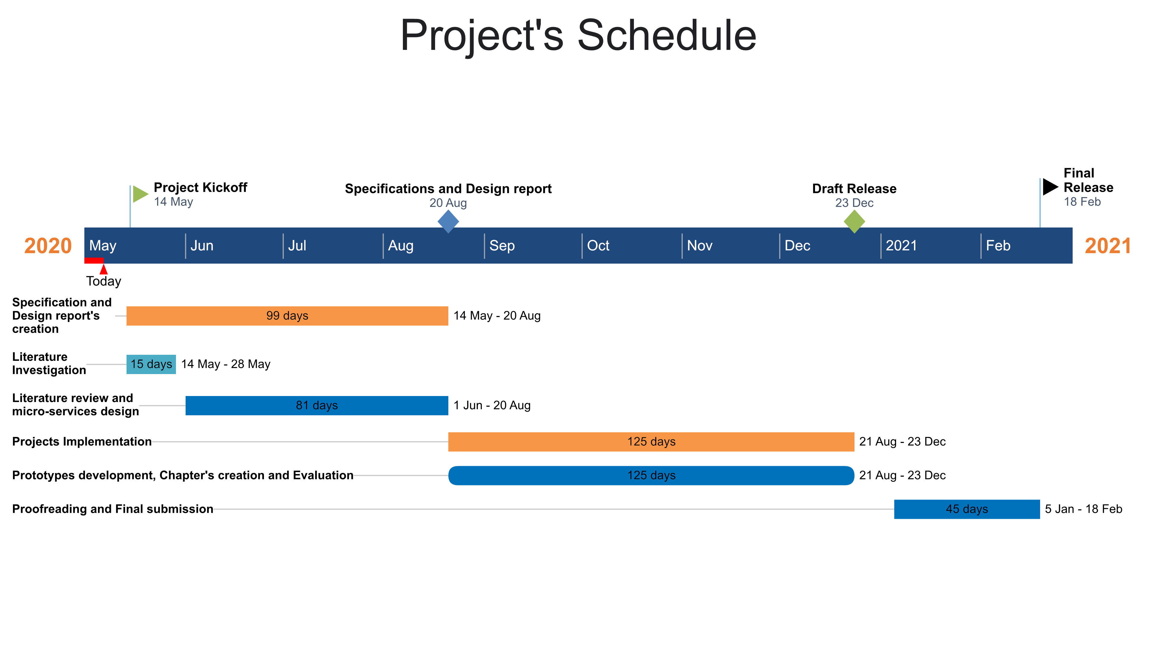

**Risk Assessment:**

|  |  |  |
| --- | --- | --- |
| Risk | Impact | Mitigation Strategy |
| Low resources and computational power. | 5/10 | * RAM expansion * Cloud deployment |
| Implementation time | 7/10 | * Time schedule between tasks * Tasks partitioning |
| External interruptions | 6/10 | * Creation of the appropriate environment |
| Number of sources management | 6/10 | * Sources investigation process implementation according tasks * Cataloging according the various subdomains |
| Family emergency requirements | 7/10 | * Tasks time allocation * Requirements mitigation |
| Computer damage/Loss | 6/10 | * Regular Back-ups * Cloud storage * Alternative laptop workstation in place. |

**Quality Assurance:**

In order to, address project’s quality considerations, the following aspects will be ensured:

* Projects tasks partitioning and frequent monitoring, to ensure their alignment with conducted schedule.
* Acquired literature material will be obtained by reliable and appropriate sources.
* Referenced material will be presented in the required format.
* Regular communication with DA, for reviewing and feedback draft reports according implementation and schedule, after each task’s accomplishment. To enable errors mitigation and corrections process’s partitioning regarding implemented tasks.
* Obtained errors information categorization, underlying errors cause identification and isolation, and problems correction processes application.

## References

Maxim, B. and Kessentini, M., 2016. An introduction to modern software quality assurance. *Software Quality Assurance*, pp.19-46.

###### Detailed design

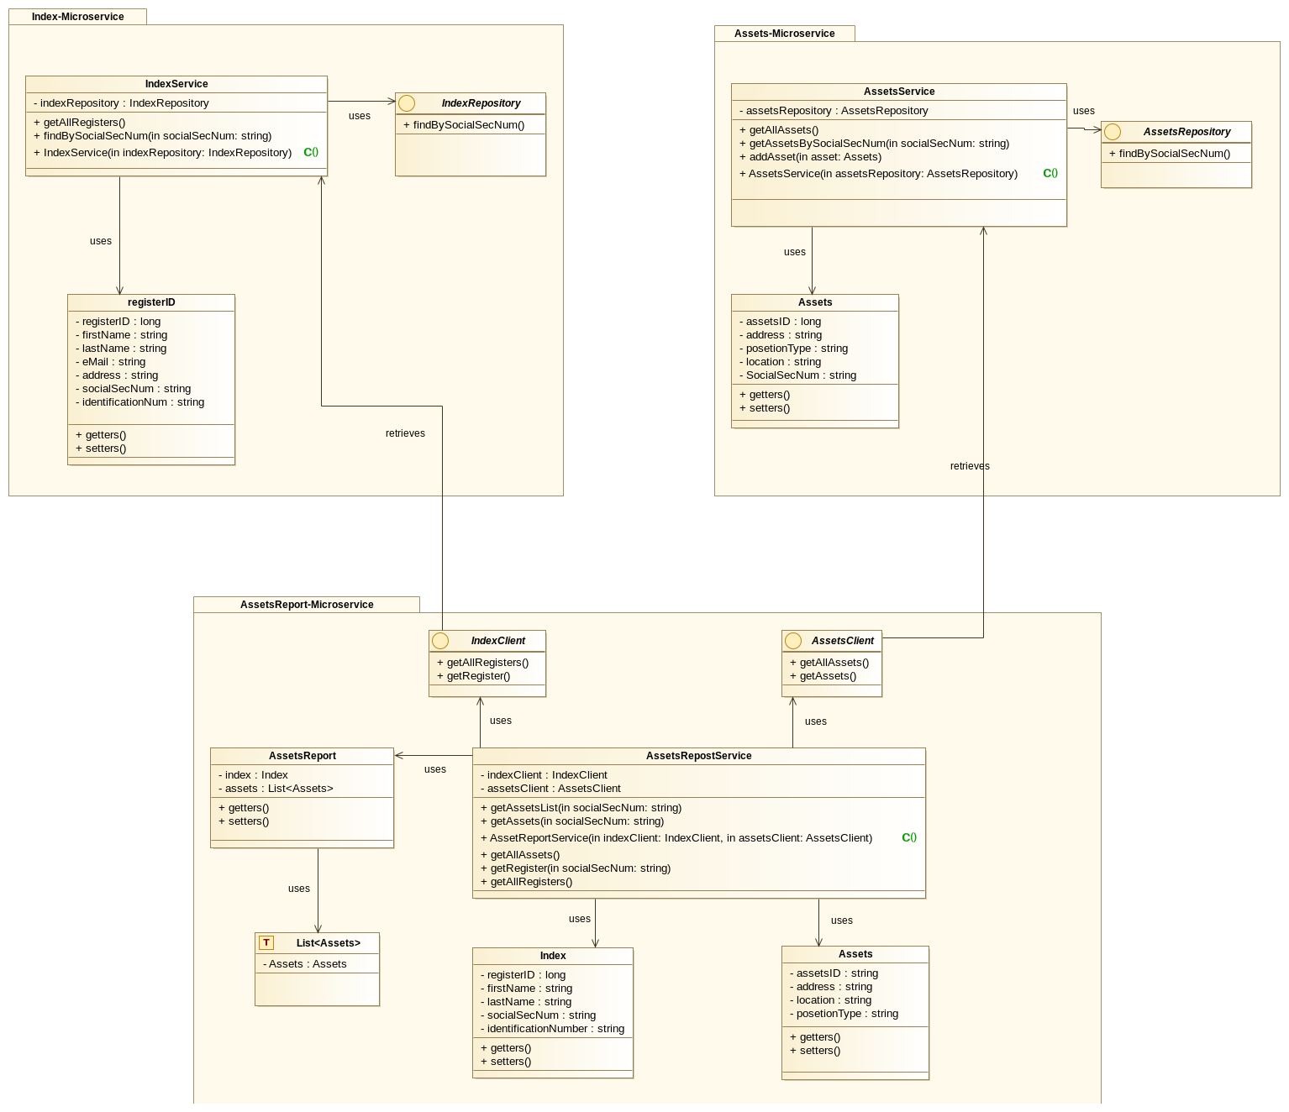

###### Code used to develop the IT artefact

###### The Index Service

Domain Models

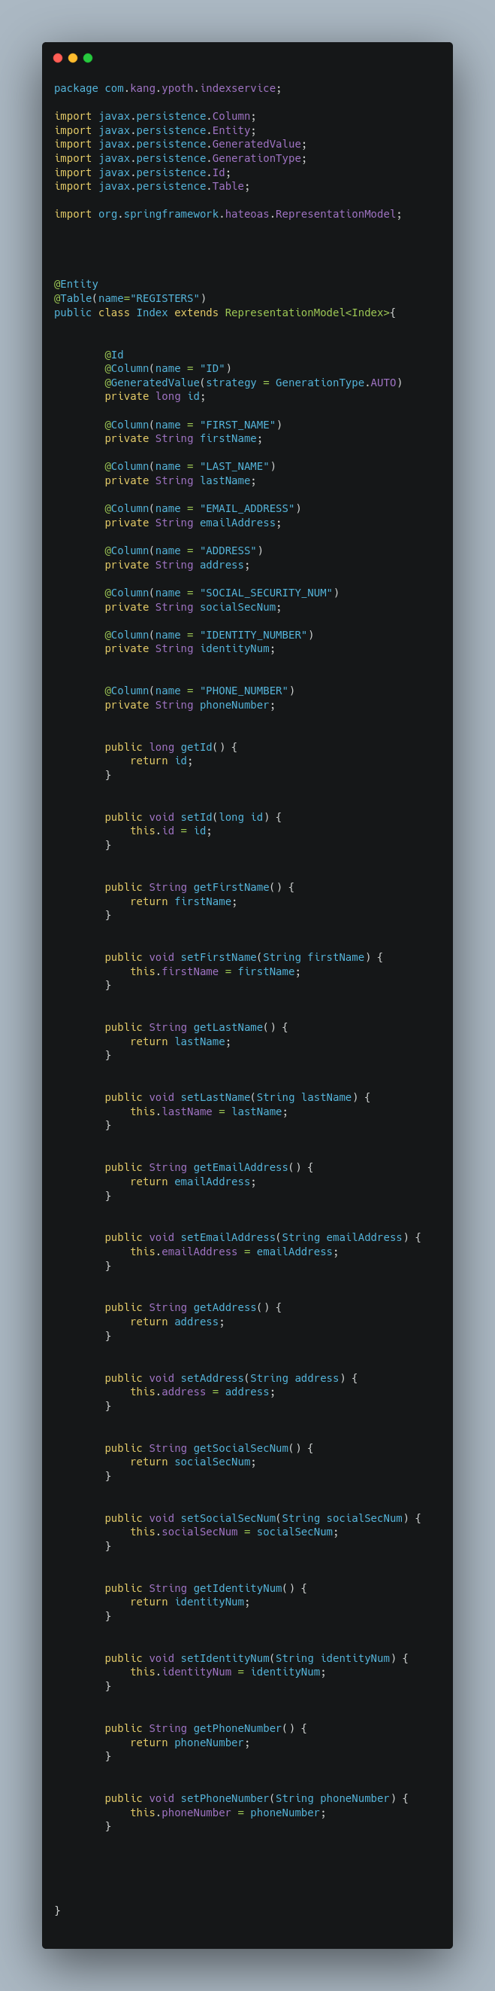

Service

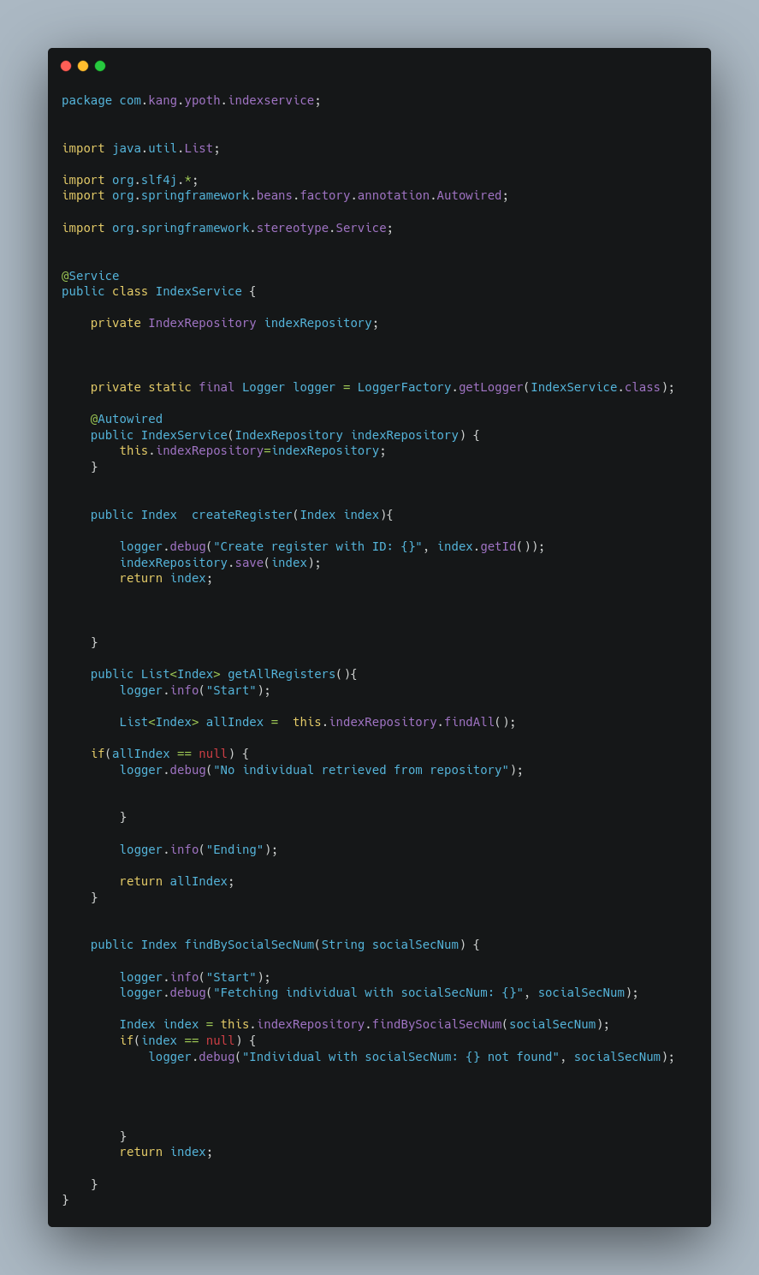

Controller:

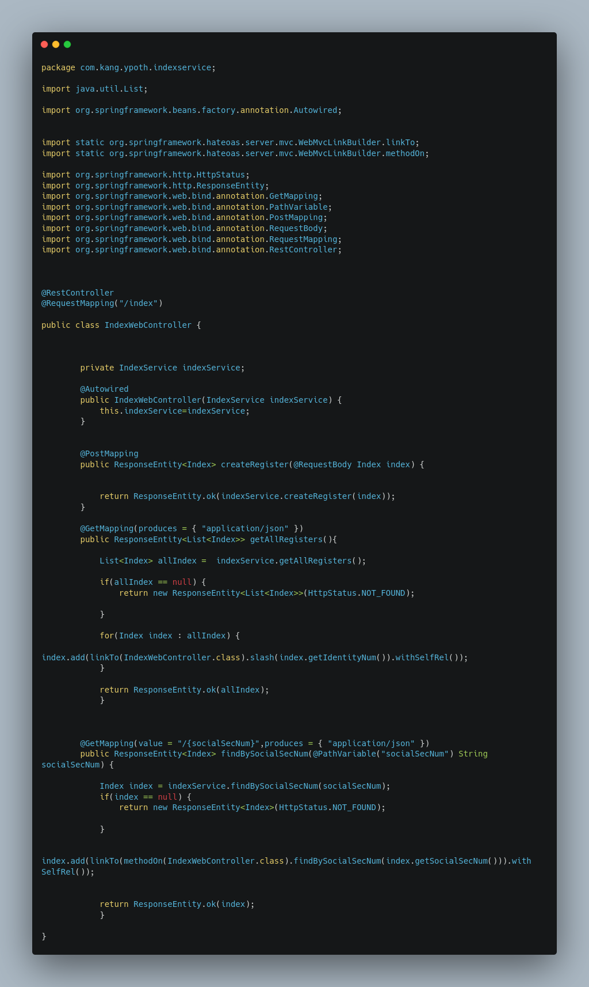

Repository:

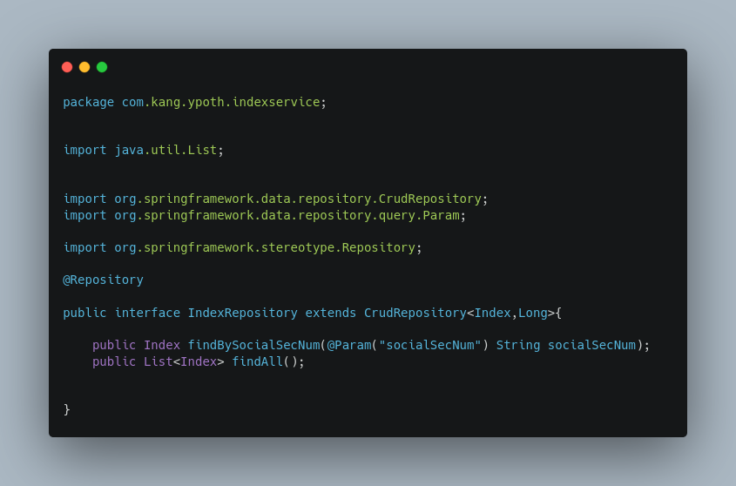

BOOTSTRAP CLASS:

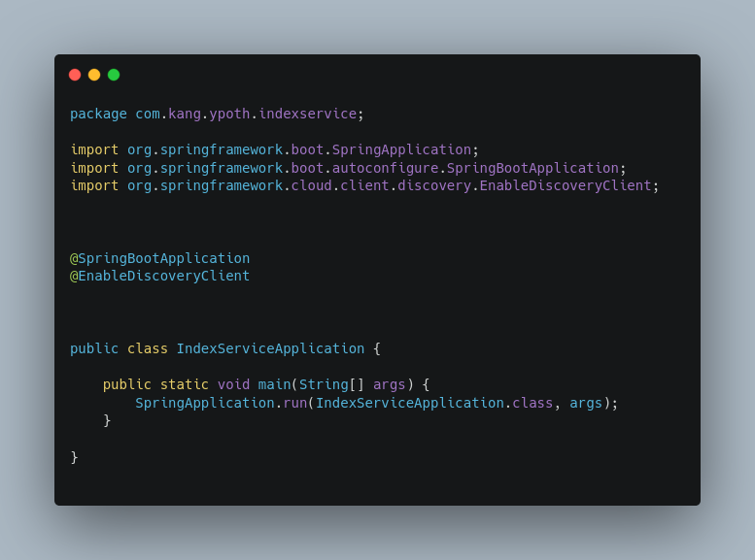

###### The assets service

Domain Model:

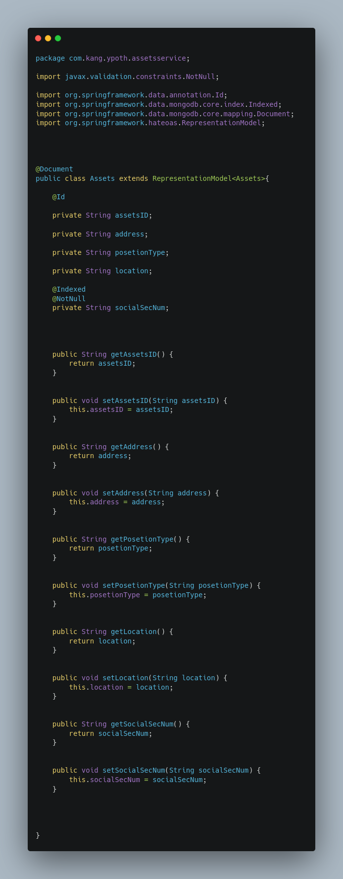

Service:

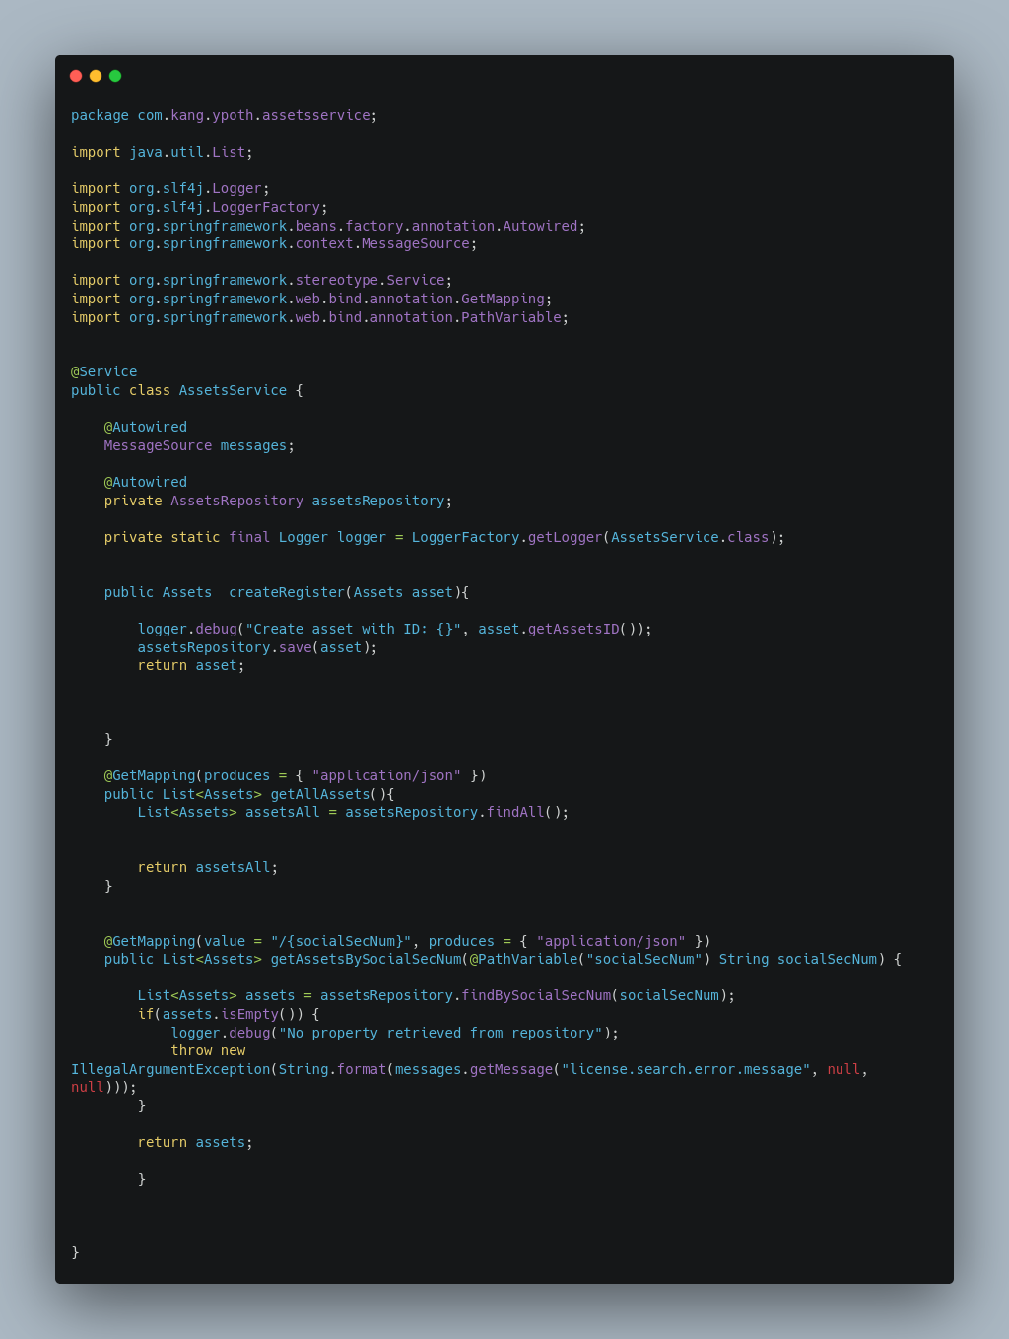

Controller:

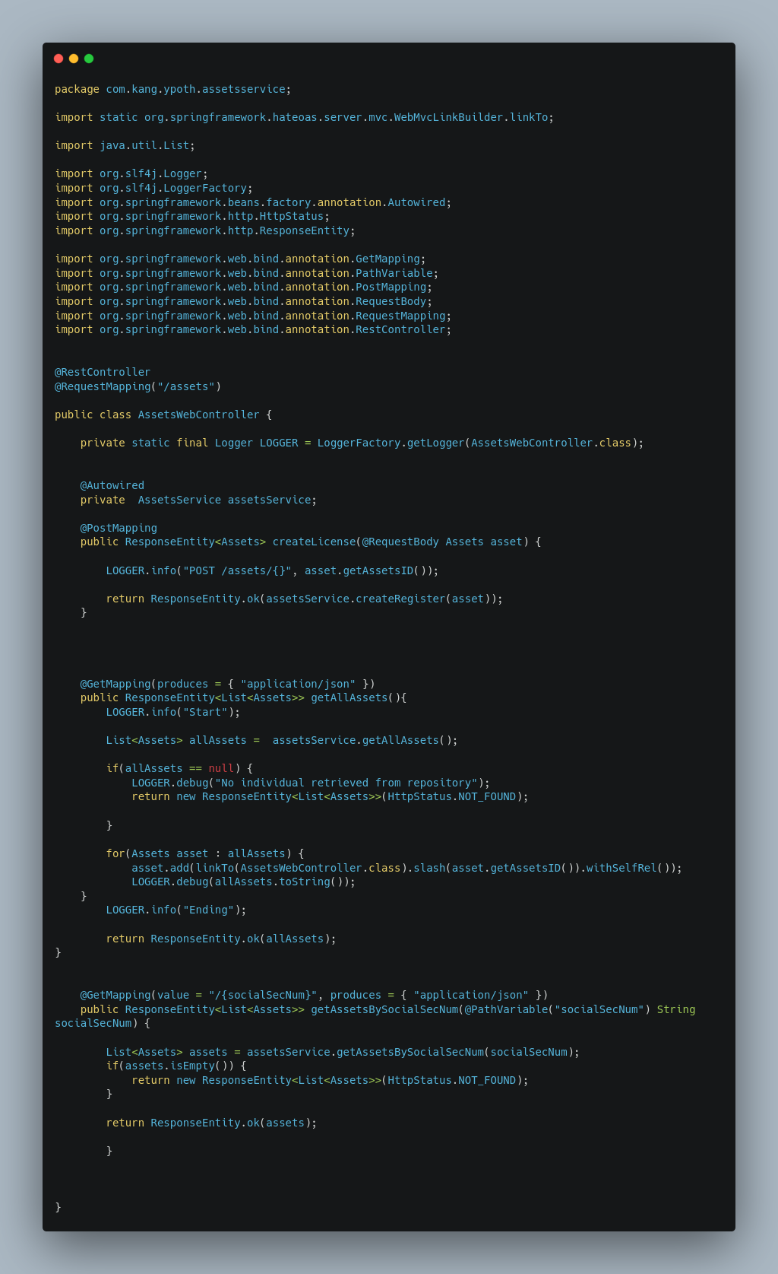

Repositorie:

BOOTSTRAP CLASS:

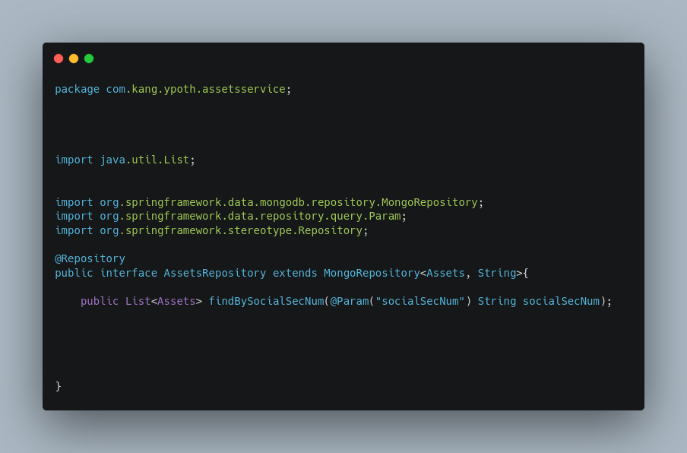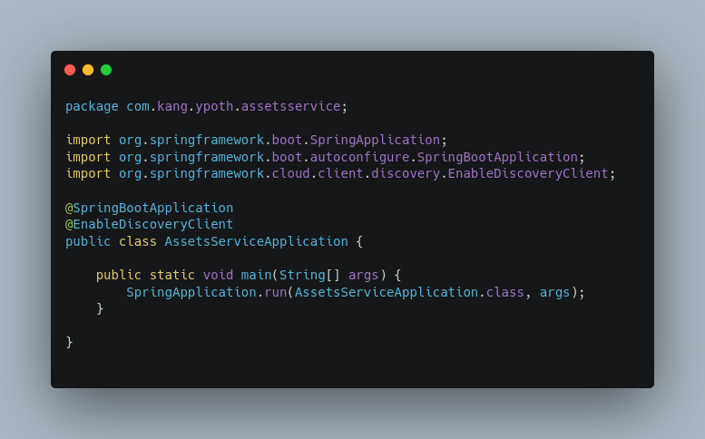

###### the asserts-rep class:

ASSETS MODEL:

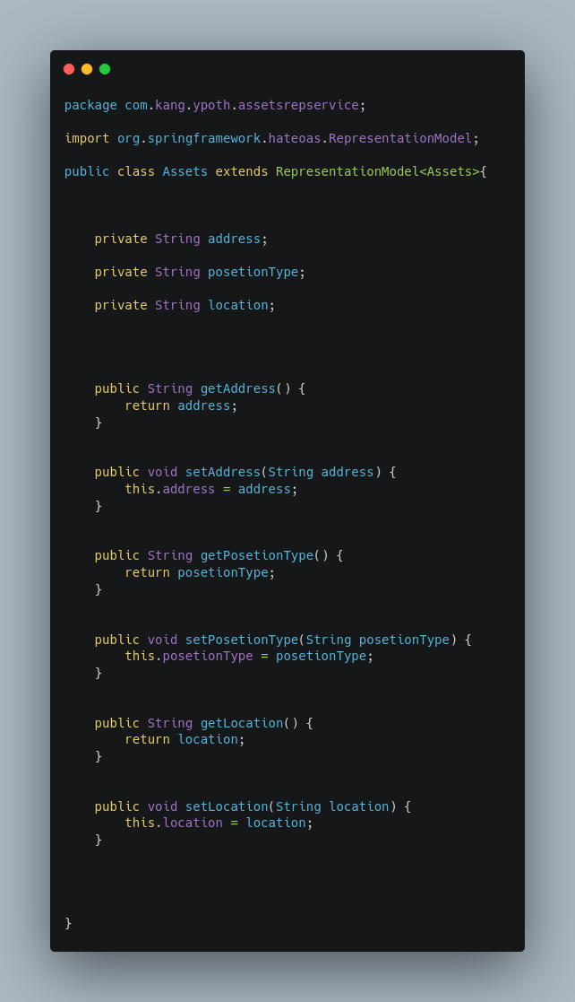

INDEX MODEL:

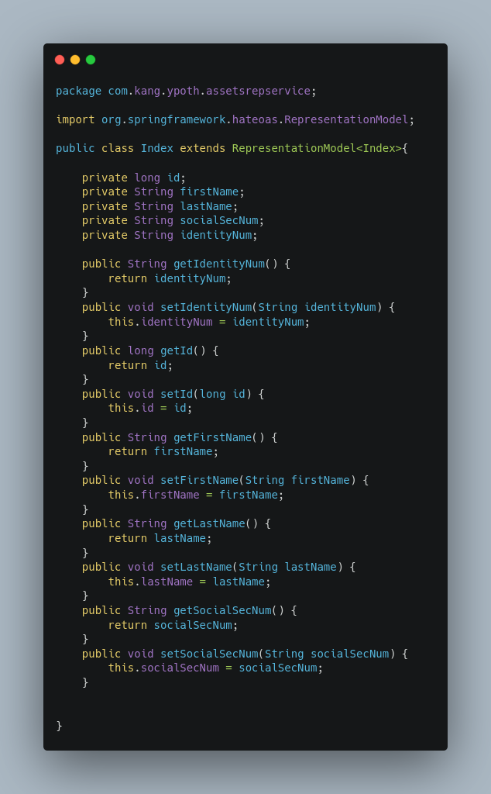

ASSETSREP MODEL:

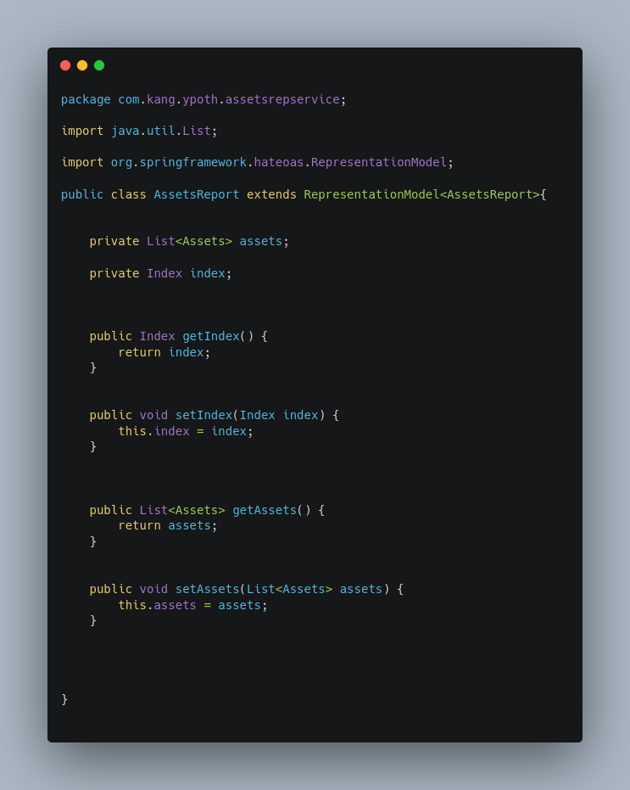

CONTROLLER:

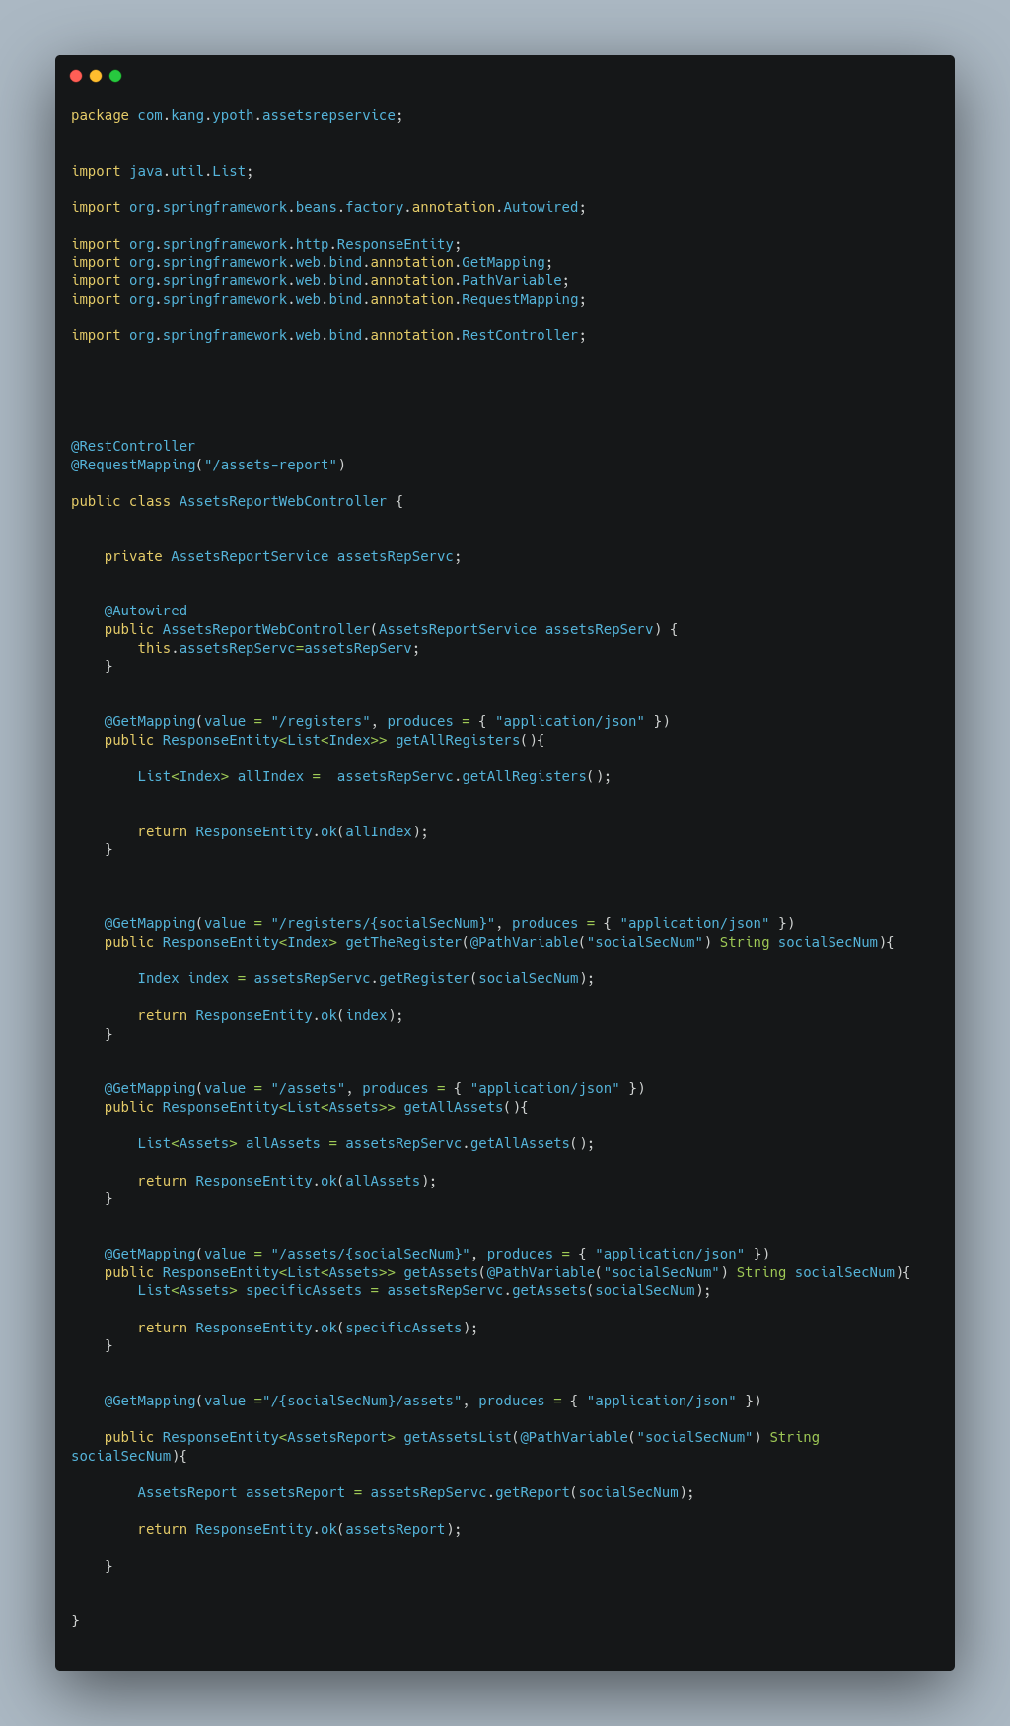

SERVICE:

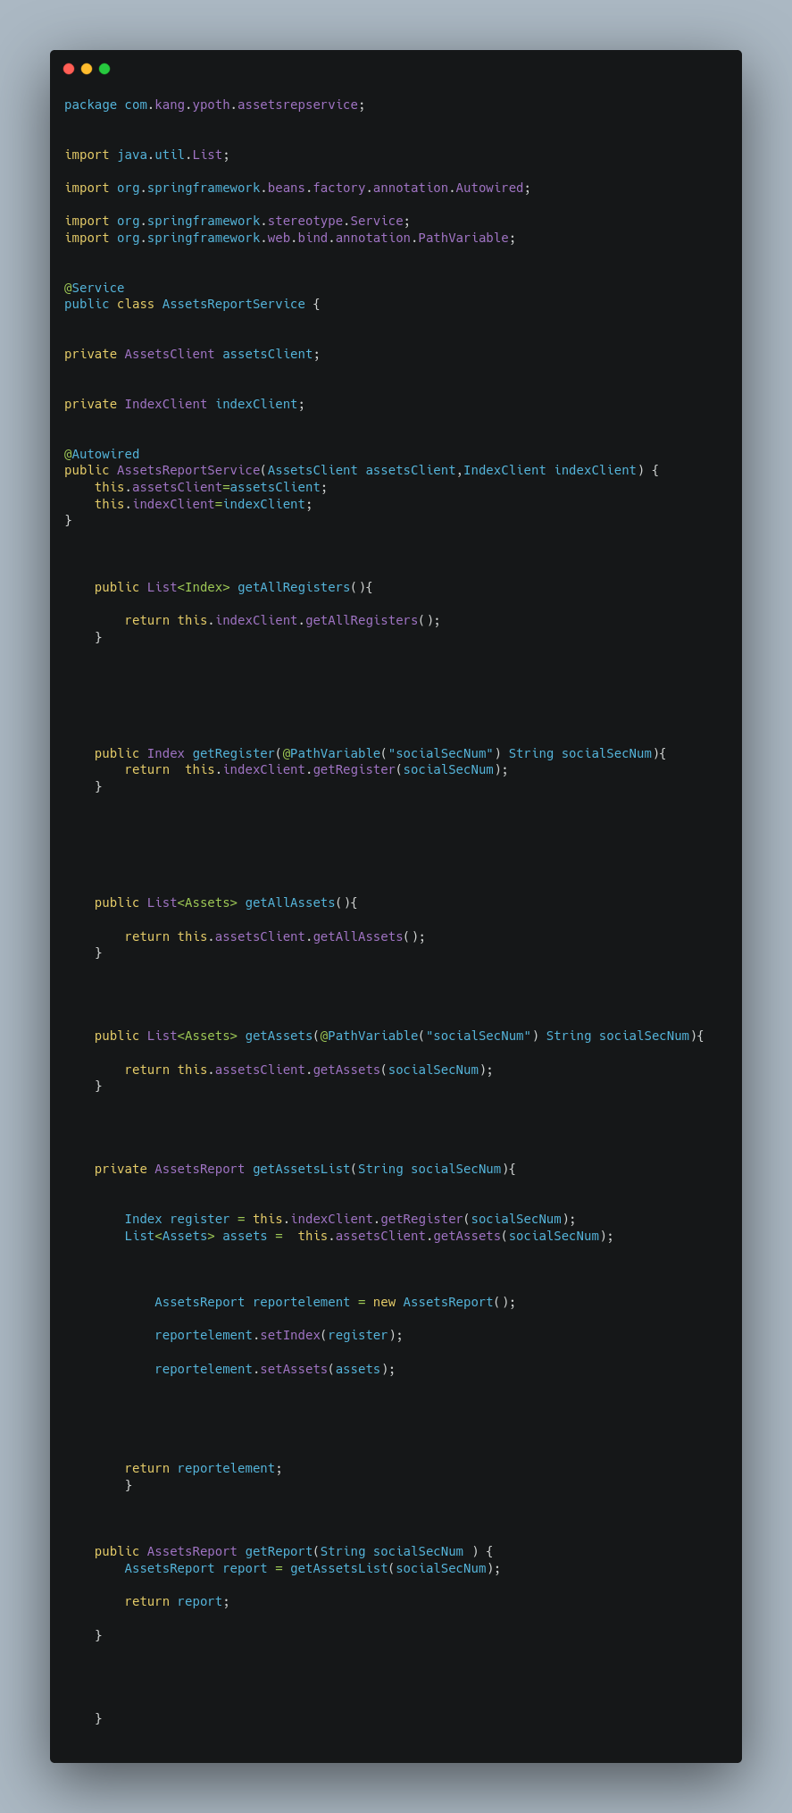

INDEX FEIGHN:

ASSETS FEIGN:

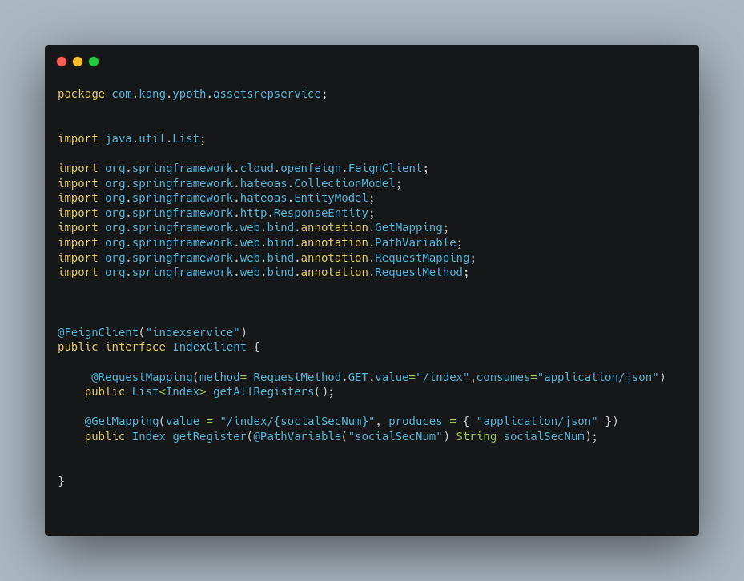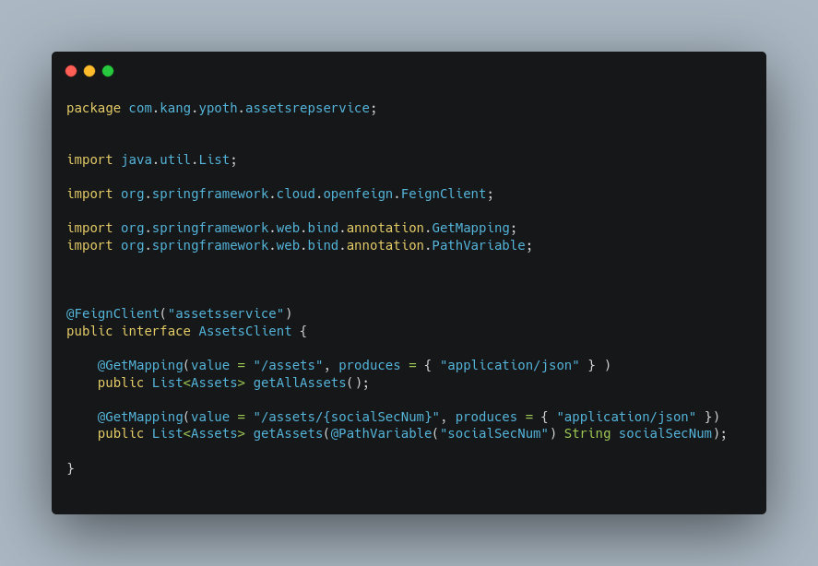

BOOTSTRAP:

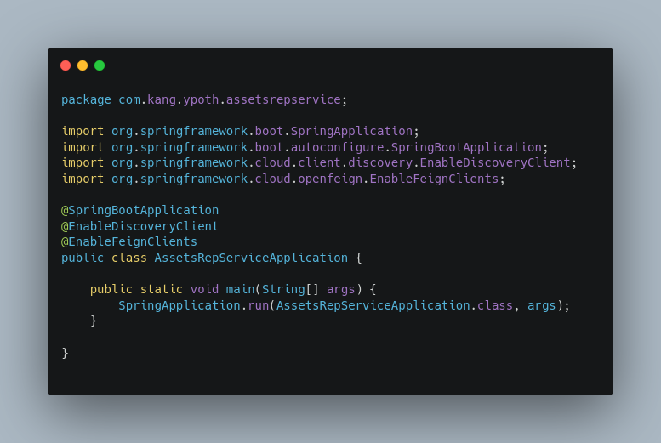

###### SECURITY

SERVICES:

TLS CONFIGURATION:

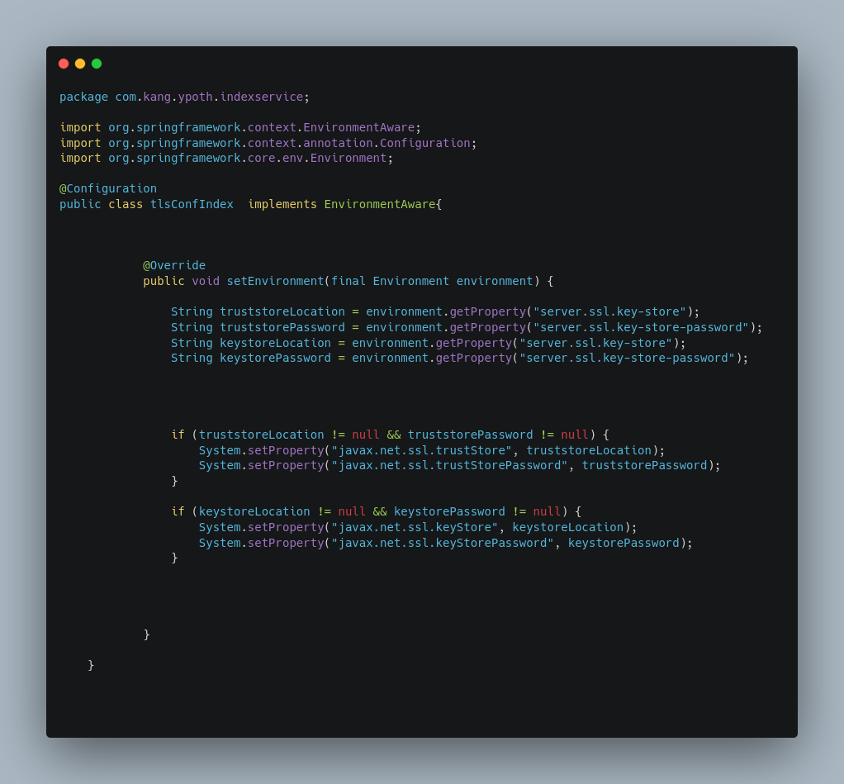

OAuth2.0 CONFIGURATION:

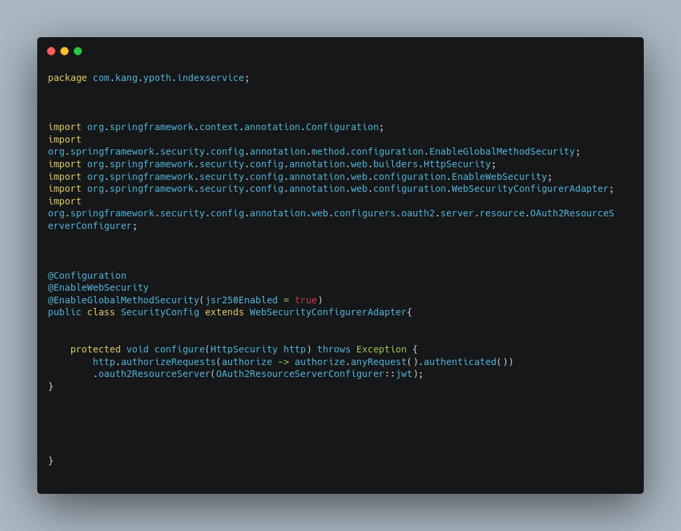

GATEWAY:

OAuth2.0:

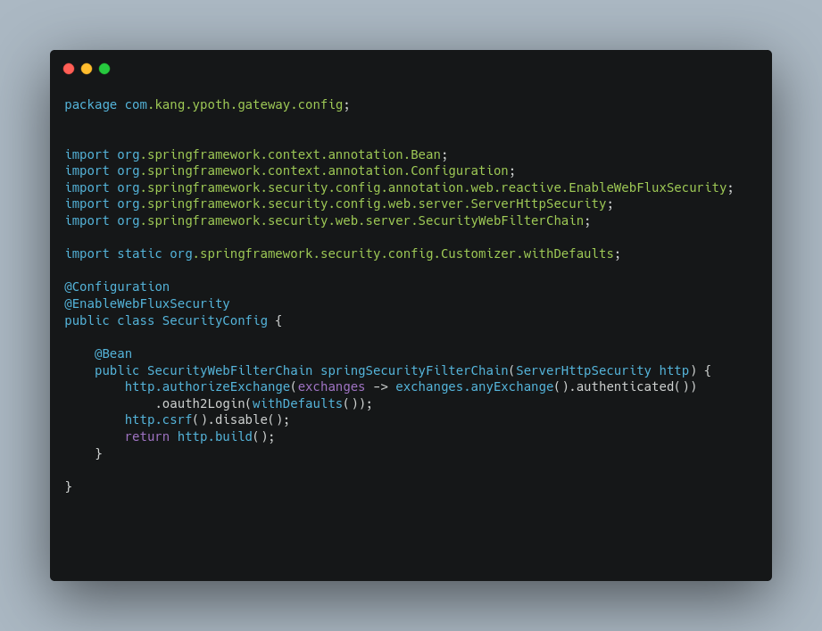

THROTTLE filter:

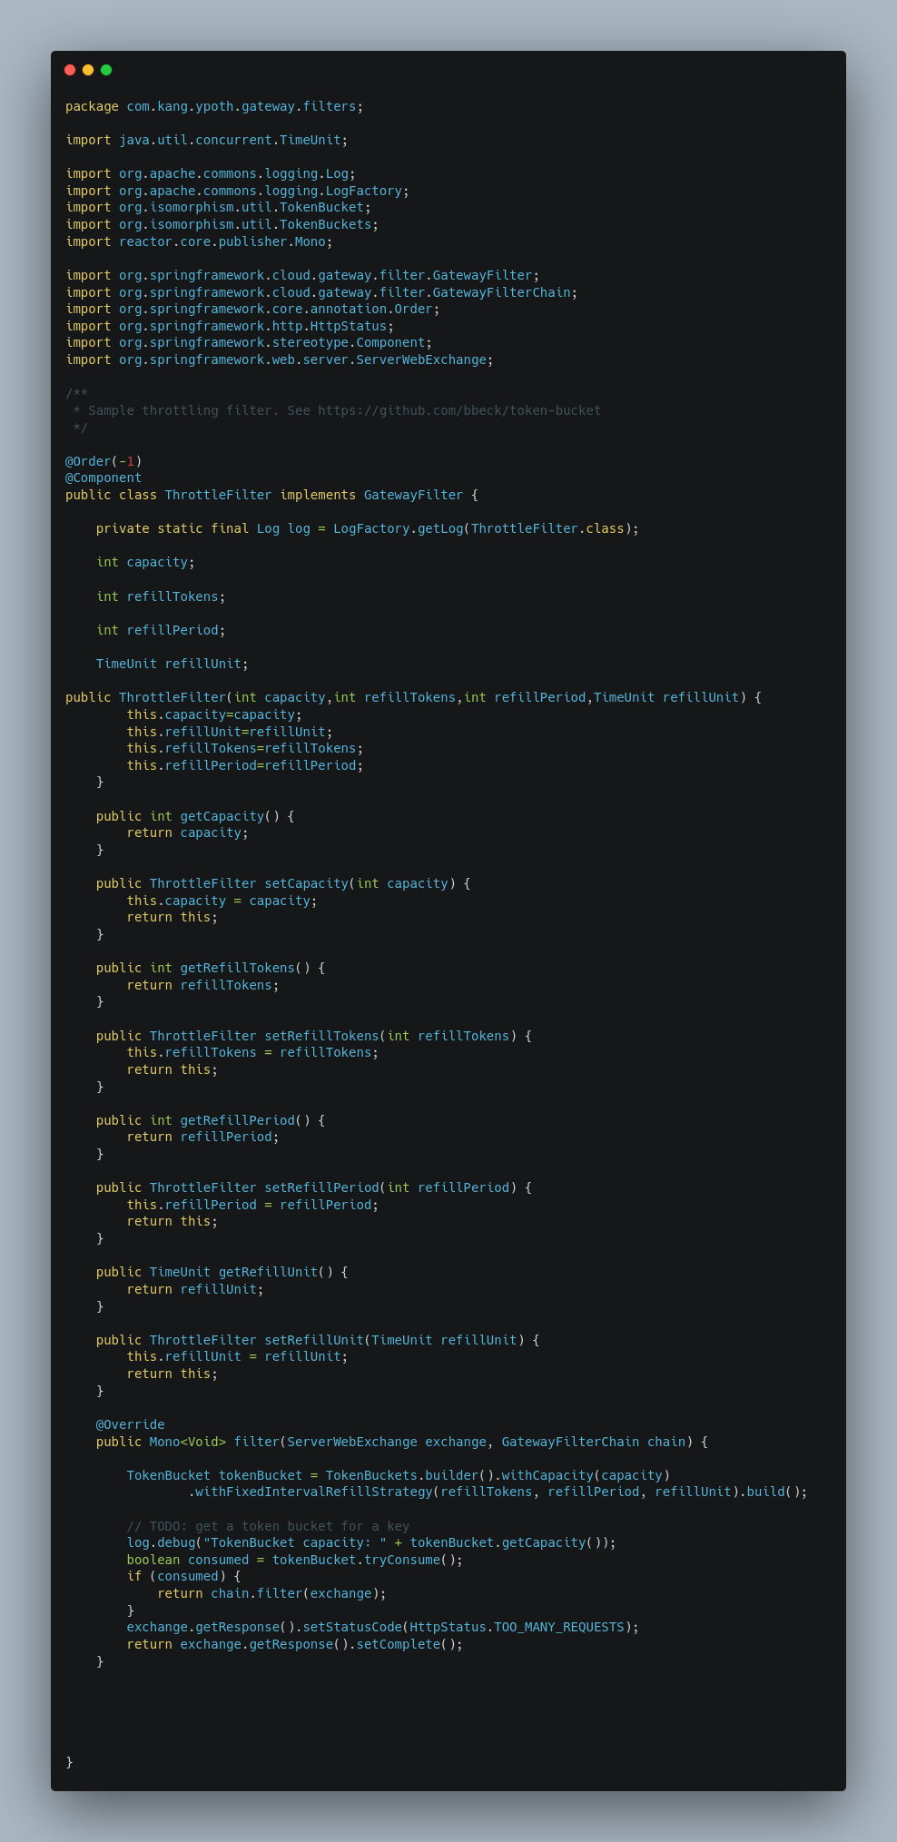

BOOTSTRAP:

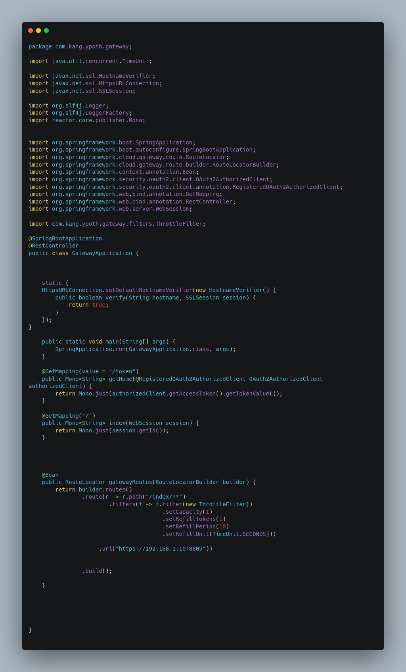

CERTIFICATES GENERATION FOR TLS ENCRYPTION:

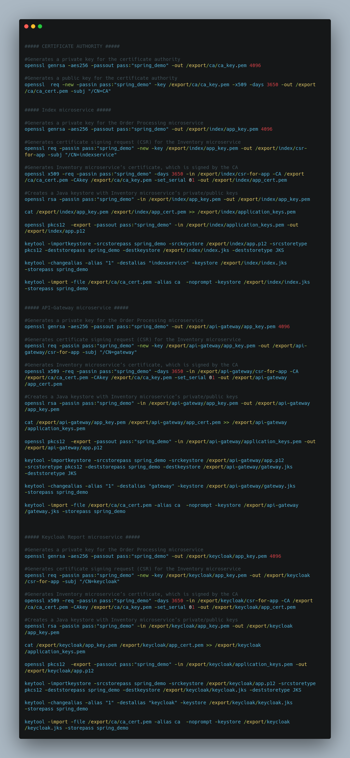

###### REACTIVE

ASSETS-REP

SERVICE:

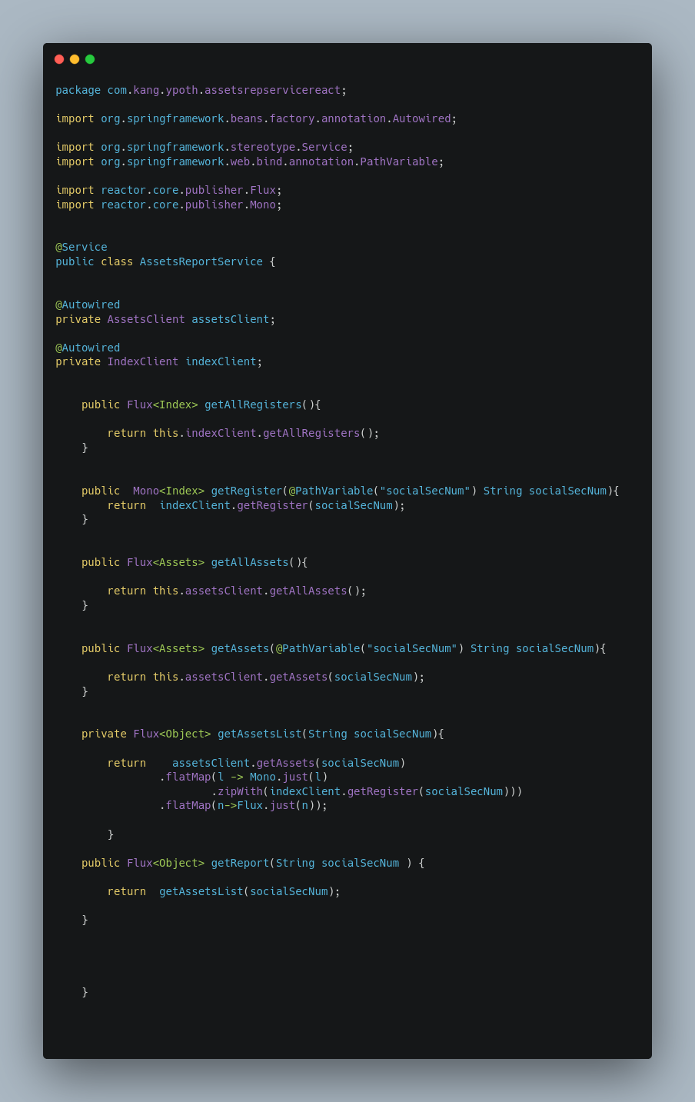

CONTROLLER:

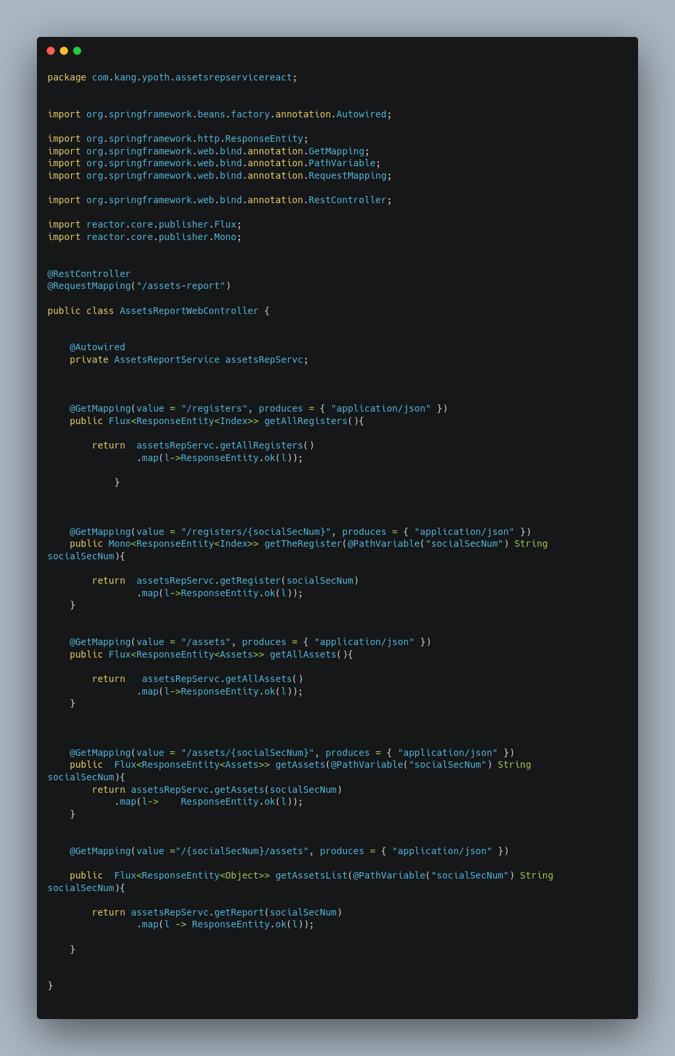

ASSETS CLIENT:

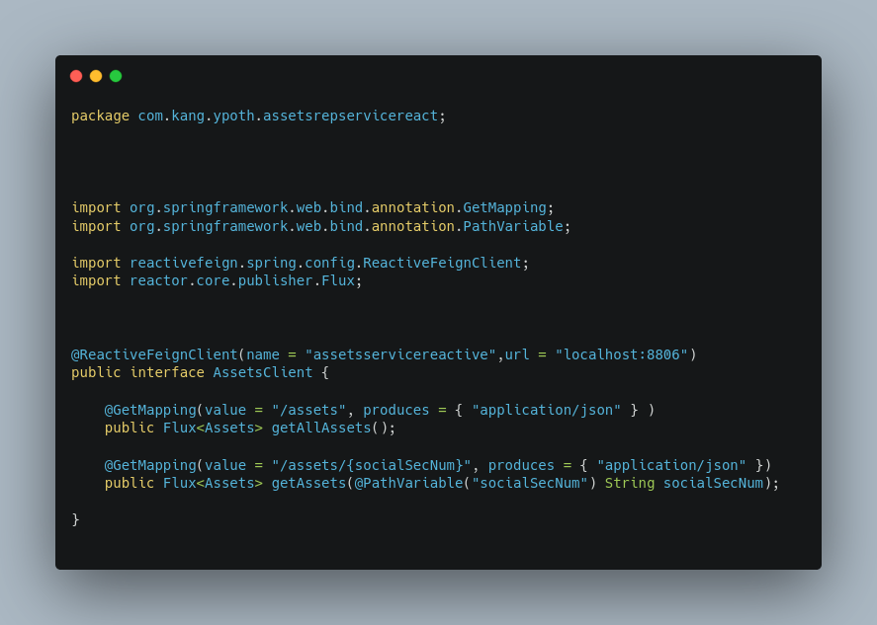

INDEX CLIENT:

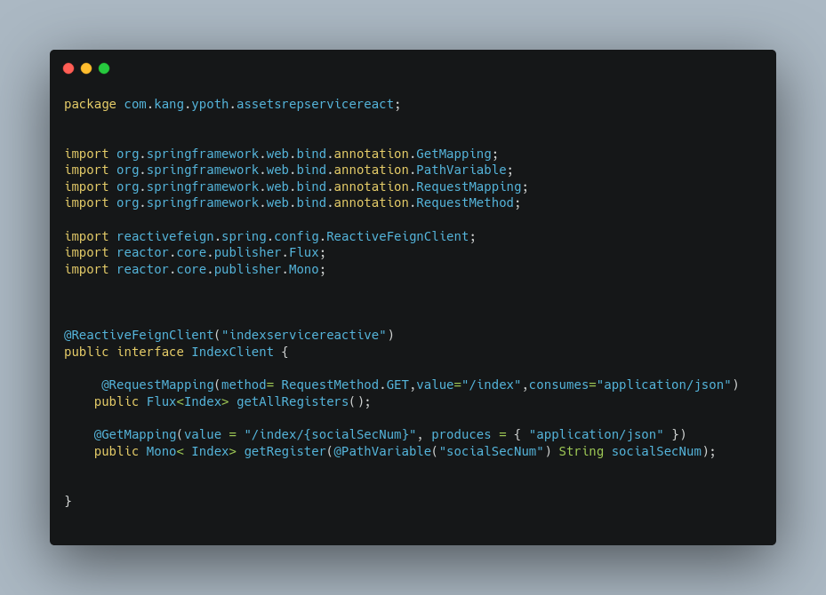

DEPLOYMENT:

ImageStreams:

